What are Capacitors Used For?
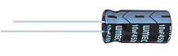
Capacitors, either standalone or used with other electronic components such as resistors and inductors, have a wide variety of uses in circuits. What capacitors are used for are shown below:

1) RC Timing Circuit
A capacitor, when combined with a resistor, is used to form a RC circuit, which acts as a timing mechanism. The combination of the value of the resistance of the resistor and the value of the capacitance of the capacitor determines how long it takes the capacitor to charge up or to discharge in a circuit. By using the needed values, a precise timing sequence can be made that is needed for a circuit.
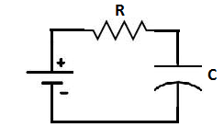
The product of the RC value is called the time constant. It is this RC product, which is measured in unit seconds, which decides the timing interval of the RC circuit.

2) AC Coupling
A capacitor is used for AC coupling. This is where a capacitor couples, or transfers, the AC portion of a signal to output and blocks the DC from being transmitted. This is necessary in situations where the AC aspect of a signal needs to be passed as output but not the DC. In this way, the coupling capacitor acts as a type of filter, passing AC and blocking DC.
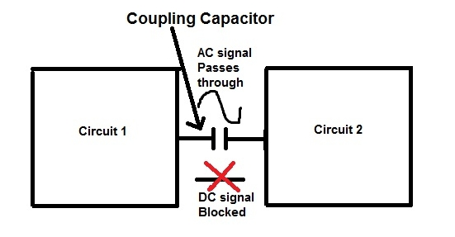
A prime example of where coupling capacitors are needed is in microphone circuits. Microphones need DC power in order to operate, in order to turn on. However, this DC output should not appear in the output; it's only for powering the microphone. The only output we want is the user's speech, music, etc, which are AC signals. If the DC were placed in output, it could cause DC offset, which means the signal could shift up or down. To counter this, coupling capacitors remove all aspects of DC and only pass the wanted AC (music, speech, etc.)
To find out more about coupling capacitors, visit the link coupling capacitors for more in-detail information.

3) Removes AC Noise From DC Signals
A capacitor can also be used as a bypass capacitor, which is a capacitor that shunts AC signals of a DC to ground. This cleans any AC noise that may be on DC signals, allowing a much cleaner DC signal to be used in a circuit.
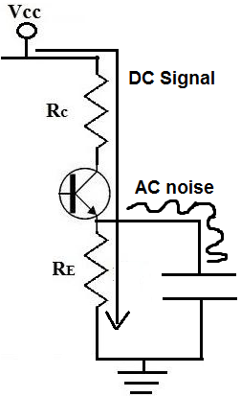
As you can see above, the capacitor in parallel to the resistor, RE serves as a bypass capacitor. This bypass capacitor bypasses the AC aspect of the signal to ground, allowing a pure DC signal to go through the resistor, RE. This helps the transistor eliminate any noise that may enter it and allows it to produce a cleaner output signal.
To find out more about bypass capacitors, visit the link, bypass capacitors for more in-detail inofrmation.

4) Power Supply Filter
Capacitors are used to smooth the pulsating voltage from a power supply into a steady direct current (DC).
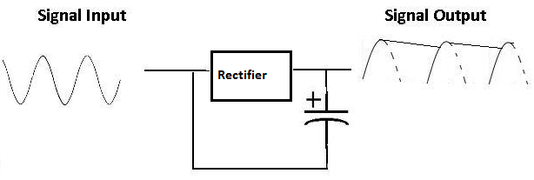
If a typical sine wave current needs to be converted into a steady DC current, the above circuit allows it to do so. A rectifier rectifies the AC signal so that it remains above the positive threshold, producing a pulsating DC signal. A capacitor then placed in parallel to the output smoothes the signal so that the DC output is steady in value.

5) Spike Remover
Digital logic circuits can use lots of momentary current when they switch from off to on and vice versa. This can cause very brief but substantial reductions in power applied to nearby circuits. These power spikes (or glitches, as they are called sometimes) can be eliminated by placing a small (0.1µF) capacitor across the power leads of the logic circuit:
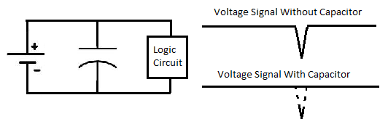
A capacitor acts like a miniature battery that supplies power during the spike.

6) RC Integrator
A capacitor can also be used as an RC integrator, which is a circuit which can act as a low pass filter. A basic RC integrator is shown below:
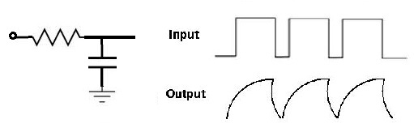
If the input pulses are speeded up, the output waveforms (often called sawtooth) will not reach their full amplitude. Therefore, this RC integrator will reproduce signals in full which have an frequency below a certain level but not those above a certain frequency. It acts as a low-pass filter. This is good for many applications where only low-frequency signals need to be output but not higher frequency signals.

7) RC Differentiator
A capacitor can also be used as an RC differentiator. Below is a basic example of one:
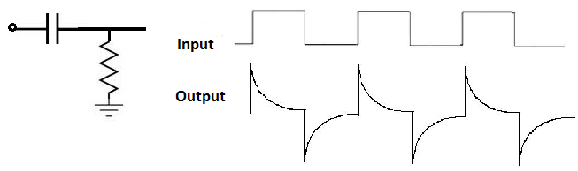
An RC Differeniating circuit produces symmetrical output waves with sharp positive and negative peaks. It's used ot make narrow pulse generators for television receivers and to trigger digital logic circuits.

What is a Coupling Capacitor?
A coupling capacitor is a capacitor which is used to couple or link together only the AC signal from one circuit element to another. The capacitor blocks the DC signal from entering the second element and, thus, only passes the AC signal.

Use of Coupling Capacitors
Coupling capacitors are useful in many types of circuits where AC signals are the desired signals to be output while DC signals are just used for providing power to certain components in the circuit but should not appear in the output.
For example, a coupling capacitor normally is used in an audio circuits, such as a microphone circuit. DC power is used to give power to parts of the circuit, such as the microphone, which needs DC power to operate. So DC signals must be present in the circuit for powering purposes. However, when a user talks into the microphone, the speech is an AC signal, and this AC signal is the only signal in the end we want passed out. When we pass the AC signals from the microphone onto the output device, say, speakers to be played or a computer to be recorded, we don't want to pass the DC signal; remember, the DC signal was only to power parts of the circuit. We don't want it showing up on the output recording. On the output, we only want the AC speech signal. So to make sure only the AC passes while the DC signal is blocked, we place a coupling capacitor in the circuit.

How to Place a Coupling Capacitor in a Circuit
In order to place a capacitor in a circuit for AC coupling, the capacitor is connected in series with the load to be coupled.
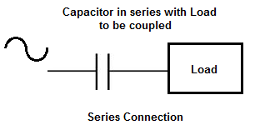
A capacitor is able to block low frequencies, such as DC, and pass high frequencies, such as AC, because it is a reactive device. It responds to different frequencies in different ways. To low frequency signals, it has a very high impedance, or resistance, so low frequency signals are blocked from going through. To high frequency signals, it has a low impedance or resistance, so high frequency signals are passed through easily.

How to Choose the Value of the Coupling Capacitor

Now that we know what a coupling capacitor is and how to place in a circuit for coupling, the next thing is how to choose an appropriate value for the coupling capacitor.
The value of the coupling capacitor depends on the frequency of the AC signal being passed through.
Capacitors are reactive devices, meaning they offer different impedance (or resistance) to signals of different frequencies. To low-frequency signals, such as DC with a frequency of 0Hz, capacitors offer very high resistance. This is how capacitors are able to block DC signals from passing through it. However, as the frequency of the signal increases, the capacitor offers progressively less resistance. The capacitor reactance changes according to the formula, reactance= 1/2πfC, where f is the frequency and C is the capacitance. So you can see that the reactance the capacitor offers is proportional to the frequency and capacitance.
Since capacitors offer less reactance at higher frequencies, a very low capacitance is value is needed to allow them to pass through. So very high-frequency signals need only very small capacitors such as in the picofarad (pF) range.
Capacitors offer greater reactance at lower frequencies. Therefore, they need much larger capacitance values to allow these lower-frequency signals to pass through. So low-frequency signals will require capacitors in the microfarad range.
So coupling capacitors are used in many different applications. One of the most common applications is for amplifiers. However, they can be used in practically any circuit that requires DC blocking with AC coupling, such as radio frequency (RF) applications.
Since audio frequency and radio frequency applications suit a wide range of frequencies that entails frequencies from hertz all the way to megahertz, this covers all the frequencies that are necessary for coupling applications.
Below is a basic rough guideline of capacitors that can be used for various frequencies.
For coupling a 100Hz signal, a 10μF capacitor can be used.
For a 1000Hz signal, a 1μF capacitor can be used.
For a 10KHz signal, a 100nF capacitor can be used.
For a 100KHz signal, 10nF capacitor can be used.
For a 1MHz signal, a 1nF capacitor can be used.
For a 10MHz signal, a 100pF capacitor can be used.
For a 100MHz signal, a 10pF capacitor can be used.
This is a rough estimate that will be effective the majority of the time. The only variable that could affect the above values is the resistance in parallel to the capacitor.
If the resistance in parallel to the capacitor is about 10K‎Ω or less, all the values will hold true. Usually the resistance is much less than this amount.
However, if the resistance is greater, such as between 10K‎Ω and 100K‎Ω, you can divide the above capacitor by 10; meaning you can use even a smaller capacitor. It's perfectly fine if you use the capacitor above, the coupling will work just as well. But you could use even a smaller capacitor, because if the resistance in parallel is larger, that makes the AC signal choose the capacitor path that much easier than the resistor path, because the capacitor path has much less resistance compared to the resistor if the resistor is larger. So as the resistance increases, the capacitance value can decrease. But, again, using a larger capacitor value than what is needed could never hurt. Using a smaller capacitor could.
So this is an effective method for choosing the value of a coupling capacitor. It allows for low-frequency or high-frequency coupling.
While coupling capacitors pass through AC signals to output, decoupling capacitors do pretty much the opposite; decoupling capacitors shunt AC signals to ground and passes through the DC signal in a circuit. Decoupling capacitors are designed to purify DC signals of AC noise.

What is a Decoupling Capacitor?
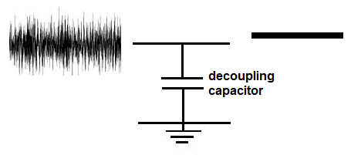
A decoupling capacitor (also called a bypass capacitor) is a capacitor which is used to decouple AC signals from a DC signal.
While coupling capacitors are used to pass through the AC component while blocking the DC component, a decoupling capacitor removes the AC component, making for a more pure DC component.

Use of Decoupling Capacitors
Deoupling capacitors are useful in many types of circuits where noise needs to be cleaned up in a DC power source.
In a perfect world, the power you get from a DC power source, such as a DC power supply, would be a perfect DC signal, containing no noise on it.
A perfect DC signal would look like the signal below.
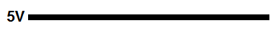
This is the type of signal a circuit designer would always desire.
However, in the real world, few DC signals, especially from power supplies come out this way.
The DC signal from power supplies often have noise and look like the signal shown below.
So, basically, the signal is usually imperfect.
When coming from a power source, there are all types of interferences why AC signals come into play and superimpose on the DC signal and make the signal noisy.
What we want to do is decouple this noise (the AC signal) from the DC signal, allowing for a much cleaner DC signal.
This is especially important when the DC signal is used for circuits such as logic circuits. This is because logic chips need very precise DC voltages in order to work properly. For example, if a logic chip operates on a supply voltage of 5V, normally voltages below 2.5V will read as a LOW signal and voltages above 2.5V will read as a HIGH signal. If there is noise on the signal (AC signals on the DC signal), this can trigger in appropriate LOWs and HIGHs on the logic circuits. Thus, for circuits where precision is involved or the signal needs to simply be cleaned, decoupling capacitors are widely used.
Capacitors function very well as decoupling capacitors due to the nature of their reactance. Reactance is how a component reacts to various frequencies. Capacitors, by nature, block DC signals from passing through but allow AC signals to pass through them, since they offer less resistance to AC signals. Capacitors offer less resistance as the frequency of the AC signal increases. Thus, they are ideal for acting to decouple AC from DC signals. The AC component gets shunted to ground.
So now that we got over the conceptual aspect of decoupling capacitors, let's see how to place one in a circuit so that decoupling is achieved.

How to Place a Decoupling Capacitor in a Circuit
In order to place a capacitor in a circuit for decoupling, the capacitor is connected in parallel with the power supply.
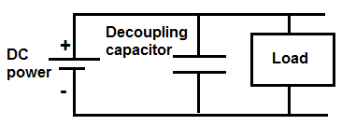
So this is a very simplified circuit, just demonstrating decoupling capacitors. You may need additional capacitors such as smoothing capacitors depending on the circuit type, but this is strictly demonstrating decoupling capacitors.
So, it's really simple, the DC power supply gives power to the circuit. The decoupling has, pretty much, infinite reactance to DC signals (resistance), so it doesn't allow DC signals to get shunted to ground. However, AC signals have much less reactance, so they can pass through the decoupling capacitor and get shunted to ground. These capacitors provide a low impedance path for high-frequency signals (which represents the noise) on the power supply, thus cleaning up the DC signal. This is how the decoupling capacitor decouples AC signals from DC signals.
Typically for decoupling capacitors, ceramic capacitors are the predominant type used. The value of the capacitor is usually between 100nF and 10nF. However, usually 100nF capacitors are used most commonly. So, the most used type of decoupling capacitor is a 100nF ceramic capacitor.
Besides power supplies, decoupling capacitors also have other uses.
One other important use of decoupling capacitors is for circuits in which there is high switching amongst components, such as logic chips for instance.
Before we spoke about logic chips needing precise voltage from a DC power supply, as to not trigger false LOWs or HIGHs. However, logic chips themselves can cause problem. If a logic chip is constantly switching logic states, for example, HIGH to LOW and LOW to HIGH, etc., it can cause transient voltage spikes in a circuit.
To contain these transient voltage spikes, a decoupling capacitor can be placed in parallel (very close next to the logic chip), so that these transient voltages get shunted down to ground. Today, many chips do come with built-in decoupling capacitors in the IC, but not all do. So, for those that don't, decoupling capacitors can be placed at the outputs of each of the logic gates. This prevents transient voltage spikes, which could cause unintended problems in the circuit.
This circuit with decoupling capacitors would resemble the circuit shown below.
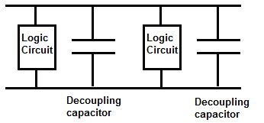
The website, hackaday, gave an image of logic chips that used decoupling capacitors vs those that did not use decoupling capacitors. It can be found at the following link: Decoupling capacitors Shown in Photographs. Basically, a 74HC04 inverter was built with a decoupling capacitor and without one. The one without the decoupling capacitor had significantly more noise on the signal.

What is a Bypass Capacitor?
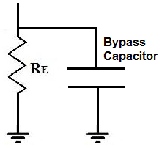
A bypass capacitor is a capacitor that shorts AC signals to ground, so that any AC noise that may be present on a DC signal is removed, producing a much cleaner and pure DC signal.
A bypass capacitor essentially bypasses AC noise that may be on a DC signal, filtering out the AC, so that a clean, pure DC signal goes through without any AC ripple.
For example, you may want a pure DC signal from a power source.
Below is a transistor circuit. A transistor is an active device, so in order to work, it needs DC power. This power source is VCC. In this case, VCC equals 15 volts.
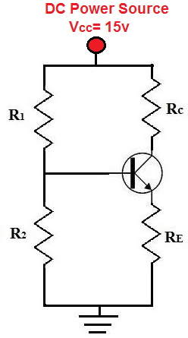
This 15 volts provides power to the transistor so that the transistor can amplify signals. We want this signal to be as purely DC as possible. Although we obtain our DC voltage, VCC, from a DC power source such as a power supply, the voltage isn't always purely DC. In fact, many times the voltage is very noisy and contains a lot of AC ripple on it, especially at the 60Hz frequency because this is the frequency at which AC signals run in many countries.
So although we want a pure DC signal, such as below:
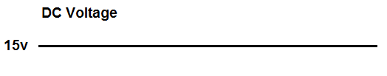
Many times, we get a noisy signal that looks like:
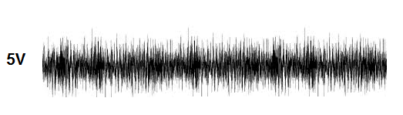
A DC signal such as this is actually very common. This is undesired because it adds noise to the transistor circuit. Therefore, this noisy DC signal will be imposed on the AC signal. So the AC signal which may have music or some type of recording will now have much more noise.
This noise which is on the signal is AC ripple. Many times when using a DC power supply connected to an AC power outlet, it will have some of the AC noise transfer to the DC power voltage. AC ripple can also appear from other sources, so even batteries can produce noise.
To eliminate this AC ripple, we use a bypass capacitor. So our transistor circuit above will have a bypass capacitor added to it:
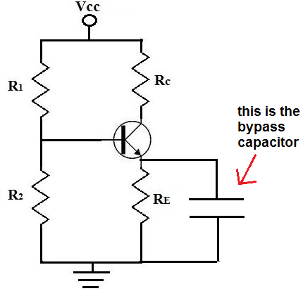
A capacitor is a device that offers a tremendously high resistance for signals of low frequencies. Therefore, signals at low frequencies will not go through them. This is because signals (current) always takes the path of least resistance. Therefore, they will instead go through the resistor, RE. Remember, again, this is for low frequency signals, which is basically DC signals.
However, capacitors offer much less resistance at higher frequencies (AC signals). So AC signals will go through the capacitor and then to gorund. Therefore, DC signals will go through the resistor, RE, while AC signals will go through the capacitor, getting shunted to ground. So AC signals get shunted to ground. This is how we have a clean DC signal across our circuit, while AC noise imposed on it is bypassed to ground.
So a bypass capacitor blocks the DC from entering it by the great resistance it offers to the signal but accepts the AC noise that may be on the DC line and shunts or bypasses it to ground. This is how bypass capacitors work.

How to Choose the Value of the Bypass Capacitor

Now that you know conceptually what a bypass capacitor is, the next step is to know how to select the value of the bypass capacitor.
And selecting the value is pretty straightforward.
The value of the bypass capacitor should be at least 1/10th of the resistance across the emitter resistance, RE at the lowest frequency intended to be bypassed.
Because capacitors are reactive devices, they have different resistances to signals based on the signal's frequency. This is referred to as the capacitor's reactance, which can be seen as the resistance it offers. We want the capacitor to have 1/10th of the resistance to the flow of current than what the resistor offers for the frequency signal that we want to bypass.
If you visualize the current moving through the transistor, it can take one of 2 paths once it passes the collector and moves through the emitter. Current can either go the resistor, RE or current can flow through the bypass capacitor. Current always takes the path of least resistance. Therefore, current will take the path of the lower resistance. This is why you want the value of the resistance of the bypass capacitor to be at least 1/10th the value of the emitter resistor or, even better, less than one-tenth. We want the AC current to flow through the least resistance path, which is the bypass capacitor if the correct value is chosen.
However, DC signals do not see it as AC. To DC, the capacitor has infinite resistance. So DC will automatically go through the RE resistor, which offers lower resistance by far to the infinite resistance of the capacitor.
AC, however, does not see infinite resistance for the capacitor. If we choose the value correctly for the capacitor, we can make the capacitor a much lower-resistance path to ground, thus shorting out the AC signal to ground.
So let's go over a practical example of how we would select the bypass capacitor value.
Let's say we want to bypass the lowest possible frequency of 50Hz, because the frequency of AC voltages worldwide are 50-60Hz. Therefore, this frequency can be a very problematic because often there is AC ripple at this frequency.
Remember, when we said we bias the value of the bypass capacitor based on the lowest frequency that we want to bypass. So by selecting the frequency of 50Hz, this blocks frequencies from 50Hz and higher; so it covers 60Hz. As frequency of an AC signal increases, the resistance of the capacitor decreases and decreases with each increase. Therefore, all the frequencies above the frequency value that we choose get bypassed easier and easier. We'll demonstrate this all mathematically.
So we decided we want to bypass AC signals 50Hz or higher to ground.
The typical value of an emitter resistor is 400-500‎Ω. The resistance is kept low so that gain on the transistor isn't lowered too much.
So let's say we choose an emitter resistor of 470‎Ω.
This means that we want the reactance of the capacitor to be one-tenth of 470‎Ω or less, which is 47‎Ω or lower. So this is our target.
The formula for the reactance of a capacitor is, XC= 1/2πfc= 1/2(3.14)(50Hz)(C)=47Ω. Solving for the capacitance, C, we get the value of approximately 67μF. So we need a capacitor of at least 67μF to get a resistance of one-tenth the value of 470Ω resistor.
Since a 67μF capacitor isn't readily available, we can round up to 100μF, which is readily available and easy to obtain. This is even better, because with a larger capacitance, the capacitor offers even less resistance to the AC signal. If we plug a 100μF capacitor into the same capacitor reactance formula, we get XC= 1/2πfc= 1/2(3.14)(50Hz)(100μF)=31.8Ω. This is much lower than 1/10 of the 470Ω resistor that we have in parallel. So it will act effectively to short all AC signals 50Hz or higher to ground to clean up the DC signal.
Even if you wanted, you could increase the capacitance even more to allow for less AC noise on the signal. But a lot of times, this will not be done for cost and size constraints reasons. The larger the size a capacitor is, the more it costs per unit. Also the larger the size of a capacitor, the larger physically is. Therefore, if a company is designing a product, the size of the capacitor could be a problem if there are size constraint issues. The way things are going in electronics, companies want products to be as small and concise as possible. So due to reasons such as these, larger value capacitors won't always be chosen, but theoretically, they would increase the purity of the DC signal, by allowing more AC to ground.
So again, this is a summary of what a bypass capacitor is and how to select the value of them based on the lowest AC signal desired to be filtered out and the value of the resistance in parallel with the capacitor.
You can check out our bypass capacitor calculator to calculate the value of a bypass capacitor based on the input AC signal frequency and the value of the resistor in parallel.

What is a Smoothing Capacitor?
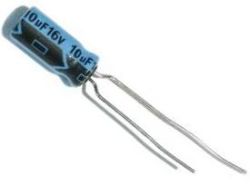
A Smoothing capacitor is a capacitor that acts to smooth or even out fluctations in a signal.
The most common and used application for smoothing capacitors is after a power supply voltage or a rectifier.
Power supply voltage can sometimes supply erratic and unsmooth voltages that fluctuate greatly.
When a steady DC signal is needed and is necessary, a smoothing capacitor is the right component needed in order to smooth out the fluctuating signal to make it more steady.
We'll go over an example of this now.
A prime example of when a smoothing capacitor is used is in conjunction with a rectifier circuit.
If you place a resistor in series with a diode and then input an AC signal into the circuit:
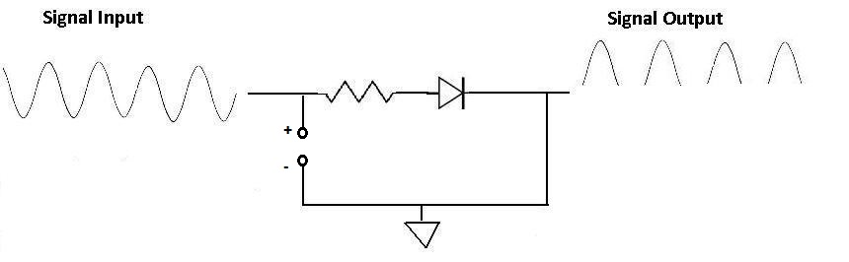
Now if you place a smoothing capacitor in parallel with the diode, like this, the resulting waveform will be:
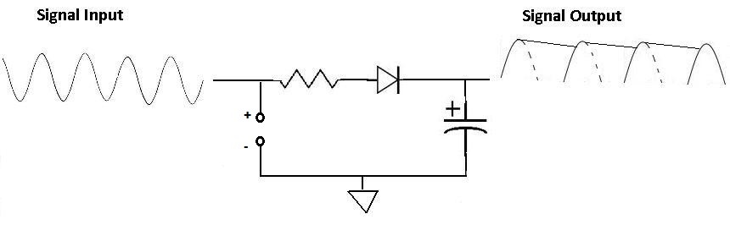
You can see now how much smoother the waveform is. It no longer goes all the way down to zero and back up. The capacitor charges up from 0 to the top of the waveform and then discharges from 0 to the bottom of the waveform. This charging and discharging smooths out the waveform so that it doesn't hit the extreme ups and downs. Thus, a smoothing capacitor is extremely useful in cases of fluctuating signals that need to be more constant and steady.
Usually when choosing a smoothing capacitor, an electrolytic capacitor is used from anywhere from 10µF to a few thousand µF. The greater the amplitude of the fluctations and the greater the waveform, the larger capacitor will be necessary. Thus, if you're smoothing a 30mV waveform, a 10µF capacitor may suffice to smooth out the signal. However, if you're dealing with a much greater signal, you will need a much larger capacitor, say, maybe 3300µF in order to smooth it out to a near DC level. Experiment with the capacitors. Check the signal on an oscilloscope to see which capacitor suffices best and is best for the circuit at hand.

Filter Capacitor- Explained
A filter capacitor is a capacitor which filters out a certain frequency or range of frequencies from a circuit.
Usually capacitors filter out very low frequency signals. These are signals that are very close to 0Hz in frequency value. These are also referred to as DC signals.

How Filter Capacitors Work
How filter capacitors work is based on the principle of capacitive reactance. Capacitive reactance is how the impedance (or resistance) of a capacitor changes in regard to the frequency of the signal passing through it. Resistors are nonreactive devices. This means that resistors offer the same resistance to a signal, regardless of the signal's frequency. This means, for example, that a signal of 1Hz and a signal of 100KHZ, will pass through a resistor with the same resistance. Frequency isn't a factor. However, a capacitor is not like this. A capacitor is a reactive device. Its resistance, or impedance, will vary according to the frequency of the signal passing through. Capacitors are reactive devices which offer higher resistance to lower frequency signals and, conversely, lower resistance to higher frequency signals, according to the formula XC= 1/2πfc.
Being that a capacitor offers different impedance values to different frequency signals, it can act effectively as a resistor in a circuit. We will explain below how using actual circuits.

Filter Capacitor Circuit To Block DC and Pass AC
Being that capacitors have offer very high resistance to low frequency signals and low resistance to high frequency signals, it acts as a high pass filter, which is a filter which passes high frequency signals and blocks low frequency signals.
Many times in a circuit, both DC and AC signals need to be both be used in a circuit, at least at a certain stage of the circuit. However, at another stage, in the circuit, we may only want AC signals and the DC taken out. An example of such a circuit is a microphone circuit. We need DC as input to the microphone for it to be able to be powered on and we need AC as input, which represents the voice signal or music, etc. which we want the microphone to record.
How do we filter out the DC component of the signal?
We use a capacitor to filter out the DC signal.
We do this by placing the capacitor in series. In this configuration, which is the circuit you see below, this is a capacitive high-pass filter. Low frequency, or DC, signals will be blocked.
Usually, a 0.1µF ceramic capacitor, or value around that range, is placed after the signal that contains both DC and AC signals. And this capacitor filters out the DC component so that only AC goes through.
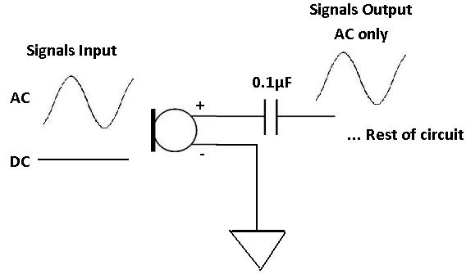

Filter Capacitor Circuit To Filter Out AC Signals
In the same way that capacitors can act as high-pass filters, to pass high frequencies and block DC, they can act as low-pass filters, to pass DC signals and block AC.
Instead of placing the capacitor in series with the component, the capacitor will be placed in parallel.
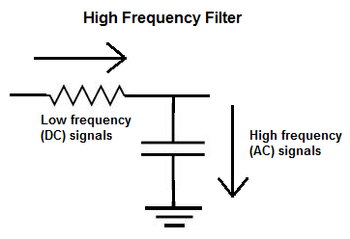
The above is a high-frequency capacitive filter. Remember that current takes the path of least resistance. Since a capacitor offers very low resistance to high frequency signals, high frequency signals will go through the capacitor. In this way, with the circuit in this configuration, the circuit is a high frequency filter. Low frequency current signals will not go through the capacitor, because it offers too much resistance to low frequency signals. Only high frequency signals go through.

Filter Capacitor Experiment
To see how a capacitor acts as a filter, you can conduct an experiment with relative ease.
All you have to do is take a capacitor, any value or type, and hook it to a function generator. Then take an oscilloscope and connect it to the output of the capacitor.
For my experiment, I hooked up a 100nF (0.1µF) ceramic capacitor in series with a function generator to see which frequencies the capacitor blocked or attenuated and which frequencies went through unimpeded.
It turns out the capacitor blocked only very low frequency signals, between 0 Hz to about 0.5Hz, or 500 mHz. It will attenuate signals a little from about 0.5Hz to 3Hz. But after that, it no longer attenuates signals above 3Hz. Signals 4Hz and above go through completely unimpeded, unblocked and unattenuated.
Frequency | Signal Output
0 Hz to 0.5Hz | Great amount of attenuation; Almost Completely Blocked
0.5Hz to 3Hz | Some attenuation of the signal but not much
3Hz and Above | Signal goes through completely unimpeded; No attenuation

And you can perform the same test in parallel for a high frequency filter setup.

Capacitive Voltage Divider
A capacitive voltage divider is a voltage divider circuit using capacitors as the voltage-dividing components.
The common type of voltage divider circuit is one which uses resistors to allocate voltage to different parts of a circuit. This is shown below.
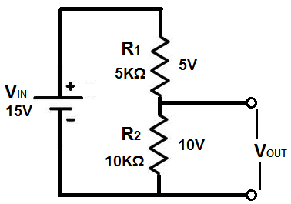
Voltage is divided in a resistor network according to ohm's law. Voltage, V, is allocated to a parts of the circuit depending on the resistance of that part, according to the formula, V=IR, where I is current and R is resistance. Being that current is the same in series circuits, only the resistance will vary. So the resistor in series with the greater resistance will receive the greater voltage.
Capacitors, also, can form voltage divider circuits just like resistors so that voltage can be divided up to parts of a circuit depending on the value of the capacitor.
Just like resistors, capacitors placed in series with a voltage source form a voltage divider network.
Capacitive networks, however, are a little more complex than plain resistive networks, because capacitors are reactive devices. This means that the resistance which capacitors offer in a circuit is dependent on the frequency on the input signal into the circuit. Resistors are nonreactive devices, so their resistance values don't change depending on the frequency of the input signal. However, capacitors do.
So now, we'll discuss how capacitor voltage divider circuits work in both DC and AC Circuits.

Capacitive DC Voltage Divider Circuit
Voltage is divided up in a capacitive DC voltage divider according to the formula, V=Q/C. Therefore, voltage is inversely proportional to the capacitance value of the capacitor. So, the capacitor with the smaller capacitance will have the greater voltage, and, conversely, the capacitor with the greater capacitance will have the smaller voltage.
Below is an example:
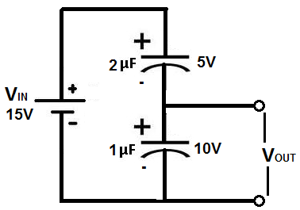
The supply DC voltage in the above circuit is 15V. This means that this 15 volts will be divided across both capacitors so that the voltage dropped across them both will equal to the 15-volt supply source. Assuming both capacitors hold the same charge, Q, the voltage can be calculated just from the capacitance values of both components. Being that the the 2μF capacitor is twice the value of the 1μF capacitor, it will have one-half the voltage. Therefore, the 1μF capacitor will drop 10 volts across it, while the 2μF capacitor will drop 5 volts across it.

Capacitive AC Voltage Divider Circuit
Voltage in capacitive AC voltage divider circuits are divided up according to the formula, XC= 1/(2πfc).
To calculate how much voltage each capacitor is allocated in the circuit, first calculate the impedance of the capacitor using the formula above. Once you calculate the impedance of each capcitor, then you can just use ohm's law to find out how much voltage gets dropped across each one.
An example below may help to clarify this:
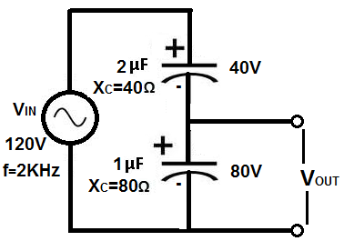
In this circuit above, the AC supply voltage is 120V. Therefore, 120V will be divided between both of these capacitors in series. To calculate how we find each voltage, we first calculate the impedances of the capacitors. Again, using the reactance formula, XC= 1/(2πfc), we calculate the 2μF capacitor to be XC= 1/(2π(2KHz)(2μF))= 40Ω. We then calculate the impedance of the 1μF capacitor, which is XC= 1/(2π(2KHz)(1μF))= 80Ω. We now can use a simple voltage divider to know voltage allocation. This makes again the 1μF capacitor receive double the voltage, which is 80V, in this case, while the 2μF capacitor receives half of that, which is 40V.

How To Test a Capacitor
In this article, we will go over different tests that we can use to tell whether a capacitor is good or not, all by utilizing the functions of a digital multimeter.
There are many checks we can do to see if a capacitor is functioning the way it should. We will use and exploit the characteristics and behaviors that a capacitor should show if it is good and, in thus doing so, determine whether its is good or defective.
So let's start:

Test a Capacitor with an Ohmmeter of a Multimeter
A very good test you can do is to check a capacitor with your multimeter set on the ohmmeter setting.
By taking the capacitor's resistance, we can determine whether the capacitor is good or bad.
To do this test, We take the ohmmeter and place the probes across the leads of the capacitor. The orientation doesn't matter, because resistance isn't polarized.
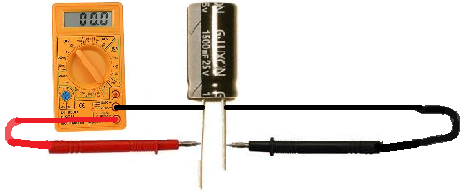
If we read a very low resistance (near 0Ω) across the capacitor, we know the capacitor is defective. It is reading as if there is a short circuit across it.
If we read a very high resistance across the capacitor (several MΩ), this is a sign that the capacitor likely is defective as well. It is reading as if there is an open circuit across the capacitor.
A normal capacitor would have a resistance reading up somewhere in between these 2 extremes, say, anywhere in the tens of thousands or hundreds of thousands of ohms. But not 0Ω or several MΩ.
This is a simple but effective method for finding out if a capacitor is defective or not.

Test a Capacitor with a Multimeter in the Capacitance Setting
Another check you can do is check the capacitance of the capacitor with a multimeter, if you have a capacitance meter on your multimeter. All you have to do is read the capacitance that is on the exterior of the capacitor and take the multimeter probes and place them on the leads of the capacitor. Polarity doesn't matter.
This is the same as the how the setup is for the first illustration, only now the multimeter is set to the capacitance setting.
You should read a value near the capacitance rating of the capacitor. Due to tolerance and the fact that (specifically, electrolytic capacitors) may dry up, you may read a little less in value than the capacitance of the rating. This is fine. If it is a little lower, it is still a good capacitor. However, if you read a significantly lower capacitance or none at all, this is a sure sign that the capacitor is defective and needs to be replaced.
Checking the capacitance of a capacitor is a great test for determining whether a capacitor is good or not.

Test a Capacitor with a Voltmeter
Another test you can do to check if a capacitor is good or not is a voltage test.
Afterall, capacitors are storage devices. They store a potential difference of charges across their plate, which are voltages. The anode has a positive voltage and the cathode has a negative voltage.
A test that you can do is to see if a capacitor is working as normal is to charge it up with a voltage and then read the voltage across the terminals. If it reads the voltage that you charged it to, then the capacitor is doing its job and can retain voltage across its terminals. If it is not charging up and reading voltage, this is a sign the capacitor is defective.
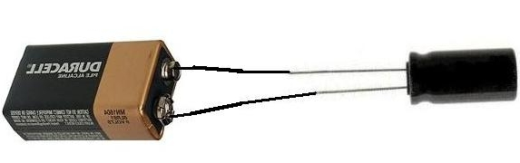
To charge the capacitor with voltage, apply DC voltage to the capacitor leads. Now polarity is very important for polarized capacitors (electrolytic capacitors). If you are dealing with a polarized capacitor, then you must observe polarity and the correct lead assignments. Positive voltage goes to the anode (the longer lead) of the capacitor and negative or ground goes to the cathode (the shorter lead) of the capacitor. Apply a voltage which is less than the voltage rating of the capacitor for a few seconds. For example, feed a 25V capacitor 9 volts and let the 9 volts charge it up for a few seconds. As long as you're not using a huge, huge capacitor, then it will charge in a very short period of time, just a few seconds. After the charge is finished, disconnect the capacitor from the voltage source and read its voltage with the multimeter. The voltage at first should read near the 9 volts (or whatever voltage) you fed it. Note that the voltage will discharge rapidly and head down to 0V because the capacitor is discharging its voltage through the multimeter. However, you should read the charged voltage value at first before it rapidly declines. This is the behavior of a healthy and a good capacitor. If it will not retain voltage, it is defective and should be replaced.
So there you have it, 3 strong tests that you can do (all or either/or) to test whether a capacitor is good or not.

RC Time Constant (τ) of a Capacitor
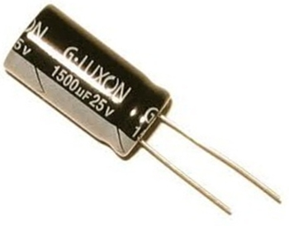
The RC Time Constant (τ) of a Capacitor is the amount of time it takes for a capacitor to charge to 63% of the supply voltage which is charging it. For capacitors that are fully charged, the RC time constant is the amount of time it takes for a capacitor to discharge to 63% of its fully charged voltage.
The formula to calculate the time constant is:
Time Constant (τ)=RC
The unit for the time constant is seconds (s). R stands for the resistance value of the resistor and C is the capacitance of the capacitor.
The Time Constant is affected by two variables, the resistance of the resistor and the capacitance of the capacitor. The larger any or both of the two values, the longer it takes for a capacitor to charge or discharge. If the resistance is larger, the capacitor takes a longer time to charge, because the greater resistance creates a smaller current. If the capacitance of the capacitor is a larger value, the capacitor takes a longer time to charge because it holds a larger charge, therefore, it takes longer to fill up. And, conversely, the smaller the resistance and capacitor values, the shorter time it takes for a capacitor to charge or discharge.

Example
Below we have a circuit of a 9-volt battery charging a 1000µF capacitor through a 3KΩ resistor:
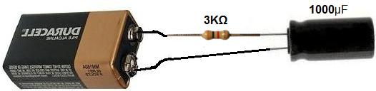
One time constant, τ=RC=(3KΩ)(1000µF)=3 seconds. So after 3 seconds, the capacitor is charged to 63% of the 9 volts that the battery is supplying it, which would be approximately 5.67 volts.
If R=1KΩ and C=1000µF, the time constant of the circuit is τ=RC=(1KΩ)(1000µF)=1 second.
If R=330KΩ and C=0.05µF, the time constant of the circuit is τ=RC=(330KΩ)(0.05µF)=16.5ms.

How to Build an LC Resonant Circuit

In this circuit, we show how to build an LC resonant circuit.
An LC resonant circuit is a circuit that is composed of a single inductor and capacitor that can do many powerful and useful things.
An LC resonant circuit, as the name implies, achieves resonance. You can think of resonance as just the right frequency achieved so that the output signal reaches a perfect state of oscillations. These oscillations manifest themselves as sine waves. So when resonance is achieved, sine wave signals will be output.
So an LC resonant circuit is able to output sine waves. Thus, LC resonant circuits are used many times to create sine wave signal generators.
In this circuit, actually, we will build the simplest LC resonant circuit that can be built. We will input a square wave signal into the LC resonant circuit and at the output we will get a sine wave signal.
This is actually a powerful illustration of resonance and how it can be used to changed signals, in this case square wave signals into sine wave signals.
We will show how to build this below.
Components Needed
- 470µH inductor
- 1µF ceramic capacitor

Inductors and capacitors can be obtained very cheaply at a number of online retailers. It can be obtained at Tayda Electronics at the following link: Tayda Electronics.
All we need in this circuit is a single inductor and a single capacitor. Using just these 2 components, we can achieve resonance in our circuit.

LC Resonant Circuit
The schematic diagram of the LC resonant circuit we will build is shown below.
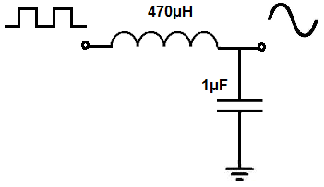
The breaboard circuit of the circuit above is shown below.
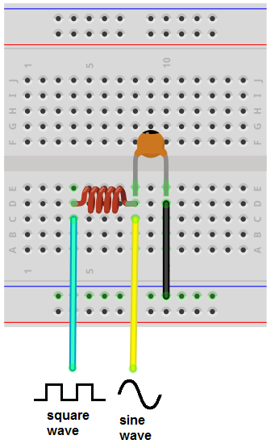
So this circuit, again, as it appears above, is very basic.
It's an LC resonant circuit- it's composed of a single inductor and capacitor.
So into this circuit we feed a square wave signal and at the output we get a sine wave signal.
It looks very basic on the outside but it requires a decent amount of math to get it to work.
So the math comes down to how to choose the values of the LC network, the inductor and the capacitor. How do we choose the values so that resonance can be achieved?
And the values are chosen based on the frequency of the signal entering the LC network.
In this case, since we are feeding a square wave signal into the LC network, we must consider the frequency of the square wave signal. Based on this frequency, we decide the values of the inductor and capacitor, so that resonance can be achieved.
How resonance works and how it's acheived is that the input signal (the square wave) must match the resonant frequency created by the LC network. When the frequency of the input signal matches the frequency created by the LC network, resonance is achieved; this resonance shows itself as a sine wave.
So let's say the frequency of the input square wave signal is 7KHz. How do we calculate the LC network to have a resonant frequency of 7KHz to match this frequency, so that we can get resonance?
And there is a formula to achieve this.
This formula is, frequency= 1/2π√LC. With this formula, we can calculate the values needed in order to calculate a frequency that is just about near KHz. So doing the math, we get the values of 470μH for the inductor and 1μF for the capacitor. Plugging these into the formula, the frequency is 7.34KHz, which is very close to the 7KHz frequency of the square wave signal. So the values are close enough so that this circuit works. Obviously, the closer you get these 2 values to match, the more perfect of a sine wave you get at the output. But, again, this circuit works.
To have a calculator calculate the inductor and capacitor values that you need based on the resonant frequency you desire, see our LC Resonance Calculator. It will automatically compute what inductor and capacitor values you need for a given resonant frequency.
So that's how this circuit operates.
With the input signal (square wave) being about 7KHz and the LC frequency being around 7KHz, resonance is achieved and we get a sine wave signal at the output. The square wave is converted to a sine wave.
So now you can see the power and importance and an LC resonant circuit and the useful effect it achieves in this circuit of converting a square wave signal into a sine wave signal.

What is a Step-up Transformer?
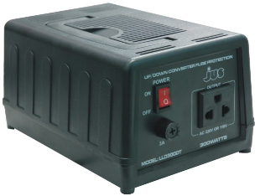
A Step-up Transformer is an AC-AC converter which converts the input AC signal into an AC signal with a larger voltage.
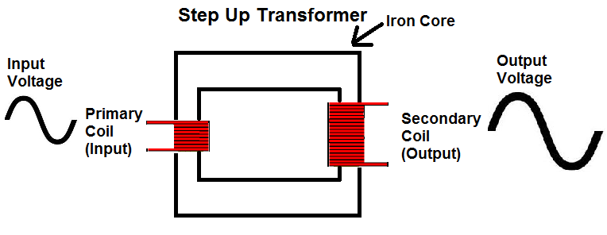
A step-up transformer acts as a voltage-increasing device. The amount by which it increases the input voltage depends on the ratio of the the number of turns in the primary coil to the number of turns in the secondary coil.
If, for example, the secondary coil has double the amount of turns as the primary coil, the ratio will be 1:2 and the output voltage will be double the input voltage.
Though step-up transformers increase the voltage of the output voltage, it comes at a price. Transformers are simply conversion devices. They do not create voltage or power. So if a step-up transformer increases voltage, it decreases current. If it doubles the voltage output, the current output gets cut in half. So that the output signal now has half the current capability as the input signal. Step-up transformers never create power; they only convert it into different forms.

What is a Step-down Transformer?
A Step-down Transformer is an AC-AC converter which converts the input AC signal into an AC signal with a lower voltage.
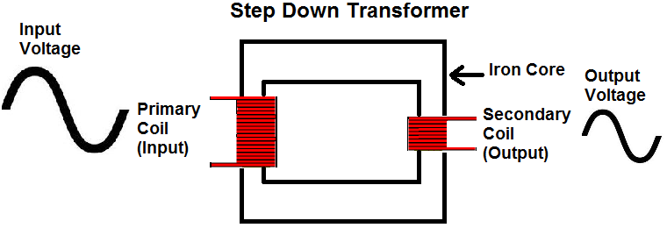
A step-down transformer acts as a voltage-decreasing device. The amount by which it decreases the input voltage depends on the ratio of the the number of turns in the primary coil to the number of turns in the secondary coil.
If, for example, the primary coil has double the amount of turns as the secondary coil, the ratio will be 2:1 and the output voltage will be half the input voltage.
Though step-down transformers decrease the voltage of the output voltage, the overall power is not decreased. Transformers are simply conversion devices. They do not create voltage or power. So if a step-down transformer decreases voltage, it increases current. If it cuts the voltage output in half, the current output doubles. So that the output signal now has double the current capability as the input signal. Step-down transformers never create or loser power; they only convert it into different forms.

How to Build a Clock Circuit with a 555 Timer
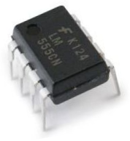
In this circuit, we will show how we can build a clock circuit with a 555 timer.
A clock circuit is a circuit that can produce clock signals. These signals are digital square waveforms, which alternate between on and off.
This is important because many different types of chips need clock signals in order to operate. Many chips such as counter chips, digital potentiometers, and many other types of ICs need clock signals in order to operate. The clock provides a way that a master and slave device can act in synchrony with each other. Either on the falling or rising edge of a clock signal, the 2 devices will work in synchrony so that they can produce a desired outcome.
With a 555 timer, we can produce clock signals of varying frequencies based on the values of the external resistors and capacitor that we choose.
We can produce clock signals of any frequency needed. A 1Hz clock signal will cycle once every second. A 2Hz clock signal will cycle every 0.5 seconds. A 100KHz signal will cycle every 0.00001 seconds or every 10 microseconds. The time period, T= 1/f, where f is the frequency of the signal.
For the 555 timer to work, it must be operated in astable mode. Astable mode is a mode in which there is no one stable state. The circuit switches constantly from low to high, which is representative of a digital square waveform that goes constantly high to low, high to low, high to low, over and over again. So the astable mode switches constantly between HIGH and LOW states. This is in contrast to the other 2 modes, monostable mode and bistable mode. Monostable mode has one state, either HIGH or LOW. Bistable mode has 2 stable states that it can be in. Like astable mode, bistable mode has 2 states but they're stable; in astable mode, they constantly fluctuate back and forth between the 2 states.
A 555 timer is a very versatile. In this circuit, we will build a clock of about 60Hz. This cycles 60 times every second.

Components Needed
- 555 Timer Chip
- 1MΩ resistor
- 10nF capacitor
- 100nF capacitor

The 555 timer can be obtained very cheaply from pretty much any electronic retailer.
The 555 timer is an 8-pin chip.
If you want to know all the pinout of the 555 timer, what each pin is and what each pin does, see 555 Timer Pinout.
In this circuit, we will connect the 555 timer to be in astable mode.
In this mode, the 555 timer will go from HIGH to LOW, HIGH to LOW, HIGH to LOW, mimicking a digital square waveform, which we will use as a clock.
The connections are shown below.

Clock Circuit Using a 555 Timer
The clock circuit that will produce 60Hz clock signals using a 555 timer is shown below.
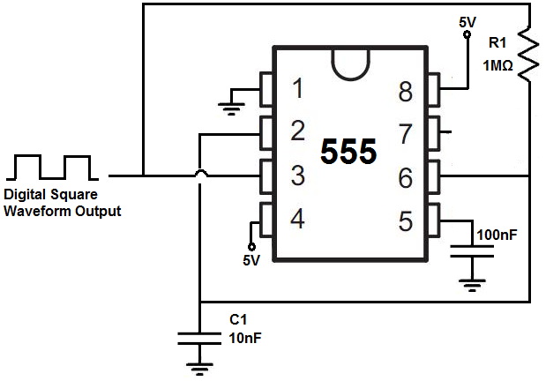
The breadboard schematic of the above circuit is shown below.
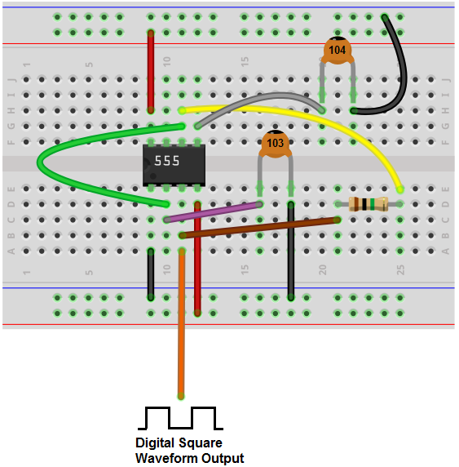

This 555 timer is in astable mode.
Astable mode can produce digital square waveforms that go back and forth between HIGH and LOW.
So we have a signal with a frequency of about 60Hz. You must realize with tolerances that resistors have, it may fluctuate a little above or below this level.
And this is how clock pulses can be created with a 555 timer.
If you want to measure the output directly and you have an oscilloscope, all you have to do is connect the positive terminal of the oscilloscope to the output pin 3 of the 555 timer and the negative terminal to ground. Then you should be able to get a picture of the digital square waveforms on the oscilloscope. And then you can see the frequency and time period that a cycle lasts.
So there's multiple ways you can test this circuit.
If you were to change the resistor or capacitor values so that you created a much higher frequency signal, then it wouldn't make sense to connect it to an output such as an LED because the human eye wouldn't be able to catch it. It would seem like it's on all the time. If you're dealing with frequencies in the kilohertz range or the megahertz range, then it would not make any sense. The only thing you can do to measure the circuit would be to connect it to an oscilloscope. And only if you have an oscilloscope that can measure such high frequencies.
To create a 6Hz signal, R1= 10MΩ and C= 10nF.
To create a 600Hz signal, R1= 100KΩ and C= 10nF.
To create a 134Hz signal, R1= 470KΩ and C= 10nF.
To create a 1.7KHz signal, R1= 33KΩ and C= 10nF.
To create a 43KHz signal, R1= 1KΩ and C= 10nF.
To create a 180KHz signal, R1= 150Ω and C= 10nF.
To create a 252KHz signal, R1= 100Ω and C= 10nF.
To see how to build this same circuit, with the added features of adjustable frequency and adjustable amplitude of the output square wave, see How to Build an Adjustable Square Wave Generator Circuit with a 555 Timer.

How to Build an Adjustable Square Wave Generator Circuit with a 555 Timer
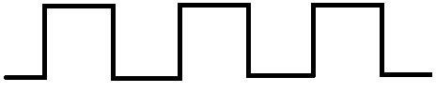
In this project, we will show how to build a square wave generator circuit that allows for adjustable frequency and amplitude of the output square wave signal.
This square wave generator circuit can be built simply a 555 timer chip and a few resistors, capacitors, and potentiometers.
The circuit is very basic. It simply uses one chip, a 555 timer.
A 555 timer is a very versatile chip. It can easily create square waves when in astable mode of operation. This circuit utilizes that principle, that 555 timers can easily generate square wave signals.
The potentiometers allow us to vary the frequency of the output signal as well as the amplitude.
This circuit can function well simply if you need square waves or if you need to use it for an IC that requires clock pulses.
So below we'll explain in detail how to build this circuit as well as how it operates.

Components Needed
- 555 Timer Chip
- 200Ω potentiometer
- 1MΩ potentiometer
- 39KΩ resistor
- 1nF ceramic capacitor
- 100nF ceramic capacitor

The 555 timer can be obtained very cheaply from pretty much any electronic retailer.
The 555 timer can be obtained very cheaply from pretty much any electronic retailer.
The 555 timer is an 8-pin chip.
The pinout of the 555 timer is shown below.
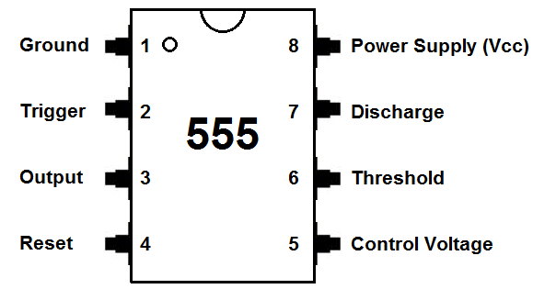
The 555 timer requires a power supply voltage of 4.5-16V. We connect this voltage to the VCC pin, pin 8, and we connect GND, pin 1, to ground.
The only other pins we use are the trigger pin, the output pin, the reset pin, and the threshold pin.
Pin 2 is the trigger pin. It works like a starter pistol to start the 555 timer running. The trigger is an active low trigger, which means that the timer starts when voltage on pin 2 drops to below 1/3 of the supply voltage. When the 555 is triggered via pin 2, the ouptut on pin 3 goes high.
Pin 3 is the output pin. 555 timer's output is digital in nature. It is either high or low. The output is either low, which is very close to 0V, or high, which is close to the supply voltage that's placed on pin 8. The output pin is where you would connect the load that you want the 555 timer to power. This may be an LED, for instance.
Pin 4 is the reset pin. This pin can be used to restart the 555 timer's timing operation. This is an active low input, just like the trigger input. Thus, pin 4 must be connected to the supply voltage of the 555 timer to operate. If it is momentarily grounded, the 555 timer's operation is interrupted and won't start again until it's triggered again via pin 2.
Pin 6 is the threshold pin. The purpose of this pin is to monitor the voltage across the capacitor that's discharged by pin 7. When this voltage reaches 2/3 of the supply voltage (VCC), the timing cycle ends, and the output on pin 3 goes low.

Adjustable Square Wave Generator Circuit Built with a 555 Timer
The adjustable square wave generator circuit we will build with a 555 timer chip is shown below.
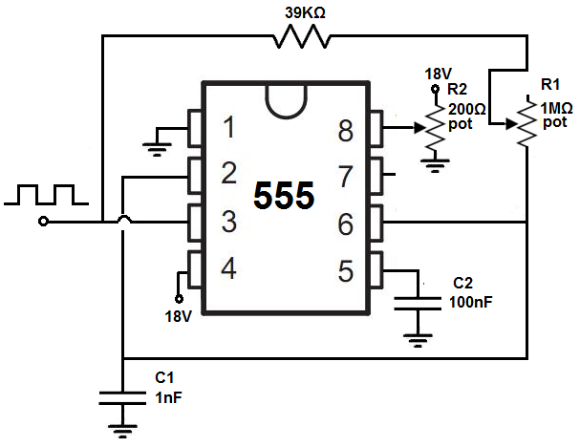
The breadboard circuit of the circuit above is shown below.
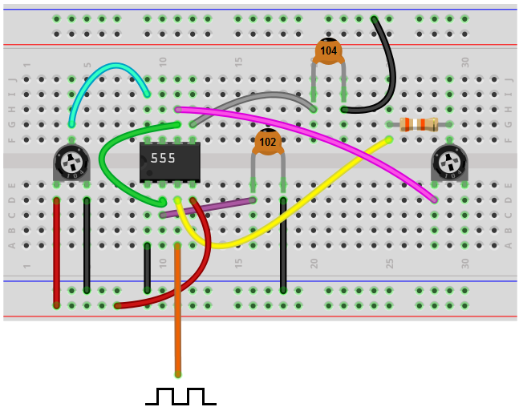
So this is our adjustable square wave generator circuit shown above.
So the first thing of concern for this circuit is power- what power the circuit will run off from.
Being that we are using a 555 timer chip, the maximum voltage that a 555 timer can withstand is 18V. Therefore, we use 18V for the supply DC voltage for this circuit. By attaching a potentiometer to the 18V, we create an adjustable power source, so that we can alter the amplitude of the output signal. If the potentiometer is turned so that it is offering full resistance, the voltage fed to the 555 timer is about 18V. This gives the maximum amplitude that the output signal can be. If we lower the resistance of the potentiometer, the voltage fed to the 555 timer decreases. This decreases the amplitude of the output signal.
For this circuit, we use a 200Ω potentiometer to allow for amplitude adjustment. You don't want to use a smaller potentiometer than this such a00s a 100Ω potentiometer, because most aren't rated to handle the amount of current that using a potentiometer this low will be. For example, with a 100Ω potentiometer, current will be 18V/100Ω= 180mA. Many potentiometers can't handle such high current and will burn out. 200Ω is a much safer bet lowering the current to 90mA (18V/200Ω). You can only use a 500Ω potentiometer. But it's best not to go higher than 500Ω. If you use a very large potentiometer value, amplitude adjustment will not work properly. Using low-ohm potentiometers allows for small changes to resistances, so that the amplitude changes slowly. Using large-ohm resistors causes abrupt changes to the amplitude, not giving good amplitude adjustment. If you use a 100KΩ potentiometer, for instance, slightly adjusting the potentiometer leads to abrupt changes in amplitude, which makes for poor amplitude adjustment.
This voltage is fed into the V+ pin of the 555 timer, which is pin 8.
So again, if the potentiometer is offering full resistance, the amplitude is at its maximum amplitude. As we lower the resistance of the potentiometer, the amplitude decreases and decreases until the voltage feeding into pin 8 is so low, that no signal is output.
18V is, fed into pin 4 of the 555 timer. Pin 4 is the reset pin of the 555 timer. This pin is active low, which means it is triggered when fed a voltage near ground or 0V. Therefore, this pin must remain connected to a positive voltage source in order for the circuit to work.
So, this fulfills the power for the circuit.
Now we get more into the other facets of the circuit.
Besides the amplitude, which we have covered, we now get into the frequency aspect of the circuit, how the frequency of the signal. And the frequency of the output is determined by the potentiometer R1 and capacitor C1. These form an RC network that determine the frequency of the output signal. The product of RC is equal to the time period of the output signal. By decreasing the value of the resistor, we decrease the time period, which creates a signal with a higher frequency. By increasing the value of the resistor, we increase the time period, which creates a signal with a lower frequency. The potentiometer allows us to change the frequency by changing the value of the RC network.
The value of the capacitor C1 that we have chosen is 1nF. If you want even a greater frequency that can go lower, you cna choose a lower value capacitor such as in the picofarads range. This extends the frequency range of the circuit, at the high end. The smaller of a capacitor you use, the higher the frequency. For example, a 330pF capacitor causes even a faster frequency.
The potentiometer value that we use for the RC network is a 1MΩ potentiometer. You can also use a 10MΩ potentiometer if you want to extend the frequency range of the circuit, at the low end. The greater of a resistance value you use, the lower frequency can extend. For example, with a 10MΩ potentiometer, the frequency will be just a few hertz on the lower end of the frequency range when the potentiometer is offering its full resistance.
The 555 timer is a very good chip that is able to produce and output very good, high-quality square wave signals. And depending on the values you use, you should be able to get any square wave of any frequency you desire. The 555 timer chip does have a ceiling of frequency but it is several megahertz. So until you exceed this, the circuit should be able to do what you want it to accomplish.
So this is an adjustable square wave generator circuit.

How to Build a Diode Clipper Circuit
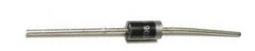
In this project, we will go over how to build a diode clipper circuit.
A diode clipper circuit is a circuit that clips an AC voltage signal of a circuit to a certain level.
When the signal is clipped, the amplitude is reduced to a certain level, which we will bias for a particular circuit.
So, for example, an AC voltage signal feeding a circuit may be 5V; so it has a peak positive voltage of 5V and a peak negative voltage of -5V. Passing this signal through a diode clipper circuit, we can clip the positive or negative portion of the AC signal or both. So we can clip the signal to 2V for instance or clip to 1V, basically any voltage we want.
A diode clipper circuit is used for various purposes. It can be used to reduce noise in a signal. If a signal has a lot of noise associated with it, especially at the peak, then reducing the amplitude with a diode can eliminate a lot of the noise. Another purpose may just to reduce the amplitude. For example, if a very loud signal is feeding a speaker, in order not to blow out the speaker, we may reduce the amplitude with diodes.
In this project, we will show all the various clipper circuits that can be constructed, including clipped positive amplitudes, clipped negative amplitudes, and clipped positive and negative amplitudes, with and without DC bias; DC bias simply means that we clip the signal to a certain DC voltage level. Without DC bias, the signal will be clipped to the natural 0.7V of a silicon diode.
We show how to build the circuit below.
Components Needed for the Diode Clipper Circuit
- 2 1N4001 Diodes
- 1KΩ Resistor
- AC Voltage Source
- DC Voltage Source

Diodes are very easy to obtain and are cheap. The type we use is the 1N4001 but you can really use any diode from the 1N400X family.
The 1N4001 is a silicon diode. Being a silicon diode, it requires aabout 0.7V across it in order to operate. This 0.7V is a significant value, as you'll see as we discuss it below. But just know that a silicon diode needs about 0.7 volts across it in order to operate.
In this circuit, the we will use 5Vp-p, which is 5V peak to peak; this means that the positive amplitude has a peak value of 5V and the negative amplitude has a peak value of 5V.

Diode Clipper Circuits

Diode Clipper Circuit with a Clipped Positive Unbiased Amplitude
The first diode clipper circuit we will build, we will clip the positive amplitude of an AC signal.
This diode circuit is shown below.
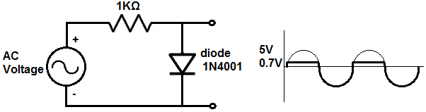
How this circuit works is as follows.
An AC signal goes through 2 phases, when it's positive and when it's negative. During the positive portion of the signal, current travels to the anode of the diode and then to ground and then repeats the process over and over again. During the positive portion of the AC signal, current flows across from the anode of the diode to the cathode. Since current flows, voltage falls across the diode and the resistor. The diode consumes about 0.7V. Silicon diodes require a steady voltage drop of about 0.7V in order to operate. Remember that voltage in parallel is the same. Therefore, since our output is in parallel to the diode, it will have a voltage of 0.7V during this positive portion of the AC signal. This is why during the positive half of the AC signal, the signal doesn't reach the peak 5V but instead has a steady DC voltage of 0.7V.
During the negative portion of the AC signal, current is impeded from travelling because current can only flow from the anode to the cathode. A diode is a one-way current device. Current can flow in from only one direction, anode to cathode. Being that no curren can flow across when the signal is negative, no voltage is dropped across the resistor or the diode. Therefore, it's as though the diode and the resistor are not present in the circuit. Therefore, at the output of the circuit is the full +5V from the AC voltage supply.
This circuit is unbiased because we are not clipping it at a certain DC voltage level, just at the voltage level that the diode uses, which is 0.7V.
Later, we will show how to bias the diode clipper circuit.

Diode Clipper Circuit with a Clipped Negative Unbiased Amplitude
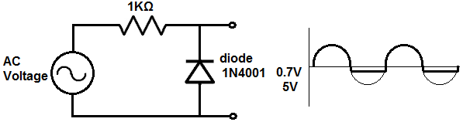
During the positive portion of the AC signal, current is impeded from flowing to the cathode, because the diode is a one-way current device. Current can only travel from the anode to the cathode, not from the cathode to the anode. Therefore, there is no current flow. Since current does not flow, there is no voltage drop across the resistor or the diode. It's as though they are not present and the output is connected directly to the AC voltage supply. Therefore, the full voltage is present at the output during the positive portion of the AC signal.
During the negative portion of the AC signal, current travels to the anode and goes across to the cathode. So current flows through the circuit. Therefore, voltage is dropped across the diode and the resistor. Being that the output is in parallel to the diode, whatever voltage is across the diode will be the voltage at the output. This is because voltage of components in parallel are always the same. A silicon diode consumes a steady 0.7V in order to operate. So during the negative portion of the signal, the signal is 0.7V straight across for the duration of the negative phase once 0.7V is reached.
This signal is also unbiased.

Diode Clipper Circuit with a Clipped Positive Biased Amplitude
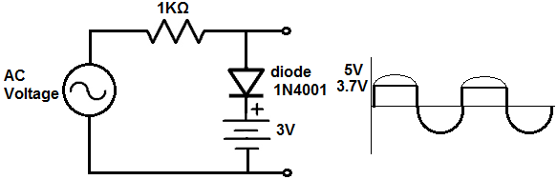
So now we will show how to bias a circuit, beginning with the positive amplitude.
To bias a circuit means to set any DC level that you want the signal clipped at. The diode always will provide 0.7V. So if we want our circuit to cut off or be clipped at 3V, then we add a +2.3 DC source in series to the diode. Both sources of voltages, the diode and the DC power supply, must be pointing in the same direction. Since the clipped portion occurs with this circuit in the positive portion of the AC signal, it is the positive amplitude that is clipped. What you have know is that the diode will always give us a voltage of 0.7V. This is because when current flows through the circuit, a diode always consumes 0.7V across it in order to operate. Now we add a DC source to bump up the 0.7V further. Since we want the circuit to clip at 3V, we must add 2.3VDC on top of the 0.7V of the diode. 2.3V + 0.7V= 3V. Therefore, this diode clipper circuits at the 3V DC level. Basically to determine any voltage level that you want all you have to do is know the DC voltage level you want the circuit to clip at, then take that number and subtract 0.7V from it, and that gives you the DC voltage source that you need to produce that clipped level.
In order for the DC level biasing to work, though, the voltage sources must be lined up so that if going from top to bottom, the diode is + to - and the voltage source is + to -. If the voltage source were inverted in the other direction, the voltages wouldn't add but subtract. So both sources must be + to - in order for the voltages to add.

Diode Clipper Circuit with a Clipped Negative Biased Amplitude
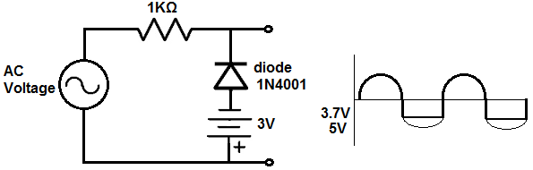
Now we will show how to bias a diode clipper ciruit at the negative amplitude.
Again, the diode gives us 0.7V. If we want to clip the signal at 3V, then we need to add 2.3V to the 0.7V. So we add a 2.3V DC source in series with the diode.
From bottom to top, the DC power source and the diode must both be + to - in polarity. If they are, the voltages add to give a clipped signal of 3V.

Diode Clipper Circuit with Clipped Positive and Negative Unbiased Amplitudes
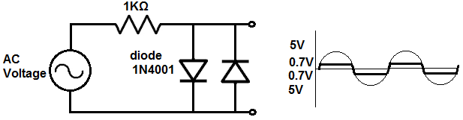
So now we show how to have clipped positive and negative amplitudes for an AC signal.
In order to have clipped positive and negative amplitudes, we must use 2 diodes. One diode is forward biased and the other diode is reverse biased. With this combination, the AC signal is clipped at both the positive and negative amplitudes.
Since this circuit is not biased to any DC level, both signals are clipped to 0.7V.

Diode Clipper Circuit with Clipped Positive and Negative Biased Amplitudes
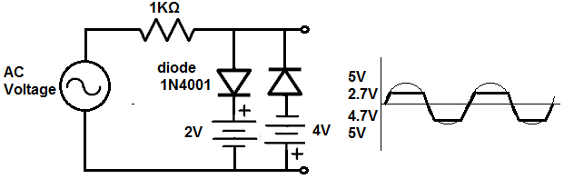
Now this circuit shows the diode clipper circuit with positive and negative amplitudes clipped with biasing.
We clip the negative signal to 4.7V and we clip the positive signal to 2.7V.
We place a 2V DC source in series with the forward biased diode. Since the diode has a voltage drop of 0.7V, the total voltage is 2.7V. Therefore, the AC voltage signal will be clipped to 2.7V during the positive portion of the signal.
We place a 4V DC source in series with the reverse biased diode. Since the diode has a voltage drop of 0.7V across it, the total voltage is 4.7V. Therefore, the AC voltage signal will be clipped to 4.7V during the negative portion of the signal.
So these are all the combinations of clipper circuits that we can build with diodes. Truly any level can be obtained in biasing. And we showed how we can clip each amplitude, positive and negative.
Again, clipper circuits have extreme uses whenever we need to reduce amplitude for whatever reason.
To see how these diode clipper circuits work in real life, see the following video below.

How to Build a Diode Clamper Circuit
In this project, we will go over how to build a diode clamper circuit.
A diode clamper circuit is a circuit built with a diode that shifts an entire AC signal up or down by a certain DC offset determined by the biasing values.
In other words, a diode clamper circuit clamps a signal up or down by a certain DC offset.
It doesn't change the value of the original signal. It simply moves it up or down a certain DC level. The signal itself is unchanged. Unlike a diode clipper circuit, the clamper does not cut off or restrict any part of the amplitude. It simply shifts it up or down.
A positive clamper circuit moves a signal so that all of it is above the 0V line. Thus, it's a purely positive AC voltage signal. It's always positive; it simply varies in amplitude depending on where it is during a given cycle.
A negative clamper circuit moves a signal so that all of it is below the 0V line. Thus, it's a purely negative AC voltage signal, that just varies in amplitude value depending on where it is during a given cycle.
Clamper circuits are useful anytime when DC offset is needed. Clamper circuits are used as DC voltage restorers. A pure coupling capacitor many times will create an AC signal that straddles the 0V line and is halfway negative and positive. This is because capacitors only allow AC signals through and block all DC signals. However, if we want to restor the AC signal back to its original DC offset, we can simply create a clamper circuit and this puts the DC offset back in with the AC signal. This is why it's clampers are used as DC restorers.
Components Needed for the Diode Clamper Circuit
- 1N4001 Diode
- 100nF ceramic capacitor
- 1MΩ resistor
- AC Voltage Source
- DC Voltage Source

The DC voltage source can either be batteries or a DC power supply.

Diode Clamper Circuits
We will show all all the various diode clamper circuits that can be built.
Below are 4 circuits showing diode clamper circuits clamping signals either up or down, with and without biasing.
The capacitor and the resistor forms a RC circuit that acts as a time constant, which determines the range of frequencies over which the clamper is effective.

Diode Clamper Circuit Positive Unbiased
The first circuit is a diode clamper circuit that clamps a signal above the 0V railing, making the entire signal positive. The trough of the signal will be on the 0V line. When a positive clamper circuit is unbiased, the clamping circuit will fix the voltage lower limit to 0V. So the trough, the peak of the bottom of the signal, will be at 0V.
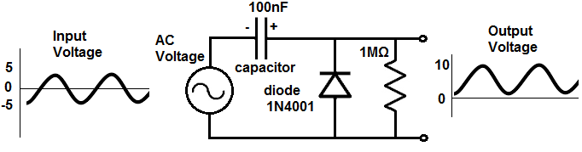
How this circuit works is as follows.
During the negative phase of the AC signal, the diode is forward biased, so current flows through the diode and the capacitor, charging up the capacitor to the 5V that the AC voltage source offers. So during this phase, the capacitor gets charged up.
During the positive phase of the AC signal, the diode is reverse biased, so no current can flow through the circuit. So no current flows through the diode. During this phase, the voltage at the output is equal to the voltage of the AC power source and the voltage at the capacitor. The voltage of the AC power source is 5V and the voltage at the capacitor fully charged is 5V. Adding up these voltages gives a total voltage of 10V. So instead of going 5Vpp, the signal goes from 0 to 10V. It's the same amplitude, only clamped up to the 0V line.

Diode Clamper Circuit Negative Unbiased
The second circuit is a diode clamper circuit that clamps a signal below the 0V railing, making the entire signal negative. The crest of the signal will be on the 0V line. When a negative clamper circuit is unbiased, the clamping circuit will fix the voltage upper limit to 0V. So the crest, the peak of the top of the signal, will be at 0V.
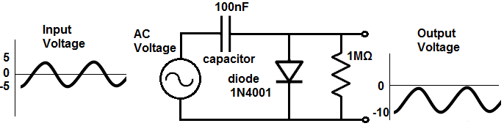
During the positive phase of the AC signal, the diode is forward biased, so current flows through the capacitor and the diode, charging up the capacitor to the 5V that the AC voltage source offers. So during this phase, the capacitor gets charged up.
During the negative phase of the AC signal, the diode is reverse biased, so no current can flow through the circuit. So no current flows through the diode. During this phase, the voltage at the output is equal to the voltage of the AC power source and the voltage at the capacitor. The output voltage sees the right hand side of the capacitor, which is negative and the right hand side of the voltage source which is negative. So the voltage of the AC power source is -5V and the voltage at the capacitor fully charged is -5V. Adding up these voltages gives a total voltage of -10V. So instead of going 5Vpp, the signal goes from 0 to -10V. It's the same amplitude, only clamped down below the 0V line.

Diode Clamper Ciruit Positive Biased
Now we will build the same circuits shown above only now with DC bias, where we clamp the circuit up or down to a specific level.
We will start with clamping the positive clamper up to a specific DC level.
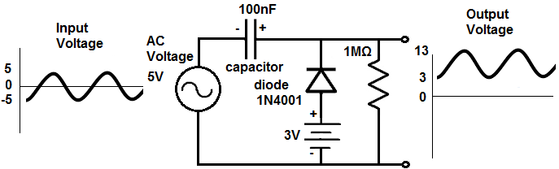
In order to set the clamper to a specific DC level, we must place a positive DC voltage in series with the diode. How you determine the polarity of the DC source is to remember that the voltage output "sees" from the right side. So it "sees" from right to left. If you are familiar with KVL (Kirchhoff's Voltage Law), you can figure out the polarity that the output sees by drawing a circular loop from right to left, or counterclockwise. Looking at the circuit counterclockwise, you see the that the DC voltage is positive, the capacitor is positive, and the DC voltage source is positive. since they are all positive, they all push the signal up. The DC source is 3V. So the trough of the signal is at the 3V line. Since the signal is 10V, the peak of the signal is at 13V. So the signal is 10V peak-to-peak, starting at 3V and ending at 13V.

Diode Clamper Circuit Negative Biased
Now we bias a diode clamper circuit so that it starts at a specific negative DC level.
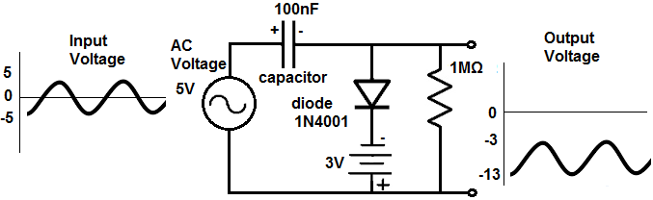
In order to set the clamper to a specific DC level, we must place a negative DC voltage in series with the diode. How you determine the polarity of the DC source is to remember that the voltage output "sees" from the right side. So it "sees" from right to left. If you are familiar with KVL (Kirchhoff's Voltage Law), you can figure out the polarity that the output sees by drawing a circular loop from right to left, which is the counterclockwise direction. Looking at the circuit counterclockwise, you see the that the DC voltage is negative, the capacitor is negative, and the DC voltage source is negative. since they are all negative, they all push the signal down. The DC source is -3V. So the trough of the signal is at the -3V line. Since the signal is 10V, the peak of the signal is at -13V. So the signal is 10V peak-to-peak, starting at -3V and ending at -13V.
And this is the essence of diode clamper circuits. They clamp signals either up or down, with or without bias.
To see the diode clamper circuits in real life, see the following video below.

Types of Diodes
Many different types of diodes today are in use in electronics.
The different kinds each have their own specialized uses. Some diodes, such as zener diodes, function as voltage regulators because when reverse bias is fed it above a certain point, the diode maintains a constant voltage across its terminals. Other diodes, such as varactors, function as variable capacitors, because the junction capacitance changes in response to the reverse-bias voltage supplied to the diode.
We will now go over the main types of diodes and what their use is.

Zener Diodes

A Zener Diode is a special type of diode that is used most extensively as a voltage regulator; this is because, in reverse bias, once the reverse voltage supplied to a zener diode reaches its breakdown voltage, referred to as VZ, the voltage across the diode remains constant at this voltage even if the current through the diode continues to increase or vary. With this constant voltage across its terminals, a load just has to be connected in parallel with the zener diode to receive this steady voltage. Zener diodes can provide many different types of steady voltages, as they are manufactured with many different levels of breakdown voltages.

Schottky Diodes

A schottky diode is a diode that has a very low forward-voltage drop and very fast switching times. The fast switching times makes them useful in applications of fast clamping and high-frequency applications approaching the gigahertz range.

Shockley Diodes
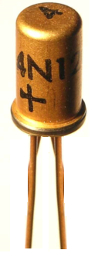
A shockley diode is another diode which is used primarily for switching applications. The shockley diode has an inherent trigger voltage. If the voltage applied across it is lower than the trigger voltage, the diode does not switch on and has extremely high resistance in a circuit. If the voltage is applied is greater than the trigger voltage, then the shockley diode switches on and has very low resistance.

Varactors
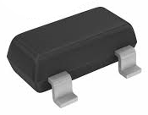
A varactor is a diode whose junction capacitance can be altered with an applied reverse voltage.
For this reason, a varactor is also called a variable capacitance diode (also it's called a varicap). A varactor's capacitance varies as the applied reverse voltage to it changes. As the applied reverse voltage increases, the width of its junction increases, which decreases its capacitance. Conversely, as the applied reverse voltage decreases, the width of its junction decreases, which increases capacitance.
The capacitance changes which varactors allow make them of broad use in oscillator circuits, where capacitance needs to be tuned to a precise capacitance value. Therefore, varactors have widespread use in tuning circuits where a change in capacitance tunes the circuit.

LEDs

The LED, which stands for Light-Emitting Diode, is one of the most popular and known type of diode. It is a diode which emits light when it receives sufficient forward current flowing through it.
LEDs come in many different types of colors and types. There are blinking LEDs which flashes on and off a certain amounts of times per unit time. There are tri color LEDs, which can emit two different colors depending on which lead receives positive voltage. And there are infrared LEDs which emit infrared light, which are used heavily in remote controls.

Laser Diodes
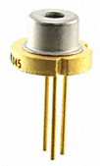
Laser diodes are diodes that emit a very narrow wavelength spectrum and, thus, can focus radiation to a spot as small as 1micrometer in diamteter. Compared to LEDs, laser diodes have very quick response times and a narrow beam spectrum. Laser diodes are used in CD players, CD-ROM drives, and other optical storage drives. They are also used in laser printers, laser fax machines, laser pointers, bar code scanners, and high-performance imagers.

Photodiodes
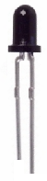
A photodiode is a diode which generates a current when exposed to light. In utter darkness, they act as an open circuit, allowing no current to pass through. When the light they are exposed to becomes bright, they conduct current across from their cathode to anode. Photodiodes, like zener diodes, connect to a circuit in reverse bias. This means that the cathode of the diode is connected to the positive voltage and the anode to the negative voltage. When the light intensity increases, current flows from the cathode to anode. Current increases with light intensity.
Photodiodes have very fast response times (in the nanoseconds).

Fast Reovery Diodes
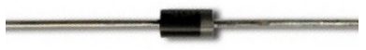
Fast recovery diodes are diodes which have quick recovery times.
One important task which a diode has many times in a circuit to rectify AC signals so that they can become DC signals, to power devices which need DC voltage. The normal frequency coming out of a US outlet is 60Hz. A certain amount of finite time is required for a diode to recover from each AC signal cycle to the next. This is the time it takes for a diode to turn off when the polarity of the applied voltage is reversed. This is normally just a fraction of a second. In low-frequency applications, the recovery time of a diode is not particularly significant, since the cycles are not very fast. However, in high-frequency applications, each successive cycle happens quicker and quicker. Therefore, it becomes necessary for a diode to recover quicker. The diode recovery time becomes crucial.
A fast recovery diode is a diode which can recover quickly from each AC cycle polarity reversal. A conventional diode could produce erratic output in these high-frequency situations. A fast recovery diode ensures much more accurate representation and signal integrity when dealing with high-frequency signals.

How To Test a Diode
In this article, we will go over different tests that we can use to check whether a diode is good or not, all by utilizing the functions of a digital multimeter.
There are many checks we can do to see if a diode is functioning the way it should. We will use and exploit the characteristics and behaviors that a diode should show if it is good and, in thus doing so, determine whether is good or defective.
So let's start:

How to Test a Diode with the Ohmmeter of a Multimeter
A very good test you can do is to check a diode with your multimeter set to the ohmmeter setting.
This is a simple test we can do to check whether it is good, open, or shorted.
So we take the ohmmeter and place it across the leads of the diode. The orientation is very important.

Anode-Cathode Diode Resistance Test
We first take the ohmmeter and place the positive probe on the anode of the diode (the black part of the diode_ and the negative probe on the cathode of the diode (the silver strip), as shown above. In this setup, the diode should read a moderately low resistance, maybe a few tens of thousands or low hundreds of thousands of ohms. For example, you may read 230KΩ.
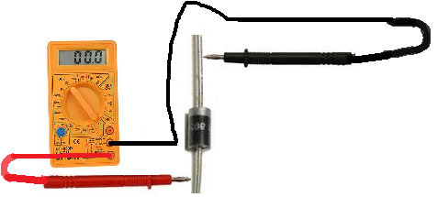

Cathode-Anode Diode Resistance Test
Now take the ohmmeter and switch the probes around so that the positive probe of the multimeter is now on the cathode of the diode and the negative lead on the anode. In this setup now, the diode should read a much higher resistance, over 1MΩ. It may even indicate 'OL' for an open circuit, since the resistance is so high.
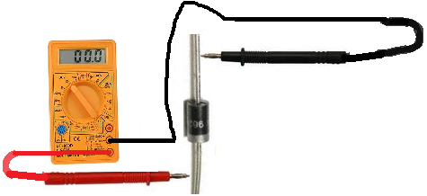
If you read a moderately low resistance with the leads on the diode one way and a high resistance with the leads the other, this is a sign that the diode is good. A diode should read relatively low resistance in the forward biased direction and very high resistance in the reverse biased direction.

Open Diode
If the diode reads high resistance in both directions, this is a sign that the diode is open. A diode should not measure very high resistance in the forward biased direction. The diode should be replaced in the circuit.

Shorted Diode
If the diode reads low resistances in both directions, this is a sign that the diode is shorted. A diode should not measure low resistance in the reverse biased direction. The diode should be replaced in the circuit.

How to Test a Diode with the Voltmeter of a Multimeter
A second test you can do to check is a diode is with a voltmeter of a multimeter (or simply just a voltmeter if you have one.)
Because diodes drop a specific voltage across their terminals with their threshold voltage is exceeded, we can use these properties to see if a diode is reading a healthy and correct voltage across their terminals.
To conduct this test, we need to place the diode in a circuit with DC voltage feeding the diode.
The circuit below is a good test to check a diode:
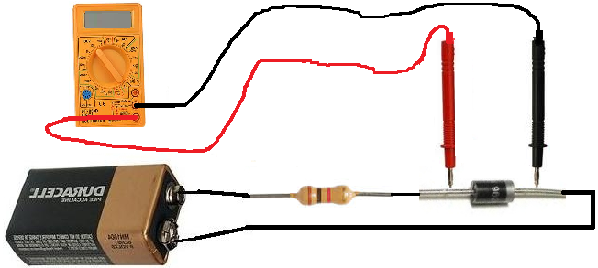
You can feed the diode any voltage you want above the threshold voltage. And the diode will drop the threshold voltage across its terminals.
The diode you are most likely using is a silicon diode. Silicon diodes drop approximately 0.6V-0.7v across their terminals. So when measuring voltage across the leads of the diodes, you should read a voltage in this range. If you do, the diode is reading a healthy voltage and should be good. If the diode is a germanium diode, then the voltage dropped across it should be anywhere in the proximity of 0.3V.
Make sure that you use a resistor when testing the diode with voltage, as to not make the diode overheat. Do not hook up the voltage directly to the diode. Use a resistor in between. Any resistor value such as 1KΩ or in that range will suffice.

Open Diode
If you reading a very high voltage across the diode, such as the voltage you are supplying it, the diode is open and, thus, defective, and should be replaced.

Shorted Diode
If you reading no to very little voltage across the diode, then the diode is shorted and should be replaced.
So there you have it, these are 2 strong tests you can do to test whether a diode is good or not.

Diode Resistance
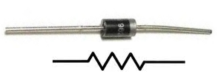
Diode resistance is the resistance which a diode offers in a circuit.
Just like a resistor or any other load in a circuit, a diode offers resistance in a circuit.
Unlike resistors, though, diodes are not linear devices. This means that the resistance of diodes does not vary directly and proportional to the amount of voltage and current applied to them. It changes parabolically.
Below is a graph of the resistance of a resistor or any other linear load:

Resistor Resistance Graph
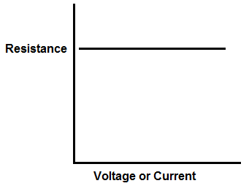
As you can based on the graph of a resistor, the resistance is constant. It does not vary when either voltage or current is changed in a circuit. When you have a 10KΩ resistor in a circuit, it will offer 10KΩ resistance in the circuit regardless of the voltage or current of the circuit.
The resistance can be calculated by the formula,R=V/I.
Diodes, however, do not work like this. Diodes are not linear devices; they are nonlinear. Since diodes are semiconductor devices doped with impurities, they do not function like linear devices. Their resistance changes based on the voltage and current that falls across them. Resistance is not constant.
And diode resistance does not change in a linear sense, but in a parabolic sense.
Below is a graph of diode resistance:

Diode Resistance Graph
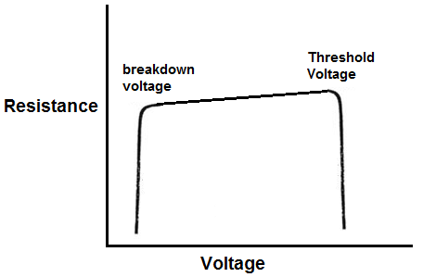
As you can see with diodes, resistance changes parabolically.
The diode has 2 key resistance change periods, at the breakdown voltage and at the threshold voltage.
Resistance does not change much but after the diode reaches the threshold voltage, resistance just decreases drastically, allowing a great amount of current to rapidly pass through the diode. The threshold voltage is the voltage where the diode has enough voltage to conduct a large amount of current through it. Without this threshold voltage, the diode does not have enough power to conduct current. The threshold voltage is normally 0.7V for silicon diodes and 0.3V for germanium diodes.
The same occurs to the left. Resistance does not change much until the diode reaches the breakdown voltage. As this point, the resistance drastically decreases, allowing a great deal of current to flow through. The breakdown voltage is the voltage which the diode has received the maximum reverse voltage that a diode can withstand. If more voltage is fed above this point, the diode will conduct a large amount of current across its terminals. Diodes are meant to only pass current when forward biased. But if enough reverse voltage is applied to it, its breakdown point, it will also conduct current across its junctions in reverse.

Diode Resistance Formula
The resistance of diodes is equal to the below formula:
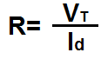
Diode resistance is equal to the thermal voltage, VT, divided by the current, Id, passing through the diode.
The thermal voltage of the diode is approximately 25mV at 300K, which is a temperature that is very close to room temperature.
The precise formula to calculate thermal voltage is:
VT= kT/q
where k is the Boltzmann constant, T is the absolute temperature of the pn junction, and q is the magnitude of the electron charge.
You can calculate the thermal voltage in this way, but for all practical purposes, 25mV should be substituted for the thermal voltage.
The current passing through the diode can be calculated according to the formula:
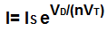
This formula can be used to calculate diode current.
If you have a circuit actually hooked up to a breadboard, then you can just use a multimeter turned to the ammeter setting. Connect the probes in series with the circuit and then read the amount of current. You can then use this value in the above formula to calculate the resistance.
Once the thermal voltage and the diode current are calculated, the diode resistance can be calculated using the formula, Rd= VT/ID.

What is a Protection Diode?
A protection diode (also called a safety diode) is a diode that is used in a circuit to protect the circuit from reverse voltage and current. Reverse voltage and current is power that flows in the opposite direction of the usual or conventional way; instead of current travelling from the positive side of the voltage source to ground and then to the negative side of the voltage source, it travels from the negative side of the voltage source, through ground, and to the positive side of the voltage source, so, in essence, reverse. A protection diode is used to block this reverse current flow; this helps to protect components in circuitry that can be damaged from reverse current.
A diode is a device that allows current to flow in through one direction but not the other. Therefore, it can be used in a circuit to only allow current to flow only in the forward direction but blocks current in the reverse direction. This can be particularly useful when components in the circuitry can be severely damaged by current flowing through them in the reverse (wrong) direction. One such device which is sensitive to reverse power is an LED, which usually has a maximum reverse voltage of about 5 volts. If more than 5 volts drops across it in the reverse direction, the LED will allow current to pass through in the reverse direction, and, thus, the LED can be permanently damaged. However, with a power diode (any diode with a 1N400X marking) acting as a protection diode, no current can pass through, since the diode essentially acts as an open circuit when in the reverse direction.
Below is a visual demonstrating this property of a protection diode:
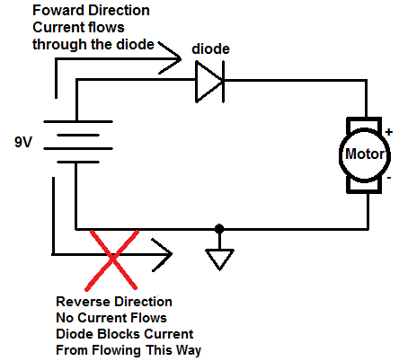
This diagram again shows how a diode allows current to flow in the forward direction but blocks current from flowing in the reverse direction. This serves to protect devices in a circuit that could be damaged from a reverse current flow.

Even though the above circuit provides protection via a diode, there is a better way to use a protection diode in a circuit.
The circuit below shows the improved design of using a protection diode in a circuit.
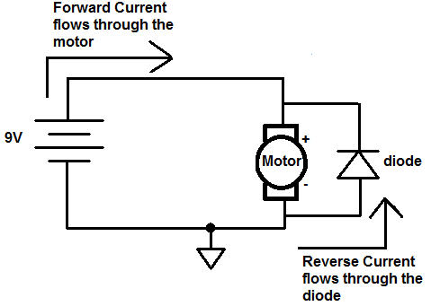
To protect a component in a circuit, a diode is normally placed reverse biased in parallel with the component.
When a diode is placed in parallel with the component you want protected reverse biasd, if current flows through the circuit in reverse, the current flows through the diode, bypassing the motor. With large amounts of current, some current may still pass through the motor, but it will be split between the diode and the motor. Therefore, all of the current will not flow through the motor, as would be the case if there was no diode present.
This setup with the diode in reverse biased works better than the setup before, because in the first setup, the diode consumes power. If it's a silicon diode, it typically consumes about 0.7V of power. Therefore, it isn't power efficient. With this setup, the diode only consumes current when there is reverse current.
Also another reason to build it this way is the limitations of a diode in reverse biased. In the first circuit, with reverse current, the diode is reverse biased. Current will not flow up to the point of the diode's peak reverse voltage. The peak reverse voltage is the maximum voltage that a diode can withstand to its cathode terminal. Any voltage beyond this will cause the diode to break down and conduct current across. For example, with a 1N4001 diode, the peak reverse voltage it can withstand is 50V. Therefore, if the voltage exceeds 50V to the cathode terminal, it will break down and current will conduct. This is the limitation of the first protection diode circuit design. However, with the second design, there is no limitation, because the diode is forward biased with reverse current. Therefore, it will never reach a breakpoint with this setup.
Therefore, this setup, with the diode in parallel reverse biased with the component to protect, is superior in design and an improved version of a protection diode circuit.
To find out in more detail how to connect a protection diode in a circuit, check out How to Connect a Protection Diode in a Circuit.

How to Connect a Protection Diode in a Circuit
A protection diode is used in a circuit so that current will not flow in the reverse direction in the circuit. Because a diode only allows current to flow in one direction in a circuit but not the other, it can protect components in a circuit that are sensitive to current that flows through them in the wrong direction.
A protection diode is connected in a circuit by placing the diode in series with the circuitry that is to be protected. For example, in this small project, we're going to connect the protection diode in series with an LED. An LED is pretty sensitive to current in the reverse direction. It can only handle a certain amount of current in the wrong direction. If enough reverse voltage drops across the LED, the LED will break down and allow current to flow through it in the reverse direction, which can cause the LED to be permanently damaged.
Parts Needed for this Project
• 9-volt Battery
• Power Diode (Any 1N400X diode)
• A 470Ω resistor (or any resistor within that proximity)
• A LED
Below is the schematic which we will build for this circuit:
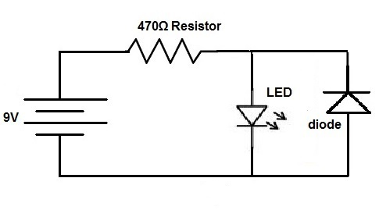
Now this is a more real life like representation of the above circuit:
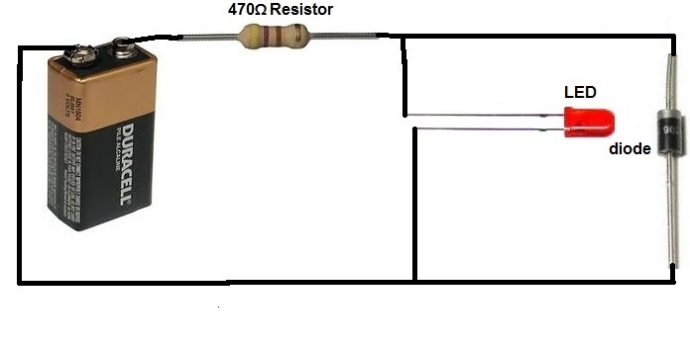
This circuit now protects against reverse current that could damage electronic components such as an LED. If a user places the battery in the wrong direction in the circuit, current will flow through the diode and then through the resistor or to the anode of the LED, bypassing the cathode of the LED. This means that the LED will not be damaged when a high reverse current flows through the circuit.
When current is flowing in the forward direction, it simply flows through the resistor, through the LED, and to ground.
Protection diodes are placed in many electronic circuitry devices to protect from reverse currents that could damage electronic components. If you think about gameboys, you've probably placed batteries in them with the wrong polarity orientation when putting in batteries in the back of them. If they weren't equipped with diodes in the circuitry, the gameboy could be damaged for good if the batteries were placed in the wrong way. But the diodes protect their internal circuitry against reverse current, so that when you place them in the right way, the gameboy still works.

What is a Photodiode?
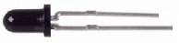
A photodiode is a transducer that takes light energy and converts it into electrical energy.
If placed in a dark room, the photodiode is exposed to no light; therefore it creates no electricity. However, if light falls upon it, it takes the light energy and produces electric current in response.
A photodiode conducts electric current directly proportional to the amount of light that falls upon it. It's a perfect direct relationship.

Graph of Photodiode Current Output Based on Intensity of Light
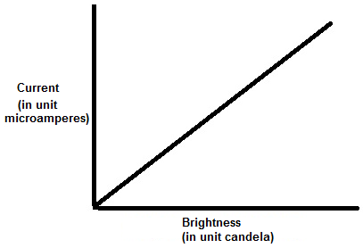
This graph shows this direct relationship between the brightness that a
photodiode is exposed to and the amount of current that it produces.

How to Connect a Photodiode to a Circuit
A photodiode operates in a circuit in reverse bias. This means that the anode connects to ground of the circuit and the cathode connects to the positive voltage supply of the circuit. Current flows from the cathode to the anode when exposed to sufficient light.
This is shown in the circuit below:
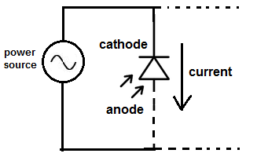
The majority of the times photodiodes are connected to a power source in a circuit. This is because photodiodes normally produce only microamperes of current, by themselves, which not enough power to drive most electronic devices. When coupled with a power source, more current can be delivered in the circuit. So normally a voltage source such as a battery is used in conjunction to them. The voltage source allows for increased output current so that there is enough current to drive a load. The photodiode provides additional current to a circuit from the light it receives and converts in the surrounding environment.
Then after the rest of the circuit can be connected to any load that the circuit needs to drive, which is denoted by the denoted lines in the circuit schematic above.
One very important application of photodiodes is in simple light meters. Because photodiodes have a linear response to light, they can function well in light meters. If a circuit being powered is exposed to more light, the photodiode will produce more current. When connected to a galvanometer, the galvanometer will shift more right when exposed to higher currents caused by an increased light intensity on the photodiode. Thus, photodiodes can be used in simple light meter circuits.
The amount of light that a photodiode can pick up and, thus, the amount of current that it produces depends mostly on the surface area of the photodiode. The larger the surface area, the more light that it can pick up; and thus the more current it produces. One tradeoff of more current production is the larger size. More space must be accomodoated for a circuit design to accomodate the greater space. Another tradeoff of the larger surface area is that response time slows down. The circuit tends to produce current more slowly in response to the light when the surface area is larger. When the surface area is small, response time is quicker and the circuit can have high-speed responses.
Photodiodes, overall, regardless of size, though, have very fast response times (measured in nanoseconds).

What is a Zener Diode?
A Zener Diode is a special type of diode that is used most extensively as a voltage regulator; this is because once the reverse voltage supplied to a zener diode reaches its breakdown voltage, referred to as VZ, the voltage across the diode remains very constant at this voltage even if the current through the diode continues to increase or vary.
For this reason of steady voltage after its breakdown voltage is this diode able to function as a voltage-regulating device.
Other diodes are not optimized to function with constant voltage after the reverse voltage has exceeded their breakdown voltages and will not display this characteristic that a zener diode contains.
Below is the voltage-current characteristics curve of a zener diode:
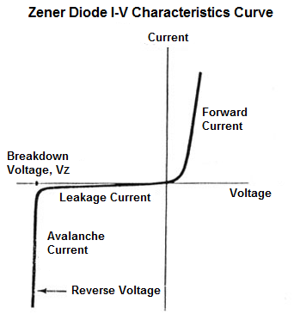
You can see in the above curve the how steady and constant the voltage across the zener diode is after it reaches the breakdown voltage, despite large changes in current.
This makes the zener diode very useful in circuits where steady voltages need to be supplied.
The zener voltage of zener diodes comes in a range of values. You can find them in 3.3V-12V easily in widespread use.
The circuit below has a zener voltage of 5.1V.
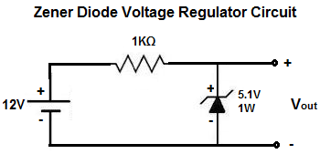
Therefore, the 12-volt power supply drops 5.1V and the voltage across the zener remains constant at this voltage. This 5.1 zener voltage is then placed in parallel to a load device, which it powers. This is a voltage regulator circuit.
The zener voltage of the diode can be any voltage, as is needed to be constant and power a circuit.

How to Build a Zener Diode Voltage Regulator
How to Build a Zener Diode Voltage Regulator
A Zener diode is a very useful device for regulating voltage. By connecting it in the right way in a circuit, it can act as a voltage regulator, to regulate how much voltage it feeds to a device.
To connect a zener diode in a circuit to provide voltage regulation, the zener diode should be connected, in reverse biased, in parallel to the power source which gives the zener diode its voltage, with the power source connected to a resistor. In this project, we will use a 1KΩ resistor.
Below is how the circuit will be connected:

How a Zener Diode Voltage Regulator Circuit Works
The above circuit is the perfect setup to make a zener diode voltage regulator. The 12V power supply drops across the 1KΩ resistor and the zener diode. This particular zener diode in use has a breakdown voltage of 5.1V. This means that the zener diode will have a voltage drop across it of 5.1V while the remaining 6.9V falls across the 1KΩ resistor. The zener diode will maintain a steady, constant voltage of 5.1V across it.
The load that the zener diode then powers is connected in parallel with the zener diode. This is because voltage in parallel is equal. So this means that the voltage the zener diode gives off to a device (if it's in parallel) will be 5.1V.
And this is how voltage regulation works with a zener diode.
If you don't have the exact values above, such as DC voltage or the exact zener diode, experiment with others. You just have to make sure that you have a voltage that is higher than the breakdown voltage of the zener diode and a resistor to dissipate excess voltage from the zener diode, which is the purpose of the 1KΩ resistor above.
To see this zener diode voltage regulator circuit in real life, see the following video shown below.

How to Build a Voltage Level Indicator with a Zener Diode
In this circuit, we will show how to build a voltage level indicator with a single zener diode.
A voltage level indicator is a circuit which can show if the voltage input into a circuit is greater than a certain threshold level. If the voltage is greater than a certain level, then an output such as an LED can light up or a buzzer can sound off.
We use a single zener diode in this circuit to function as our voltage level indicator.
A zener diode is a diode which has a break downs when a certain voltage level is reached and conducts current- when it is connected reverse biased in a circuit. This voltage that causes current to conduct across it is called the breakdown voltage of the zener diode. If a zener diode has a breakdown voltage of 5.1V, after 5.1V or greater is applied to it, it will conduct current across it which can then power on a load.
In this circuit, the type of zener diode we will use is the 1N4733 zener diode, which has a breakdown voltage of 5.1V. The type of output we will use is an LED.
So when the voltage reaches above the threshold of 5.1V, the diode conducts current across and lights up the LED, indicating the voltage level.
Components Needed
- 1N4733 5.1V Zener Diode
- 220Ω resistor
- LED

The 1N4733 zener diode can be obtained very cheaply from a number of online retailers. It can be obtained from Tayda Electronics at the following link: 1N4733 5.1V Zener Diode.
The datasheet for this diode can be found at: 1N47XX Zener Diode Datasheet.
This diode again has a breakdown voltage of 5.1V. After 5.1V, it will break down and conduct current across from cathode to anode.
The pinout for a zener diode is shown below:
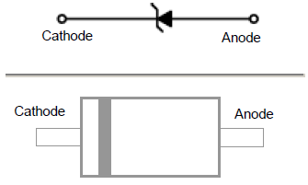
The cathode end of the zener diode is the end with the band on it. The other end is the cathode.

Voltage Level Indicator Circuit
The voltage level indicator circuit we will build with a 1N4733 zener diode is shown below.
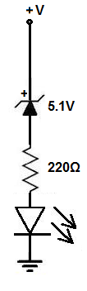
The breadboard schematic of the above circuit is shown below.
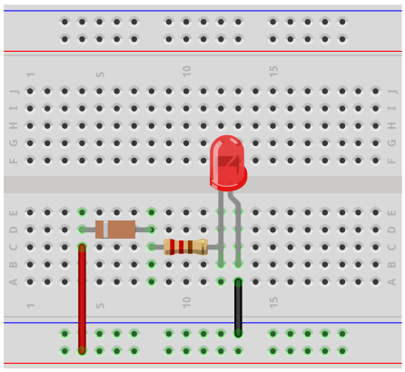
So the circuit is very simple.
The zener diode is connected in reverse biased to the power source. After this comes the 220Ω resistor that limits current to the LED and then we have the LED.
How this circuit works is the power source feeds voltage to the circuit.
When the voltage goes above the 5.1V threshold, then the zener diode breaks down and begins to conduct current across from its cathode to its anode. This current then powers on the LED, lighting it up. The LED serves as a visual indicator that the voltage that is being fed into the circuit is greater than 5.1V, the breakdown voltage of the 1N4733 zener diode.
Be aware that since the LED needs requires a forward voltage across it, normally of about 2-3V in order to turn on, the LED won't turn on until the voltage fed into the circuit is about 7-8V. This is because the zener diode consumes 5.1V and then the LED needs about 2-3V of forward voltage in order to turn on. So this circuit really is an indicator that the voltage in the circuit is greater than 7V. If the LED is on, then the voltage is definitely greater than 5.1V, which is the breakdown of the zener diode. But since you have to take into account the voltage needed for the LED to turn on, you have to add that voltage amount. Then you can truly see the level the volage is at. Of course, if you're just building a circuit to see if the voltage exceeds the breakdown voltage of a zener diode generally (by a few volts or so), then you don't need to worry too much about the forward voltage that an LED consumes.
And you can make many modifications to this circuit. You can swap out this zener diode for another to get a different voltage threshold.
The types of zener diodes you can use are:
1N4728: 3.3V
1N4729: 3.6V
1N4730: 3.9V
1N4731: 4.3V
1N4732: 4.7V
1N4734: 5.6V
1N4735: 6.2V
1N4736: 6.8V
1N4737: 7.5V
1N4738: 8.2V
1N4739: 9.1V
1N4740: 10V
1N4741: 11V
1N4742: 12V
1N4743: 13V
1N4746: 18V
These are many different zener diodes you can use. They all have different breakdown voltages, so they can set a different threshold voltage for the voltage level indicator circuit.
And this is how a voltage level indicator can be built with a zener diode.

How to Build a Voltmeter Circuit with Zener Diodes
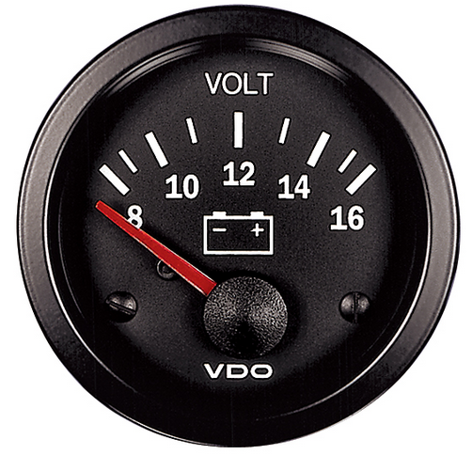
In this circuit, we will show how to build a voltmeter using zener diodes.
A voltmeter is a device that can measure voltage and give out a status indicator of what the voltage level is.
The voltmeter we build won't be capable of showing the voltage output on a digital screen such as an LCD. It shows us the voltage strength by the number of LEDs that are lit.
We place multiple zener diodes in parallel in a circuit. Each zener diode has a different breakdown voltage. As we go from left to right, each successive zener diode has a greater breakdown voltage. So as the voltage rises, the number of LEDs that turn on increase. This is because as the voltage gets greater, more zener diodes surpass their breakdown voltage and conduct current across from cathode to anode to light up the LEDs.
In this circuit, we use 4 zener diodes. These diodes have breakdown voltages of 3.3V, 5.1V, 9.1V, and 12V.
So if the voltage rises above 3.3V, one LED will light up.
If the voltage rises above 5.1V, 2 LEDs light up.
If the voltage rises above 9.1V, 3 LEDs light up.
And if the voltage rises above 12V, all 4 LEDs turn on.
So the number of LEDs that are lit serve as a visual status indicator of the voltage level.

Components Needed
- 1N4739 9.1V Zener Diode
- 1N4733 5.1V Zener Diode
- 1N4741 12V Zener Diode
- 1N4728 3.3V Zener Diode
- 4 470Ω resistors
- 4 LEDs

The 1N47XX zener diodes can be obtained very cheaply from a number of online retailers. They can be obtained from Tayda Electronics at the following link: 1N47XX Zener Diodes.
The datasheet for these diodes can be found at: 1N47XX Zener Diode Datasheet.
This diode again have breakdown voltages of 3.3V, 5.1V, 9.1V, and 12V, for the 1N4728, 1N4733, 1N4739, and 1N4741. After a breakdown voltage is reached, the diode will break down and conduct current across from cathode to anode.
The pinout for a zener diode is shown below:
The cathode end of the zener diode is the end with the band on it. The other end is the cathode.
All the zener diodes will be connected reverse biased to the power supply.

Voltmeter Circuit with Zener Diodes
The voltmeter circuit we will build with zener diodes is shown below.
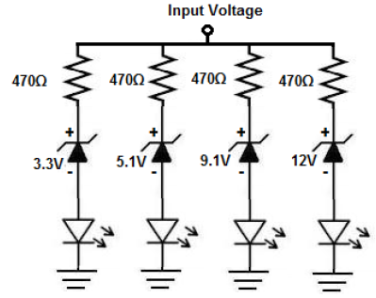
The breadboard schematic of the above circuit is shown below.
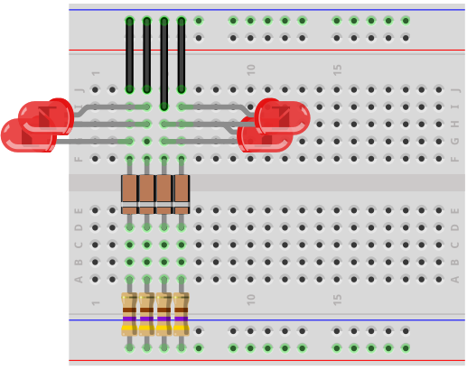
So the circuit is very simple.
The zener diodes are all connected in reverse biased to the power source. Each zener diode has a 470Ω resistor in series with it to limit current to the LED and then we have the LED.
How this circuit works is the power source feeds voltage to the circuit.
When the voltage goes above the 3.3V threshold, then the zener diode breaks down and begins to conduct current across from its cathode to its anode. This current then powers on the LED, lighting it up. So if the voltage is above 3.3V but below 5.1V, the first LED will turn on.
When the voltage goes above the 5.1V threshold, then the first 2 LEDs are lit, since both diodes' breakdown voltages have been reached.
When the voltage goes above the 9.1V threshold, then the first 3 LEDs are lit, since the 3 diodes' breakdown voltages have been reached.
When the voltage goes above the 12V threshold, then all 4 LEDs are lit, since all 4
So if none are on, this means the input voltage is less than 3.3V.
If only 1 is on, this means the input voltage is between 3.3V and 5.1V.
If 2 are on, this means the input voltage is between 5.1V and 9.1V.
If 3 are on, this means the input voltage is between 9.1V and 12V.
If 4 are on, this means the input voltage is greater than 12V.
So this is how the LEDs serve as status indicators of the voltage levels.
You can make many modifications to this circuit. You can swap out this zener diode for another to get different voltage thresholds.
The types of zener diodes you can use with their breakdown voltages are:
1N4729: 3.6V
1N4730: 3.9V
1N4731: 4.3V
1N4732: 4.7V
1N4734: 5.6V
1N4735: 6.2V
1N4736: 6.8V
1N4737: 7.5V
1N4738: 8.2V
1N4740: 10V
1N4741: 11V
1N4743: 13V
1N4746: 18V
These are many different zener diodes you can use. They all have different breakdown voltages, so they can set a different threshold voltage for the voltage level indicator circuit.
And this is how a volmeter can be built with zener diodes.

How to Build a Peak Detector Circuit
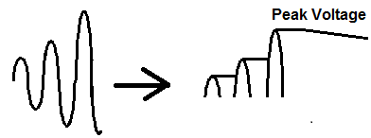
In this project, we will show how to build a peak detector circuit using only simple components, a diode and a capacitor.
A peak detector circuit is a circuit that is able to measure the peak amplitude that occurs in a waveform. It is able to tell us what's the highest value a waveform reaches.
It is important because it can measure the maximum amplitude value of a signal. It can be used in many applications for any signal that needs to be analyzed for highest maximum value. One application that is used in frequently is sound measuring applications. This is because sound signals vary depending on the level of the sound. For example, it may need to be known what the maximum sound that is generated in a certain place is. The peak detector would be able to measure this maximum sound and output it to us. Therefore, you could know how loud a certain place is. This could be used, for example, at a sports arena, where they want to know how loud the crowd in the arena is. Or it could be used for voice applications to determine how loud a person is, etc. And you could use that data for anything. So the applications for a peak detector circuit is really endless and it's a very useful circuit for many reasons.
It turns out that the simplest peak detector circuit can be built without the need for any complex components such as chips; it can be built simply with a diode and a capacitor.
A diode and capacitor are placed in series with one another. Being that a diode is a one-way current device that only allows current to flow in one direction, we exploit this principle in our peak detector circuit. We place a positive voltage source in series with a forward biased diode and in series with a capacitor. This allows current to flow from the power source through the diode and then to charge up the capacitor. With each new peak in the waveform, the capacitor charges up to that level. It follows the signal, so to speak. And once charged to that peak, it holds it. This is because the charge from the capacitor cannot flow out because the diode prevents it from doing so. To the capacitor, the diode is reverse biased, so no current can flow out from the capacitor. It retains the charge and we are able to read the voltage from this capacitor to tell the peak amplitude of the signal fed into the circuit.
We will explain this circuit in much greater detail below.
We will explain the advantages and disadvantages that come with the circuit, as well as how it can be modified so that the circuit can act according to how we want it to.
However, this circuit still functions as a great peak detector circuit as long as you don't need too much precision, which we'll discuss below.
Components Needed
- Diode
- 100μF electrolytic capacitor
- 10KΩ resistor (optional)
- Transistor (optional)

Any diode really can be used.
All we really need is a device that permits current to flow in one direction but not the other.
However, with the diode you choose, we will need to know the voltage drop across the diode. All diodes have voltage drops across them. This is called the barrier voltage. It is the voltage that is necessary to allow current to conduct across the diode and is necessary to be sustained so that current flow can continue across the diode. So in simple terms, it is the minimum voltage needed across the diode in order for it to conduct current. You can find out this value simply by measuring the voltage across the diode. If you have the datasheet for the specific diode you are using, you can find it out via the datasheet. But we will need to know this because the output at the capacitor, which reflects the peak amplitude of the input signal, isn't directly the voltage read from the capacitor. This is because we must take into account that the diode consumes some of the voltage. Therefore, the voltage at the output, that is from the capacitor, is higher than the input signal by the value by a value that is equal to the voltage drop across the capacitor. So the voltage at the output would be the same as the input if the diode consumed no voltage. But it does. So you must take into account that the diode consumes voltage for operation. Therefore, the voltage at the output is higher by an amount equal to the diode voltage consumption. Being that most diodes consume anywhere from 0.3V-0.7V, the output voltage will be higher by a factor of this amount. So if we have a silicon diode that consumes 0.7V of power and the output signal is 15V, the peak voltage is really 14.3V (15V - 0.7v= 14.3V).
The capacitor should be sufficiently large. For DC voltage that isn't too high, a 100μF capacitor will do well. The more capacitance, the more charge it can hold. So depending on how large the input voltage you are working with determines the amount of capacitance you need. They have a direct relation. So the larger the input volage, the greater the capacitance needed. The smaller the input voltage, the smaller the capacitance needed.
Another factor that we need to be concerned about in terms of the capacitor is the voltage rating. Depending on how large we expect the voltage to scale, we need a capacitor with a voltage rating matched for that voltage. So we can decide a rough estimate for how high we believe the voltage we reach. Say, we have good estimates the voltage will peak no higher than 30V, then for that application, a 50V voltage capacitor will suffice. But if the voltage is going to reach, say, 70V, we would make sure the capacitor is rated for a higher voltage than this, say 100V or even 200V. The peak voltage of the input signal should not exceed the voltage rating of the capacitor, because then the capacitor can be damaged, and the circuit will not work. So this is a very important spec that must be taken into consideration.

Peak Detector Circuit
The peak detector circuit we will build with a diode and capacitor is shown below.
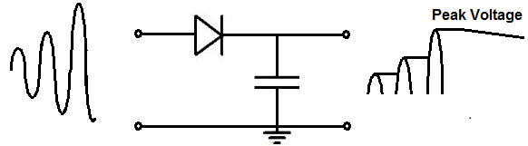
The breadboard circuit of the circuit above is shown below.
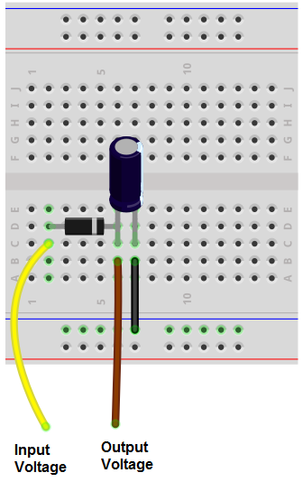
So we have a very basic circuit.
We have a diode connected in series to a diode which is in parallel to an open circuit.
The positive power source is connected to the anode (positive terminal) of the diode and the negative power source is connected to ground.
How the circuit works is the power supply allows current to flow through the diode and into the capacitor. The current charges up the capacitor and the capacitor increases in volgtage corresponding to the amount of charge following through it. The capacitor basically follows the input voltage source. It will charge up to the peak voltage of the signal. Once it reaches this voltage, it holds it. This is because if you look at the circuit, the capacitor cannot discharge. It does not discharge back through the diode because the diode is a one-way current device. It only allows current to flow from the anode to the cathode end, but not cathode to anode. The capacitor sees the diode as an open circuit, so no current can flow across. To the right, the capacitor cannot discharge because the circuit is open, so to the capacitor, there is infinite resistance. Therefore, each time the capacitor charges up to meet the peak of the input voltage, it retains that charge until a new peak is reached and it charges up again to match that peak. You can see this in the waveform above.
Also note, as we stated, the voltage across the capacitor isn't directly the peak voltage of the waveform. This is because the diode consumes some voltage. Therefore the voltage measured across the output is actually higher than the input voltage by a factor of the voltage drop across the diode. To get the true peak voltage, we must subtract the voltage that the diode consumes from the output signal. So if we measure the voltage at the capacitor to be 13V and the diode consumes 0.6V, the peak voltage of the input signal is actually 12.4V.
Also note that over time, the capacitor voltage will slowly drift lower over time. This is because there is no such thing as an ideal component. Every component has fallacies. The capacitor will leak small amounts of current over time, slowly decreasing the voltage. The diode allows so small amounts of reverse current. With all these leakage sources, the voltage slowly drifts downward over time. This is why it is best to read the voltage right when it occurs instead of waiting a long time to measure it.
So this is one way to create a peak detector circuit with simple components. The advantage is that it's very simple. The disadvantage is because it's just simple components being used, it leaks current and drifts over time. These inaccuracies don't create a high-precision peak detector. However, it's still great if you just need something basic and not high precision. In other words, it's great for low-precision applications.
To make a distinction, this peak detector circuit functions as a positive peak detector. It detects the peak voltage only on the positive side of the AC signal. All voltage below 0V is clipped because the diode only allows current flow in the forward direction and not the other direction. If you want the circuit to instead detect the negative peak of the circuit, the diode simple needs to be flipped in the other direction. Then the circuit will detect the peak negative voltage. If you change the circuit to be a negative peak detector and you are using a polarized capacitor such as an electrolytic capacitor, you will need to switch the capacitor around so that the cathode of the diode connects to the anode of the capacitor.

Circuit Modifications
Now we will talk about modifications we can make to the circuit so that it can act in other ways we may want it to.
So the circuit we created above obtains and holds the charge indefinitely, even though it does decrease slightly over time due to leakage current. However, what if we want to reset the value back to zero, maybe because we want the peak value of a new signal every certain time period. In that case, we want to completely wipe off the charge on the capacitor, so that it discharges completely back to 0V.
One way we can discharge the capacitor is by connecting a resistor in parallel to the capacitor.
This is shown in the circuit below.
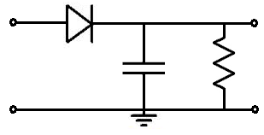
The value of the resistor and capacitor determines how long it takes for the capacitor to charge. The time it will take for the capacitor to completely discharge is 5RC, where R is the resistance and C is the capacitance. So if we have a 100μF capacitor and a 10KΩ resistor, it will discharge in approximately Τ= 5RC=5(10KΩ)(100μF)= 5 seconds. You can adjust this rate to a longer or shorter interval. If you want a longer interval, then you would increase the value of the resistance and/or capacitance. If you want a shorter interval, you would decrease the value of the resistance and/or capacitance.
Let's say that you don't want the circuit to reset every 5 seconds because it's way too short. You want it to reset every minute. That way, it gives you more time to read the signal. Then you could choose the values of 1000μF and 60KΩ. This makes for a 1-minute, or 60-second, self discharge.
With this type of circuit, you can predict how long the circuit takes to discharge. So the circuit self-discharges so that it can read new peaks every 5RC time period.
This is one way of building a peak detector circuit that discharges itself regularly.
Another way of doing it is to connect a transistor to the circuit instead of a resistor.
Below is the circuit showing the transistor connection to the peak detector circuit.
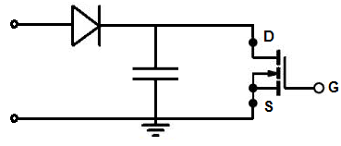
A transistor works really well also.
Again, with this circuit, the voltage across the capacitor is the output voltage minus the diode voltage drop.
It works because when there is no voltage or insufficient voltage across the gate of the transistor, no current flows from drain to source. Therefore, all the voltage is retained across the capacitor, because the transistor acts as an open circuit. However, once we have read the peak voltage and want to reset the voltage back to 0 by draining the capacitor of all its charge, we apply a sufficient voltage to the gate of the transistor. The transistor now conducts current across from drain to source and the capacitor discharges through the transistor.
So this functions like the resistor circuit but it's more advanced and allows for resets whenever we want instead of at a predictable time interval.
We can also connect this circuit to an ADC converter or microcontroller to read the chip. We can program the circuit to discharge whenever we want by placing a HIGH voltage at the gate terminal.
So these are all peak detector circuits that allow us to measure the peak and allow reset if wanted. Again, it doesn't provide high precision peak detection but for basic applications where only a good approximation is needed, it works really well.

How to Build a Peak-to-Peak Detector Circuit
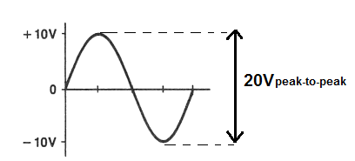
In this project, we will show how to build a peak-to-peak voltage detector circuit.
This is a circuit that measures the amplitude of the peak-to-peak voltage of a signal.
The peak-to-peak voltage is the voltage all the way from the tip of the negative portion of a signal to the tip of the positive portion of a signal.
For example, if an AC signal goes to +10V on its positive cycle and to -10V on its negative cycle, it has a peak-to-peak voltage of 20V. The peak voltage of this signal, however, is 10V. Because the peak voltage only takes into account the top of the positive half cycle.
So, if an AC signal swings halfway from the 0V line, the peak-to-peak voltage will always be double the peak voltage of the signal.
The circuit that we're building here takes an AC signal that swings from the 0V, equally positive and negative during their respective cycles and clamps it so that the negative peak of the AC signal is at the 0V line. Now the signal swings from 2 times the peak voltage to the 0V line. A capacitor at the end of the circuit then charges up to this maximum voltage, which represents the peak-to-peak voltage. Therefore, the voltage across the capacitor represents 2 times the peak voltage, which is the peak-to-peak voltage.
The voltage across a capacitor is DC voltage. Therefore, even though, we're using an AC voltage source as the input voltage source, the output voltage is a DC voltage. So, this circuit is an AC-to-DC converter. But that's not the point. The circuit achieves its goal of measuring the peak-to-peak voltage of an AC signal. It's able to give out the peak-to-peak amplitude, so that we know the maximum voltage that a signal reaches when considering it from an aspect of being peak-to-peak.
We will show how to build this peak-to-peak voltage detector circuit below.

Components Needed
- 2 100µF electrolytic capacitors
- 2 1N4001 Diodes

All we need to build this circuit are 2 diodes and 2 capacitors.
The diodes can be any really. Any diode from the popular and widely used 1N400X family will work with this circuit.
The capacitors used in this circuit are electrolytic capacitors. 100µF will work fine.

Peak-to-Peak Detector Circuit
The peak-to-peak voltage detector circuit we will build with 2 diodes and 2 capacitors is shown below.
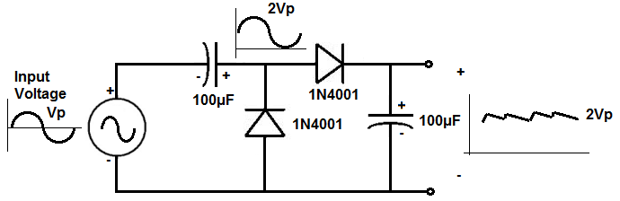
The breadboard circuit of the circuit above is shown below.
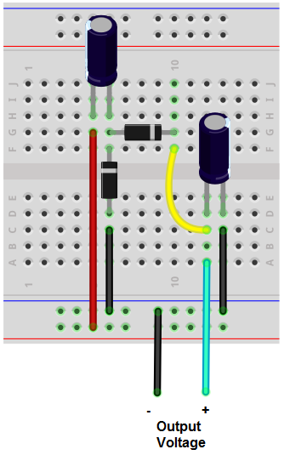
So input into this circuit is an AC voltage signal.
This circuit works by the fact that it is a DC clamper and a peak detector cascaded together. If you cascade these two together, you get a peak-to-peak voltage detector.
The input AC signal is positively clamped. So instead of an AC signal swinging positive and negative from the 0V line, it is clamped to being all above the 0V line. Therefore, the maximum value is now 2 times the peak voltage, since the circuit is shifted up. This is clamping part of the circuit.
The next part of this circuit features the last capacitor. The full clamped signal now enters into the capacitor. A capacitor stores voltage up to the maximum voltage that the signal is. So if the peak-to-peak voltage is 20V, the capacitor stores a DC voltage equivalent to 20V. Just make sure that the capacitor has a voltage rating above the maximum voltage you are using so that it doesn't damage the capacitor. So if you're expecting a voltage range to say 20V, for example, make sure to use a capacitor that has a voltage above 20V, such as at least 25V.
After this, to check the voltage across the capacitor, all you need to use is a DC voltmeter to read the peak-to-peak voltage value.
Realize for this circuit that the displayed peak-to-peak voltage on a DC voltmeter will be slightly lower than the true peak-to-peak value. This is because you must take into account the voltage drop that occurs across the diode. Usually silicion diodes consume about 0.6-0.7V, while germanium diodes consume about 0.3V. Therefore, the output voltage will be lowered by this amount.
Also for this circuit, realize that the discharge time have the capacitor and the load of the circuit must be much greater than the period of the incoming signal. This is so that the voltage across the capacitor doesn't discharge quickly, losing the peak-to-peak voltage value. If this is met, in this circuit, you get good clamping action and good peak-to-peak detection. The output ripple will be small.
This circuit has application when using an AC voltmeter may get the wrong reading. For instance, suppose an AC signal swings from +40 to -10V. If you try to measure this with an ordinary AC voltmeter, you will get an incorrect reading. If you use this peak-to-peak detector circuit built, you will read 50V for the peak-to-peak value.

How to Build a Peak Precision Detector Circuit
In this project, we will show how to build a precision peak detector circuit.
This is a peak detector circuit that can detect the peak of an input analog signal with more precision than a simple peak detector.
Previously, we've shown how to build a peak detector circuit using only the simple components of a diode and a capacitor. Though this circuit is effective and works well, it is only good for rough estimates and lacks high precision. This is because simple components are much less sophisticated than more complex components such as integrated circuits and are subject to leakage and a number of other factors that make it lack precision. Diodes will allow some reverse leakage current. Capacitors will leak small amounts of current over time. Even those these are small, over time, they continue and equal to substantial loss. All these factors contribute to making a low-precision peak detector that should not be used in cases of high-precision needs.
So instead of using only simple components to build a peak detector circuit, we also add buffers to the circuit. The buffer is much more stable than a diode. A diode is a simple component that is not as precise. Understanding, the physics a diode is basically a PN junction semiconductor material and it is very sensitive to temperature variation. The reverse current is very sensitive to the junction temperature. If you're building this circuit at home, where you're at room temperature and you keep it there, you shouldn't encounter too any problems because of this. But if you're building a commercial-grade product, you wouldn't want to be use a diode for precision applications due to fluctations the diode can cause. Instead an op amp provides much better stability with a diode rather than with just a diode alone.
So we will still use a diode in our circuit but not alone. The diode is still important because the diode will be reverse biased to the capacitor, so that the capacitor cannot discharge back. We want the capacitor to hold the charge once it gets stored up. This way, we are able to hold the peak value. But we will use a buffer with the diode. The buffer acts a voltage follower because it follows the input voltage.
So we will show how to design this precision peak detector and what factors need to be taken into consideration when choosing the components.
Components Needed
- 2 LM741 Op Amp Chips
- Diode
- 100nF electrolytic capacitor

The LM741 is an operational amplifier chip.
It is composed of a single op amp.
The LM741 is an 8-pin chip.
The pinout for the chip is shown below.
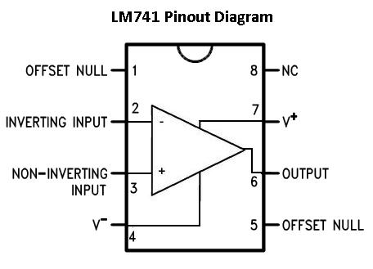
Pin 1: Offset Null- This pin will be left open
Pin 2: Inverting Input- This is where the positive part of the input signal that we want to amplify goes if we want our amplified signal inverted. If we don't want it inverted, we place the positve part of the signal into the Non-inverting terminal and place the negative or ground part of our signal here.
Pin 3: Non-inverting Input- This is where the positive part of the input signal that we want amplified goes if we want our signal non-inverted. Pin 4: V-- The LM741 Op amp is a dual power supply op amp, meaning it must be supplied positive DC voltage and negative DC voltage. Pin 4 is where the op amp gets supplied with negative DC voltage.
Pin 5: Offset Null- This pin will be left open.
Pin 6: Output- This is the terminal where the output, the amplified signal, comes out of. Whatever output the amplifier will drive gets connected to this terminal.
Pin 7: V+- This is the terminal which receives the positive DC voltage.
Pin 8: NC- This pin will be left open.

Precision Peak Detector Circuit
The precision peak detector circuit we will build with 2 LM741 chips is shown below.
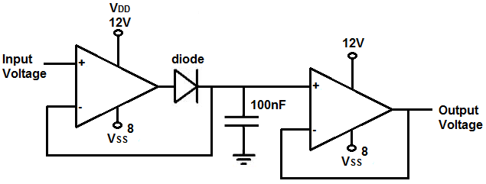
The breadboard circuit of the circuit above is shown below.
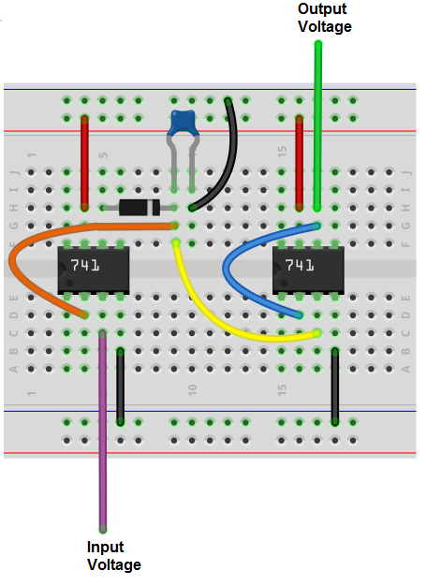
So for this circuit, to power the LM741 chip, we place about 12V into VDD, pin 7, and we ground pin 4, the ground pin. This establishes sufficient power for the chip.
The input to the first buffer is pin 3. To the input, we can the input voltage which we want to buffer.
The output of the buffer is pin 2. To the output, we place a diode in series and then a capacitor in parallel.
We then connect the anode of the capacitor to a second buffer. The second buffer's input is pin 5. The output of the second buffer is pin 4. The output from the second buffer is the output of the circuit and represents the original input voltage signal.
How this circuit works is the buffer acts as a voltage follower.
A buffer, in general, follows the voltage exactly. When we place a diode in series with the output of the buffer, the voltage stored up in the capacitor cannot discharge back through the diode because to the capacitor, the diode is reversed biased. So once the capacitor gets charged up to the peak voltage of the input signal, it cannot discharge back either through the diode (since it is reverse biased) or the input of the second buffer (since it has such high input impedance). The high input impedance of the buffer impedes the leakage of current from the diode. Since current, I=V/R, where R is the resistance, this high resistance value impedes the flow of current from the diode. Thus, the current is contained across the the capacitor.
If we didn't have this second buffer and we connected the output of the capacitor directly to the output load, it would be much more susceptible to leakage. The high input impedance from the buffer prevents current from flowing out of the capacitor and contains it within the capacitor. This allows the peak of the voltage to remain relatively constant, with a very slow drop of the voltage due to leakage. Even with high input impedance, there will always be some droop because the resistance isn't perfectly infinite. So very small amounts of current will still leak and the voltage will droop down still, though not much.
This is why we use 2 buffers.
Now that you know conceptually how this circuit works, we'll now go into some of the considerations you have to when when choosing the value of the components, chiefly the capacitor.
The diode can really be any diode. It isn't very important.
What's really important is the values of the capacitor we choose. When choosing the capacitor, we have to consider both the capacitance and voltage rating.
The voltage rating is simply how much voltage we expect the circuit will peak at. We want the capacitor to have a voltage rating higher than the peak voltage of the input signal. Therefore, if we expect your peak voltage to be 9V, you should use a higher voltage-rated capacitor such as 12V or 15V or higher.
The other value we must take into consideration is the capacitance of the capacitor. This is important because it works hand in hand with the slew rate of the capacitor. If you choose a capacitance value that is too small, you risk having the capacitor have a fast droop rate. This is because with a smaller reactance, the RC network has a smaller value, and thus discharges faster. If you choose a capacitance value that is too large, the slew rate of the capacitor may not be quick enough to charge up the capacitor. This is because the RC network now has a greater time charge time. If the slew rate isn't fast enough to match this capacitance value, there may be huge delay between the input and output signals, so the circuit will be slow and efficient. So you want to keep the capacitor as small as possible for maximum speed and efficiency (smaller capacitors take less time to charge) but you also want to have the capacitor large enough so that you don't have a lot of droop (smaller capacitors discharge quicker). So it's a delicate balancing act.
Another thing that is very important is the type of capacitor that is used. Capacitors have a phenomenon called the dielectric absorption. This is when capacitors have a memory, so to say, in which even after being fully discharged, they can rise back to their previous memory state. This is a real problem when you're talking about a precise peak detector circuit. We do not want the capacitor having these memory and rising back to previous states. This could really mess up the functionality of a precision detector. The type of dielectric material used in the capacitor determines its dielectric absorption. We want to use a capacitor with a low dielectric absorption such as a polystyrene capacitor or, even better, a teflon-based capacitor. So if you want to occasionally short out the capacitor, completely discharging it, having a low dielectric absorption capacitor is very important.
So, for our circuit, we use a 100nF polystyrene or teflon-based capacitor. This value and type of capacitors suits this circuit well.
An important consideration that must be kept in mind is the frequency of the input AC signal. Keeping in mind that the op amp has a certain slew rate, in which it can amplify voltage per unit time, the op amp will only be able to properly amplify signals up to a certain frequency. Above this threshold, the slew rate of the op amp will cause poorly formed and distorted waveforms on the output.
The LM741 has a slew rate 0.7V/μs. This means that it can output a voltage of 0.7V for every microsecond of time that transpires. We'll do the math in reverse so that you can see the frequency the op amp is capable of managing. This all depends on the amount of voltage that it outputs. So being that the slew rate is specified in terms per each microsecond, let's do the math. The inverse of a time period is the frequency. F= 1/t, where T is the time period. So, F=1/T= 1/1μs= 1MHz. So the op amp is capable of outputting 0.7V for a 1MHz signal. But 0.7V is a small voltage to output. Many times, the voltage needed on the output will be much higher. Let's say, the op amp will pass 10V on the output. If you take 10V and divide it by 0.7V, you get 10V/0.7V= 14.3. So 10V is 14.3 times the voltage of 0.7V. So we said that the LM741 can output 0.7V per 1MHz. Since 10V is 14.3 times the voltage of 0.7V, this means that the op amp can output 10V per 69930Hz (1MHz/14.3=69930Hz). Any frequency above this for 10V will be greatly distorted due to limitations of the slew rate. So you can see for this circuit if we're outputting 10V, the frequency must be limited to about 60KHz, to be on the safe range. If you're outputting even a larger voltage such as 15V, the frequency limitation of the input voltage is 46729Hz (1MHz/21.4=46729Hz). To be on the safe side, it's good to limit the input voltage to a frequency a good distance away from the upper limit. This is because an op amp also has a minimum slew rate range. So the typical range for the LM741 is 0.7V/μs, while the minimum range is 0.3V/μs. So it's best to keep the upper limit at the minimum range to have the highest quality output signal.
But seeing how the slew rate calculations work out and how it puts a limitation on high-frequency signals is important to get how signal integrity for this circuit. For this circuit, the minimum slew rate range calculates to be approximately 30KHz. So the input voltage signal should go no higher than 30KHz or distortion may be introduced into the output signal.
The LM741's slew rate of 0.7V/μs isn't particularly fast. If you are dealing with relatiely low frequency applications such as 20KHz or less, it will work fine enough, because the slew rate can still output voltage at a fast enough rate. However, if you are dealing with frequencies over 50KHz or so, it's best to use a high-speed op amp. A high speed op amp has a much greater slew rate, so it's able to output voltage at a greater rate than a regular op amp. A high-speed op amp typically has a slew rate of 100V/μs. The LH0063C is a high-speed op amp that has a slew rate of up to 6000V/μs, so if you are using an op amp to deal with high to very high frequencies, you would need op amps with high slew rates. But for basic low-frequency applications, op amps such as the LM741 are perfectly fine.
Another limitation of this circuit is the input voltage of the LM741. So the LM741 can't accept an infinite voltage range. It can only accept voltages up to values its rated for. So you have to also keep this in mind.
But this circuit works very well as a precision-type peak detector circuit. It's much more stable than simply using simple components to control due to greater temperature stability and impedance factors.

How to Build a Diode AND Gate Circuit
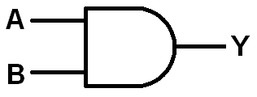
In this project, we will show how to build an AND gate circuit with diodes.
An AND gate is a logic circuit that only turns on an output when all the inputs are HIGH or a logic state of 1. If any inputs are off or at a logic state of 0, the output is off.
AND gates can be built using a variety of electronic components, including transistors and mechanical pushbuttons.
In this circuit, we will accomplish building an AND gate with simply diodes and a single resistor.
We then connect our output to this circuit which can turn on our load if all inputs are HIGH.
We will show exactly how this circuit works to achieve this logic condition.
We will build our circuit so that there are 3 inputs to the AND gate. You can change this so that there can be 2 or more. All an additional input requires is another pushbutton and another diode. You will see how to do this once you see the schematic below. We'll also explain it.
Our output will be an LED. We use a current-limiting resistor along with the LED to limit current to the LED. However, you can modify this to suit anything else, as long as the circuit is capable of powering in on given power requirements.

Components Needed
- 3 1N4001 diodes
- 10KΩ resistor
- 470Ω resistor
- LED
- Toggle switches (optional)

The diodes really can be any type. The 1N400X diodes are an easy type to find and very cheap, so any one from that family can be used.
The amount of diodes you need are proportional to the number of inputs you want for the AND gate. Since we are building a 3-input AND gate, we will need 3 diodes.
We use a 10KΩ as a pull-up resistor.
Optionally, you can use toggle switches to control the input values instead of having to manually connect or disconnect positive voltage or ground. We will show how to incorporate toggle switches into this circuit so that inputs can be changed more easily.

Diode AND Gate Circuit
The AND gate we will build with diodes and a single resistor is shown below.
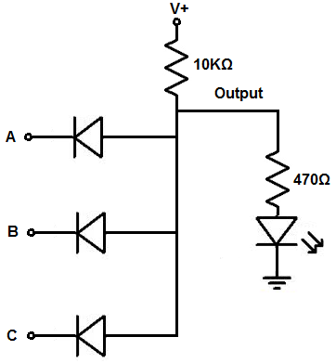
The breadboard circuit of the circuit above is shown below.
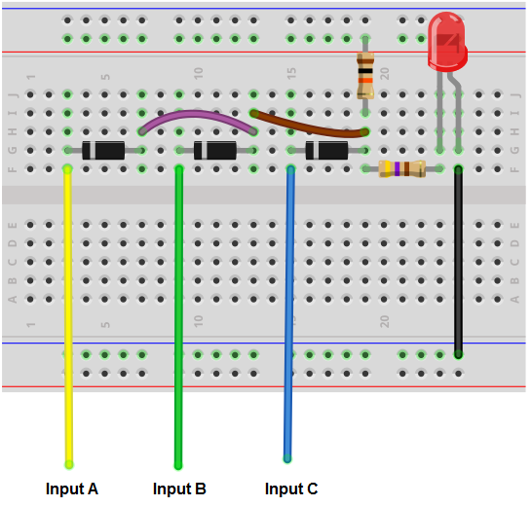
So we power the circuit with about 5V of power. This is enough to power on the LED.
The voltage we need for the circuit is considered based on the power requirements of the load. If your load needs 12V, then the voltage must be at least 12V.
So we can use 5 volts because that is enough to power on the LED.
The 10KΩ resistor is used as a pull-up resistor. It takes the voltage from the power source and concentrates it across the resistor. This voltage is then placed on each of the diodes at the anode end. So at the anode terminal of each of the diodes is the positive voltage we supply. Since we supply this circuit with 5V, there will be 5V present at the anode terminal of each of the diodes.
Now at the cathode terminal of each of the the diodes is the input. This represents the input of the gates. The cathodes are all independent of each other, while the anodes of the diodes are all tied common together.
Know that the same voltage you connected to the pull-up resistor must be connected to the inputs of the gates. It should not be a different voltage. We'll explain why below. But just know that if you're connecting +5V to the pull-up resistor, you must connect +5V to the cathodes of the diodes.
When a positive voltage is connected to the input, it connects the cathode end of the diode to +5V or a HIGH logic state.
When the input is connected to ground, it connects the cathode end of the diode to a LOW logic state.
So how the physics behind this works is like this. When an input of the gate is connected to ground, the cathode of the diode is basically at 0V, a logic LOW state. Remember that the anode terminal of the diode is connected to +5V through the pull-up resistor. So when the input is connected to ground, with the cathode at 0V and the anode at +5V, there is an electric potential difference, or voltage. When voltages are at different potentials, current can flow across. Therefore, when the input is grounded, current flows across the diode and down to ground. Voltage does not concentrate across the 10KΩ resistor.
If any of the inputs are grounded, current will always be able to flow through at least one of the diodes and down to ground. So with any input grounded, voltage will not build up across the 10KΩ resistor, which then powers the output. Instead, current leaks, so to say, and goes out to ground.
Now, if an input is connected to positive voltage, the same voltage feeding the 10KΩ resistor, a different scenario. Since the cathode is at an electric potential of +5V and the anode is also at an electric potential of +5V, there is no difference in electrical potential between the anode and cathode of the diode. With no different in electric potential, current cannot flow. Current only flows from a higher voltage to a lower voltage. If the voltages are same across the 2 terminal of a component, there is no difference to allow electrons to flow across. You could almost say it's equally pressurized. Think of voltage as a push needed to get electrons flowing. This is why a circuit cannot work without voltage. Voltage provides the force or push for electrons to flow. Voltage is normally referenced to ground. This shows how much force it gives in reference to ground, or 0V. If voltage is equal across components, there is no force, and, therefore, no current.
So in this situation, where the inputs are all to connected to +5V, no current can flow through the diodes, because they both ends are at the same electric potential. This is the reason why the voltage at the pull-up resistor and the inputs must be the same.
Since no current flows through the diodes, the pull-up resistor concentrates all the voltage from the power source and current flows through the output, which in this case is an LED, lighting it up.
So that's the physics behind it in a nutshell.
If you want to add additional inputs to the gate, you simply add more diodes in parallel to existing diodes with the cathode independent and the anode tied common with the anodes of the other diodes. If you want to remove inputs, you remove diodes.
You don't have to manually connect and disconnect positive voltage or ground to the inputs. You can also simply add toggle switches instead so that it's much easier to work with.
If you want to build the above circuit with toggle switches, see Diode AND Gate Circuit built with Toggle Switches. This is the breadboard schematic of the of the toggle switch AND gate circuit, Diode AND Gate Breadboard Circuit built with Toggle Switches.
Doing this circuit with toggle switches works well because you can switch easily between positive voltage and ground without having to connect and disconnect wires.
And this is how an AND gate circuit can be built with diodes.

How to Build a Diode OR Gate Circuit
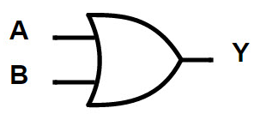
In this project, we will show how to build an OR gate circuit with diodes.
An OR gate is a logic circuit that turns on an output if one of the inputs is HIGH or a logic state of 1. If any 1 of the inputs are HIGH, the output will turn on. If all inputs are LOW or 0, the output will be off.
OR gates can be built using a variety of electronic components, including transistors and mechanical pushbuttons.
In this circuit, we will accomplish building an OR gate with simply diodes.
We then connect our output to this circuit which can turn on our load if at least 1 input is HIGH.
We will show exactly how this circuit works to achieve this logic condition.
We will build our circuit so that there are 3 inputs to the OR gate. You can change this so that there can be 2 or more. All an additional input requires is another pushbutton and another diode. You will see how to do this once you see the schematic below. We'll also explain it below.
Our output will be an LED. We use a current-limiting resistor along with the LED to limit current to the LED. However, you can modify this to suit anything else, as long as the circuit is capable of powering it on given power requirements.
Components Needed
- 3 1N4001 diodes
- 470Ω resistor
- LED
- Toggle switches (optional)

The diodes really can be any type. The 1N400X diodes are an easy type to find and very cheap, so any one from that family can be used.
The amount of diodes you need are proportional to the number of inputs you want for the OR gate. Since we are building a 3-input OR gate, we will need 3 diodes.
We use a 10KΩ as a pull-up resistor.
Optionally, you can use toggle switches to control the input values instead of having to manually connect or disconnect positive voltage or ground. We will show how to incorporate toggle switches into this circuit so that inputs can be changed more easily.

Diode OR Gate Circuit
The OR gate we will build with diodes is shown below.
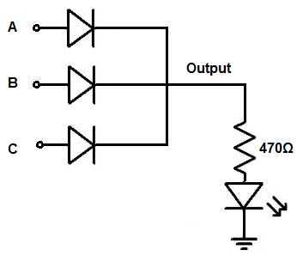
The breadboard circuit of the circuit above is shown below.
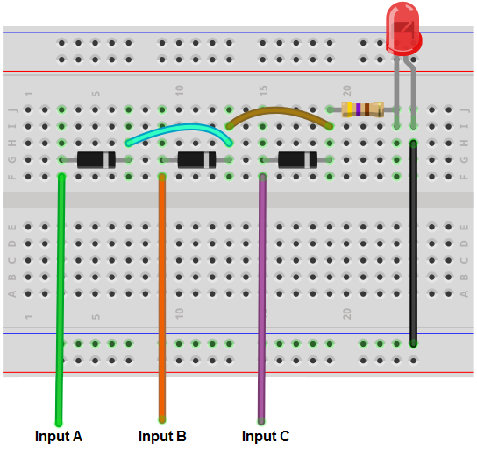
So we power the circuit with about 5V of power. This is enough to power on the LED.
The voltage we need for the circuit is considered based on the power requirements of the load. If your load needs 12V, then the voltage must be at least 12V.
So we can use 5 volts because that is enough to power on the LED.
So the inputs to this circuit connect to the anodes of the diodes. The anodes are all indepedents.
The cathodes of all the diodes are connected together, so they're common. They then connect to the output of the circuit, which is an LED along with its current-limiting resistor.
So how the physics behind this circuit works is as follows. It's very simple.
So when no positive voltage is connected to the inputs, the circuit receives no voltage. Therefore, there is no current flow to turn on and light up the LED. So with no positive voltage to any of the inputs, the output of the circuit is off.
Now, if sufficient positive voltage, +5V, is connected to any of the inputs of the gate, then this produces current flow through the diode, which then turns on the LED. Only 1 input needs +5V for the output to turn on. However, if more than 1 input is logic HIGH, the output will be HIGH as well. With an OR gate, if 1 or more inputs are HIGH, the output is HIGH. Only if all inputs are LOW is the output off.
So that's the physics behind it in a nutshell.
If you want to add more inputs, you simply add more diodes with the anode independent and the cathode connected to the cathodes of all the other diodes. If you want less, you remove diodes.
You don't have to manually connect and disconnect positive voltage or ground to the inputs. You can also simply add toggle switches instead so that it's much easier to work with.
If you want to build the above circuit with toggle switches, see Diode OR Gate Circuit built with Toggle Switches. This is the breadboard circuit of the toggle switch Diode OR gate circuit, Diode OR Gate Breadboard Circuit built with Toggle Switches.
Doing this circuit with toggle switches works well because you can switch easily between positive voltage and ground without having to connect and disconnect wires.
And this is how an OR gate circuit can be built with diodes.

Types of Relays
Relays are electrically actuated devices that act as switches. When the relay's coil receives sufficient voltage, its relay contact switch closes, turning the device connected to it on. When the voltage is shut off, the relay's switch opens, turning the device connected to it off.
There are many types of relays and, in this article, we go through many of the various kinds.

Types of Relays by Composition

There are 3 main types of relays: mechanical relays, reed relays, and solid state relays.

Mechanical Relays
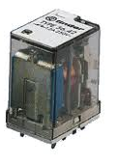
Mechanical relays are usually the largest and most rugged of all relays. For a typical mechanical relay, a current sent through a coil magnet acts to pull a flexible, spring-loaded conductive plate from one switch contact to another.
In general, mechanical relays are designed for high currents (typically 2A to 15A), but they have relatively slow switching (typically 10ms to 100ms).

Reed Relays
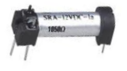
Reed relays are smaller than most mechanical relays and are somewhere in the middle between mechanical and solid-state relays. They are kind of the median.
They are designed for moderate currents (typically 500mA to 1A) and moderately fast switching (0.2ms to 2ms).

Solid-state Relays
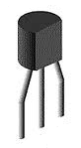
Solid-state relays are transistors. They are usually the smallest in size of all relays, though they can at times be comparable to reed relays in size. They come with a wide range of current ratings, from a few microamperes for low-powered packages up to 100A for high-power packages, and they have extremely fast switching speeds (typically 1 to 100ns), the fastest of all relays.
Mechanical relays have the advantage that they can handle large amounts of current. They are used in applications where large currents are used and switching speed is not critical. An application where mechanical relays are used is in car door locks. Solenoids are used in which a current switches activates the solenoid, closing the switch. For an application like this, switching speed doesn't need to be fast at all. Reed relays are used for moderate current and switching times. And solid-state relays are used in applications where high-speed switching is necessary such as transistors in computers. Computers perform millions of instructions per second and need extremely quick switching from transistors. In these applications, only solid-state relays will suffice.

Types of Relays By Poles and Throws

Single Pole Single Throw Relay
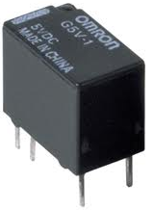
A Single Pole Single Throw Relay is a relay that has one input and one output terminal.
Internally, it is wired so it is connected as shown below:
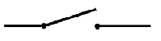
Being that it only has one input and one output, they act as simple on-off switches in circuits, as they can only take on 1 of 2 states. When the relay does not receive any power, it is off and the Normally Open (NO) contact pin remains opens. When the relay receives sufficient power, the NO contact pin closes and whatever load is connected to it will power on.
For an in-detail description of SPDT relays, check out Single Pole Single Throw Relay Wiring Diagram

Single Pole Double Throw Relay
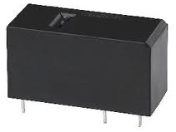
A Single Pole Double Throw Relay is a relay that has one input and two outputs.
Internally, it is wired so it is connected as shown below:

Being that it has 2 outputs, it is more dynamic than a single throw relay. It can connect to 2 different outputs, so it can switch a circuit in between any 1 or 2 states, such as ready mode-pause mode, etc.
For an in-detail description of SPDT relays, check out Single Pole Double Throw Relay Wiring Diagram

Double Pole Single Throw Relay
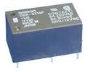
A Double Pole Single Throw (DPST) Relay is a relay that has 2 inputs and 2 outputs.
Internally, it is wired so it is connected as shown below:

Each of the inputs can connect to one ouput. A DPST relay is constructed internally as if they are 2 separate SPST relays connected together. So a DPST is really just 2 separate SPST relays.

Double Pole Double Throw Relay
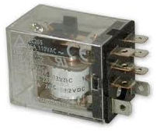
A Double Pole Double Throw (DPDT) is a relay that has 2 inputs and 4 outputs.
Internally, it is wired so it is connected as shown below:

The 2 input stages can each connect to 2 different outputs, allowing for 4 different output modes. A circuit with a DPDT allows for the most dynamic and versatile of outputs being that it can switch between these different modes.

How to Connect a Single Pole Single Throw (SPST) Relay in a Circuit

In order to know how to connect a single pole single throw(SPST) relay, you must know what each pin terminal represents and how the relay works.

Terminal Pins
A Single Pole Single Throw Relay comes with four terminal points.
The terminals are COIL, COIL, COM, and N.O.
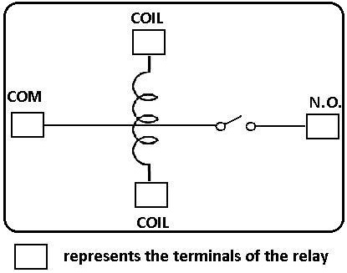
This correlates to the following in the relay:
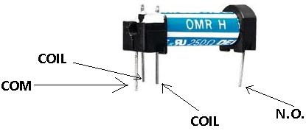

Terminal Descriptions
-COIL- This is one end of the coil.
COIL- This is the other end of the coil. These are the terminals where you apply voltage to in order to give power to the coils (which then will close the switch). Polarity does not matter. One side gets positive voltage and the other side gets negative voltage. Polarity only matters if a diode is used.
NO- This is Normally Open switch. This is the terminal where you connect the device that you want the relay to power when the relay is powered, meaning when the COIL receives sufficient voltage. The device connected to NO will be off when the relay has no power and will turn on when the relay receives power.
COM- This is the common of the relay. If the relay is powered and the switch is closed, COM and N.O. have continuity. This is the terminal of the relay where you connect the first part of your circuit to.
Now that we know what each terminal pin represents, we now wire it to a circuit for it to do a real-world function. We're going to connect a single pole single throw relay to a circuit to light up a LED.
This is the circuit below to connect a single pole single throw relay to light a LED:
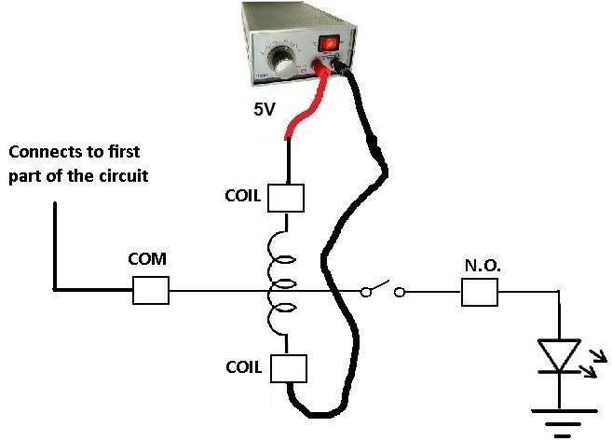
Since the relay is rated for 5V, it should receive 5 volts in order to power on. It may work with less voltage, but 5V is really what it should receive. This goes into either side of the COIL terminals. Even if you switched the positive and negative voltage of the power supply, it should work exactly the same.
The COM terminal of the relay gets connected to the first part of the circuit. If there is no first part of the circuit, this terminal can be left open.
The N.O. terminal of the relay gets connected to the output of the device that it powers on or off. In this case, we are using a LED as output. When the relay receives 5V of power in its coil, the LED will light up. If the 5v are cut off from it, the LED will no longer light.

Battery Internal Resistance
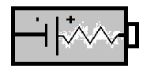
All batteries have some internal resistance to some degree.
Batteries have internal resistance because the elements that make it up aren't perfect conductors. The electrodes and electrolytes aren't 100% conductive. So they will have some resistance (internal resistance) in them.
Ideally, a battery should have 0Ω internal resistance. So during battery operation, all the voltage will be dropped across the element that the battery is powering instead of the battery dropping voltage across itself. According to voltage division, voltage drops across the element with the higher impedance. Ohm's law tells you this in V=IR, showing the higher the resistance, the greater the voltage drop. So if a battery has 0Ω of resistance and it will power a device that has at least some impedance, this ensures, according to ohm's law, that the device will get the voltage and not the battery. This is the ideal case but it doesn't occur in real life.
Batteries will always have some resistance. Though the internal resistance may be or appear low, around 0.1Ω for an AA alkaline battery, and about 1Ω to 2Ω for a 9-volt alkaline battery, it can cause a noticeable drop in output voltage if a low-resistance load is attached to it.
This is understood when you take into account how voltage division works. Taking into account ohm's law, voltage is equal to current * resistance (v=ir). The larger the resistance is, the more voltage gets allocated to that component. If a component has a very large impedance, that component will get most of the voltage, which comes from the battery. However, if the component has a small impedance, say, a few ohms, the voltage output from the battery will not necessarily be received fully by the component. Voltage may be lost, because the battery's internal resistance may compete with that element and the battery will drop voltage across itself instead of the component. This is for small load impedances. Remember, voltage gets allocated according to impedance values. So the impedance of the output device and the battery will always be divided up between each other.
Without any load, we can meaure the open-circuit voltage of the battery by placing a multimeter on the DC voltage setting to measure voltage. This voltage is essentially equal to the battery's rated nominal voltage- the voltmeter has such high input impedance that all of the voltage drops across it. Therefore, it's able to measure the voltage fully. Another way to consider it is that is has such high input impedance that it draws practically no current (v=ir), so there is no appreciable voltage drop.
However, if we attach a load to the battery, the output terminal voltage of the battery drops. By treating the internal resistance Rin and the load resistance Rload as a voltage divider, you can calculate the true output voltage presence across the load.
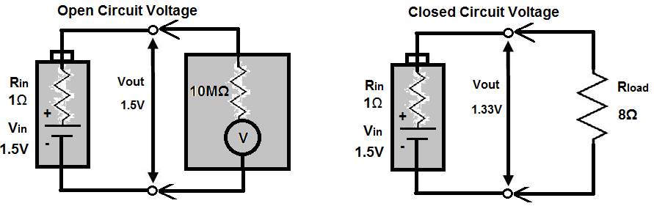
Batteries with large internal resistance show poor performance in supplying high current pulses. This is because current is decreased with higher resistance. Current equals voltage divided by resistance (i=v/r). So the higher the internal resistance, the lower the current output ability. Low internal resistance batteries are much better at supplying high current pulses.
Internal resistance also increases as the battery discharges. Therefore, a typical alkaline AA battery may start out with an internal resistance of 0.15Ω but may increase to 0.75Ω when 90 percent discharged.
The following is a list of typical internal resistances for various batteries. However, the values cannot be assumed to be universal. Check the specific specifications of your battery in use to find out the exact values.
Battery | Internal Resistance
9-V zinc carbon | 35Ω
9-V lithium | 16Ω to 18Ω
9-V alkaline | 1Ω to 2Ω
AA alkaline | 0.15Ω
AA NiMH | 0.02Ω
D Alkaline | 0.1Ω
D NiCad | 0.009Ω
D SLA | 0.006Ω
AC13 zinc-air | 5Ω
76 silver | 10Ω
675 mercury | 10Ω

Both AA alkaline and AANiMH double in resistance after a 50 percent discharge.
This table is useful when selecting batteries. The lower the internal resistance, the more desirable the battery. The lower the internal resistance, the more current it can output. However, the batteries all have their different uses, and if high current output is not a necessity, other battery selections can be just as useful.

Battery Specifications- Explained

Batteries come with a good deal of specifications which you would find with their specs, or datasheet.
Common specifications include the type of cell the battery is in, its standard voltage, its mAH rating, its standard charge (for rechargeable), and its rapid charge (for rechargeable).
In this article, we hope to explain and clarify all specifications which you may find with either standard or rechargeable batteries, so that you can understand each one.
Battery Specifications
Standard and Rechargeable
Type of Cell
Battery Voltage
Milliampere-hours(mAH)
Rechargeable
Standard Charge
Rapid Charge

Standard and Rechargeable Batteries

Type of Cell
All batteries, standard or rechargeable, come in the standard cells, such as AAA, AA, C, or D cells.
When choosing batteries, you choose the type of cell you need for the device which you are powering.

Battery Voltage
Batteries, many times, are also referred to by the amount of volts which they have.
You've probably heard of a 9-volt battery. This is a battery which has 9 volts of energy across its terminals and which gives out 9 volts when connected in a circuit.
Usually 'AA' batteries have a voltage range of 1.2-1.5V. To know which it is, check the spec that comes with the batteries. This amount of voltage specified in the spec is the amount of voltage which the battery has across its terminals when it's fully charged. Battery voltage decreases during operation and usage. Therefore, the voltage will become less as the battery drains. Therefore, the voltage specified is the voltage which the battery has when fully charged.
Depending on the voltage you need for a circuit determines the amount of voltage which you would need in a battery.

Milliampere-hours (mAH)
All batteries, standard or rechargeable, also come with a specification of milliampere-hours (mAH). This shows how long the battery can last for in operation; or in other words, how long its life is.
Millliampere-hours shows how many milliamperes of current the battery can supply per hour of use. For example, a 1900mAH battery can supply 1900mA of current to a circuit for one hour, and then it will have used all of its charge.
Usually a circuit will not demand 1900 mAH of current all at once for operation. A circuit may instead use 380mA of current. In this case, the battery can supply 380mA for 5 hours, since 380*5=1900. Or it can supply 190mA of current for 10 hours, since 190*10=1900.
The product of the current consumed x the number of hours in use must equal to the mAH specification.
Thus, our same example, of a 1900mAH battery can be used in the following ways, as examples:
3800mA for 0.5hours
1900mA for 1 hour
950mA for 2 hours
475mA for 4 hours
etc...
The mAH specification shows how long a battery will be able to last in a circuit, given the circuit's power requirements, how much current the circuit demands.
Being that the mAH is the battery's life, the more mAH's means the longer a battery can last, or the more current it can supply in a circuit. When considering AA to D cell batteries, AA batteries usually have the shortest mAH life, while D cells have much greater mAH. A AA battery may have a mAH of 2000, while a D cell may have 10,000mAH. For this reason, D cells are physically bigger and are more expensive than C or AA batteries. It provides current for a longer period of time.

Rechargeable Batteries

Standard Charge
The standard charge of a battery is now specific to rechargeable batteries, since they are the only types of batteries which can recharge.
The standard charge is the normal amount of time which it takes to recharge a battery back to its full capacity or power.
The time it takes to do a standard charge is normally given as the amounts of hours it takes to charge the battery at the amount of current fed into the battery.
Standard Charge= Amount of Hours to Charge @Milliamperes of Currents
Thus, a battery's standard charge may be 16 Hours @ 300mA.
This means that it would take the battery 16 hours to charge up back to full power when fed 300mA of current.
Know that rechargeable batteries recharge up by current, when current is fed into them, this is how they recharge.

Rapid Charge
Many rechargeable batteries also come with a rapid charge specification.
The rapid charge is a quicker way to recharge a battery. It uses less time; thus, it must use a greater amount of current into to charge it.
Like the standard charge, the rapid charge is expressed by amount of hours @amount of charge fed into it.
Rapid Charge= Amount of Hours to charge@Milliamperes of Current
Thus, if a battery has a standard charge of 16 hours @300mA, it may have a rapid charge of 3 Hours @ 4000mA.
Rapid charge decreases the amount it takes for a battery to charge by significantly by increasing the amount of current that charges it.

How to Recharge Batteries with a DC Power Supply

You can easily recharge batteries if you have a DC power supply.
All that is needed to recharge battery cells is DC current. With DC current, electrons will flow back into the battery, establishing the electric potential, or voltage, that a battery was meant to have when it's fully charged.
Components Needed
- DC Power Supply
- Battery Holder (for battery that needs recharge)
- 2 Alligator Clips
- Battery to be Recharged

A DC Power Supply is needed that allows for adjustable voltage and current. Any such as that shown on the right will suffice to provide the voltage and current that we need in order to recharge a battery cell.
We use a battery holder for our battery because the battery holder gives us two leads (one negative and one positive) so that we can connect it to the DC power supply via 2 alligator clips. Without the battery holder and its leads, it would be very difficult to allow for connection with the battery cell. So if we are charging a single 'AA' battery, we need a single 'AA' battery holder. If we are charging 2 'AA' batteries, we need a double 'AA' battery holder, and so on.

Power Requirements
Now how much voltage and current do we need to give from our DC power supply to recharge the batteries?
And the answer is, the battery you are recharging should come with a specification of the amount of current needed to recharge the battery. For example, a Duracell Rechargeable 'AA' Battery 2650mAh battery specifies the standard charge of 270mA for 16h. This means to recharge, you must supply it with 270mA. Follow the standard charge current of the battery to know the power requirements.
Again, batteries recharge on current. Voltage isn't as important. However, for safety, we will keep voltage low.

Setup

This is how the circuit will be set up:
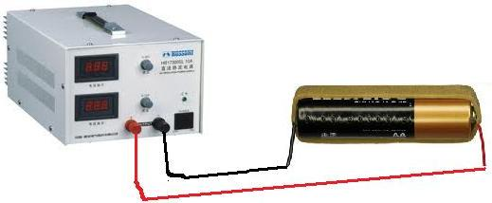
The alligator clips were omitted in this depiction. However, they would connect from the battery holder test leads to the DC power supply output power terminals.
Using this setup, batteries can be charged and recharged. The important thing is to adjust the current to the right levels. In this case we are charging a 270mA 'AA' battery. Therefore, the current output must be 270mA. There are two ways to check if the correct current is being output. One is to change the DC Power Supply to the "Amp" Setting. It should display the amount of amperes being output. The next is to use a multimeter to read the amps output. Make sure that it's the current the battery was designed to be charged at. In this project, I kept the voltage at 3 volts and it dropped to about 1.8 volts when loaded with the battery.
If you want to charge multiple 'AA' batteries, the setup stays the same. This is because current remains the same in series. The only difference is it will take longer to charge, double the time, because it now has to charge 2. If you want to charge 4, it will take 4 times the time it would to charge one. However, current output remains the same.

How to Recharge Batteries with Solar Cells
To recharge a battery with a solar cell, all you need is a solar cell that outputs the current necessary to recharge the battery as well as a diode.

Parts
-Solar Cell(s)
-Diode
-Battery Holder (for battery to be recharged)
-Alligator Clips
-Battery(s) to be recharged
When recharging a rechargeable battery, the battery comes with a specification to the amount of current that is needed to recharge this. This is the current that you have to make sure to feed the battery in order for it to charge properly to full strength.
When you are arranging your solar cells, check the current specification to see how much current it can output up to in bright light.
In our example, we will use a solar panel that can output a maximum of 3 volts and a maximum of 0.1A (or 100mA) when exposed to bright light. Let's also say that the battery we want to charge, a 'AA' Duracell 2650mA needs 270mA for 16h in order to charge to its full potential.
Since each solar cell can only output 100mA and the battery needs 270mA to charge, we need to take 3 solar cells and place them in parallel in order to increase the current output to acceptable charging levels for the battery.

Circuit
When recharging batteries, the circuit will be arranged like this:
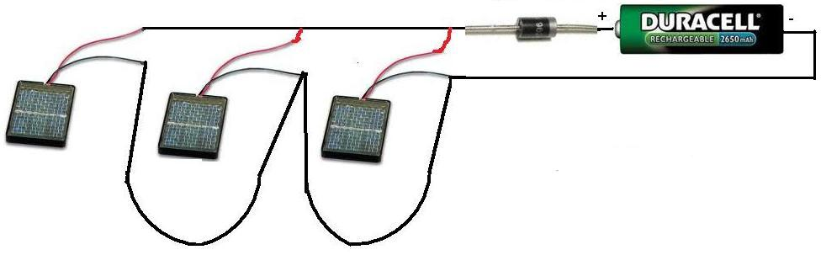
Once we have the 3 solar panels in parallel, the current output will be about 300mA. The reason we connect a diode in the circuit is to keep the charged battery from leaking back current into the solar cells. We have omitted the battery holder and alligator clips in this above illustration, but you will need these for connecting the circuit.
All one must do is keep this circuit exposed to bright light for about 1 day or 2 days and the battery will be fully charged. This is how solar panels can charge batteries.

DC Motor Specifications- Explained
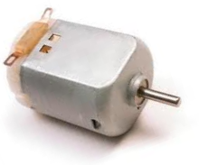
DC motors come with a variety of specifcations, including RPM, no-load speed, maximum current load, and stall torque.
These are all specifications which you find on a datasheet for a DC motor, but what do these terms mean?
In this article, we go over what these terms mean so that you can better understand them when reviewing a DC motor datasheet. Understanding them can help you choose a more appropriate DC motor for an engineering project.
DC Motor Specifications
RPM
No-load Speed
Stall Torque
Maximum Current

RPM (Revolutions per minute)
RPM is one of the most important specifications of a DC motor. RPM, which stands for revolutions per minute, is the amount of times the shaft of a DC motor completes a full spin cycle per minute. A full spin cycle is when the shaft turns a full 360°. The amount of 360° turns, or revolutions, a motor does in a minute is its RPM value. So a motor with an RPM of 24,000 is much more high speed than a motor which has 2400RPM. RPM is important when you need the motor to spin a certain number of times in a given time period. When speed is important, RPM is a crucial factor to look over when choosing a motor. In certain high-speed applications, it is imperative that motors that have high RPM are chosen. This may include applications such as washing machines with high-speed rinse cycles, treadmills that reach high speeds, and any such applications.
Usually when the RPM value for a motor is specified, it normally is given with the voltage that will make it make that amount of turns per minute, such as 2400RPM @ 3V. Thus, the motor will spin 2400 times per minute when fed 3 volts DC into it.

No-load Speed
The no-load speed of a DC motor is the speed that the DC motor will turn when nothing is attached to its shaft. This is why it is called no load. The DC motor isn't loaded with an object.
When a DC motor has nothing attached to its shaft, it is able to operate at its highest maximum speed. When it is then loaded with an object on its shaft, its speed will decrease. This is because it now has to bear with the weight of an object on it.
The no-load speed serves as a reference to how fast the shaft of a motor will turn before weight is added to it. Thus, a circuit designer can have a frame of reference.
The RPM value of a motor that will be specified will normally be the no-load speed.

Stall Torque
Stall torque is the torque produced on a motor when the output rotational speed is zero. This is why it is called the stall torque. It stalls the shaft of the motor, so that it longer spins and has rotational motion. This occurs when the torque load is either equal to or greater than the motor shaft torque. In this condition, the motor draws maximum current but does not rotate.
Electric motors are devices which continue to provide torque when stalled. It's the same as a situation where a machinery is trying to lift up an object that is too heavy to lift. Though the object can't be lifted because it's too heavy, the machinery is still exerting force on it (to try to get it to lift up). This is the same with motors. If too much weight is applied to the shaft, more load than it can handle, the motor will not be able to sufficiently rotate.
So stall torque has to do with the amount of weight a motor shaft can handle before it stalls. For this reason, stall torque is specified as g∙cm. This is the amount of grams of weight that a motor shaft can withstand per centimeter (cm) of its length. An example of a stall torque of a motor is 36 g∙cm. So the motor shaft has more than 36 g∙cm on its shaft, it will stall. Below this weight, it will have more torque than the load and, thus, will be able to rotate.
Stall torque is a very important specification of a motor when weight on a shaft is important. If a circuit designer is only going to put a lightweight object on the motor's shaft, it isn't such a concern. If the designer is going to place a heavy item on the shaft, then it plays a huge role. The designer must be able to know whether that motor can handle that type of weight and still rotate. For motors spinning heavy objects, much more powerful motors must be used.

Maximum Current
The maximum current specification of a motor is the maximum amount of current that a motor can withstand passing through it without being damaged or destroyed.
So the maximum current is a power restraint that circuit designer must make sure is not exceeded.
An example of a maximum current specification of a 9V DC motor is 115mA. This means the motor cannot be fed more than 115mA.

How to Build a DC Motor Circuit
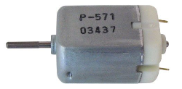
In this project, we will go over how to connect a DC motor to a circuit so that we can build a DC motor circuit which can either rotate forward, reverse, or bidirectionally.
This is valuable because DC motors can tremendous applications and are used in all types of electronics products, such as vehicles (wheels to spin), fans (spinning blades), power drills (spinning of the drill either forward or in reverse) and much, much more. The world world not be the same today if it wasn't for motors.
Before we go into how to build the circuit, however, we will go over what a DC motor is, so you can have proper background and education on this topic.
A DC motor is a motor which runs off of DC power.
This means that a DC motor works off of direct current (DC), not alternating current (AC). This means that DC motors work off of AC power rectified or batteries.
Now that you know the type of power off of which DC motors operate, let's go into the internal construction of a DC motor, which helps to understand how it operates in a circuit.
A DC motor is made up of a stator, which is a permanent magnet, with an electromagnet made to circulate, or rotate, around this permanent magnet.
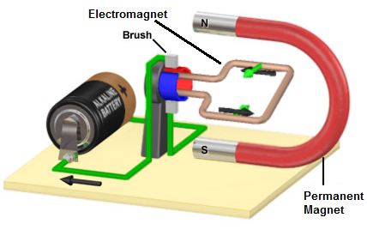
The magnet is called a stator because it is fixed; it doesn't move. The electromagnet, the turning coil of wire, is called an armature, or rotor, because it rotates about the permanent magnet.
The electromagnet carries current produced by the battery; a wire which current flowing through it generates a magnetic field. This magnetic field attracts it to the permanent magnet and what allows it to spin about the permanent magnetic. The interplay of the magnetic field from the permanent magnet and the moving charged electrons in the current creates torque, which is the spinning motion of a DC motor.

DC Motor Circuit
To connect a DC motor to a circuit simply so that it will spin is very easy.
All you have to do is connect the amount of DC voltage to the motor which it is rated for. Therefore, for a DC motor rated at 9 volts, all you must do is connect 9V to the circuit.
Below is a Nichibo PC-280P DC motor, which operates on 3-18VDC. This means it can operate on any voltage between 3-18 volts of power. In the circuit below, we give it 9VDC.
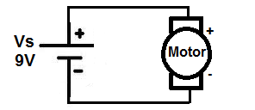
When DC voltage is supplied to a DC motor, positive lead to positive lead and negative to negative, the DC motor spins in a forward direction.

DC Motor Circuit in Reverse
Now if we reverse the voltage going to the DC motor, so that the battery or DC voltage is flipped around, so that positive voltage is now going to the negative lead of the motor and the ground of the DC voltage or battery is going to the positive lead of the motor, the motor will spin in the opposite direction, or in reverse.
Below is the circuit schematic of the DC motor now in reverse:
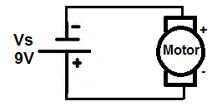
Now the motor will spin in the opposite direction with the polarity switch.

A Bidirectional DC Motor Circuit
Now how can we build a DC motor circuit which is capable of spinning forward and in reverse with the flip of a switch, so that the motor can spin forwards or backwards when we want it to. This has tremendous applications in many different items. Think of a car that goes forward when in one gear and goes in reverse in another. The motor of the car spins forward for forward drive and then in the reverse direction to go in reverse. Also think of a power drill which goes forward to drill a nail in the wall and then in reverse to take a nail out of the wall.
To build a bidirectional DC motor circuit, we need to use a switch, so that we can go back and forth when we want between forward motion and reverse motion. And the type of switch which is best for this is a Double Double Throw (DPDT) switch. This will allow us to make connections to the DC motor so that in one direction, the positive voltage is connected to the positive lead of the DC motor and the ground of voltage is connected to the negative lead of the DC motor, and in the other way, the positive voltage is connected to the negative lead of the DC motor and the ground voltage is connected to the positive lead of the motor. This will allow forward and reverse voltage with the flip of a switch.
Below is the bidirectional DC motor circuit which allows forward and reverse motion with the flip of a switch:
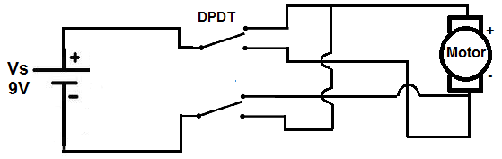
When the switch is up, the motor spins in the forward direction. When the switch is thrown down, the motor spins in the opposite direction. Again, this is how cars, power drills, and many other equipment work.

How to Control Speed of a DC Motor
The last thing that can be varied, besides direction, in a DC motor circuit is speed. And to vary speed is also a simple concept. To decrease speed, the voltage supplied to the motor needs to be decreased. And to increase speed, the voltage supplied to the motor needs to be increased. So if a motor can operate on 3-18V, 3V is when it will operate at its slowest speed. 9V will be its median speed. And at 18V is when it will go the fastest it can go. The quantity of voltage varies speed in a motor.

How to Build an H bridge Circuit with Transistors
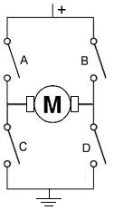
In this circuit, we will show how to build an H-bridge circuit with transistors.
An h bridge is a circuit that is used primarily to control motors; they allow for forward and reverse motion of the motors. Therefore, the motor can be utilized with its full bidirectional capability.
To build an H-bridge, the only option is not to use an IC chip for an H-bridge. You can also build it with discrete and simple components such as with transistors and resistors.
Even though it's almost invariably simpler to use an IC to act as an H-bridge such as the popular L293 IC, there may be times you may want to design one yourself for any various reasons. You may also just be interested in knowning how an h bridge works.
So in this circuit, we will build an H-bridge simply with bipolar junction transistors.
Since motors run off a good amount of current, we will use high-current gain and high-power transistors. These are transistors provide very good current gain and transistors that deal with a lot of power.
In total, we use 4 different transistors, 2 PNP transistors and 2 NPN transistors.
The 2 types of transistors we will use are the TIP107 PNP transistors and the TIP102 NPN transistors. These are darlington transistors that can deal with high power outputs. Again, since motors require a good amount of current, normally about 75mA or so, we want a high-power transistor. Motors require several times more current than an output device that say an LED would. We will talk about these transistors more.
Know that h bridges are useful for circuits that require bidirectional functioning. Otherwise, the only way to be able to operate the device bidirectionally would be to manually switch the polarity leads of the device. An H-bridge eliminates this need.
So, again, h bridges can be used for any type of bidirectional 2-lead device that works in opposite directional depending on which lead is connected to power. It's mostly for motors, but it can also be for other devices as well.

Components

- 2 TIP107/127 PNP transistors
- 2 TIP102/120 NPN transistors
- 4 1KΩ resistors
- 2 5.6KΩ resistors
- DC motor

Really any NPN transistors or PNP transistors can be used. But it is better for them to be high-power transistors, since motors need adequate current.
The TIP107/127 transistors are PNP darlington transistors.
Being that they are a darlington transistors, they provide high current gain. They also can deal with high power. The collector of the TIP107 transistor can deal with up to 80 watts of power, while the TIP127 can deal with up to 65W.
Being that the highest-rated DC motors are normally 12V, this means that the collector can pass 6.7A. Obviously, the motor requires nothing close to this. We need less than 100mA. So this transistor is well above the same range in power that we need.
The datasheets for the TIP107 or the TIP127 can be found at the following links: TIP107 PNP Datasheet and TIP127 PNP Datasheet.
The TIP102/TIP120 transistors are NPN darlington transistors.
Being darlington transistors, they also provide high current gain. This is good so that they can drive a high-power device such as a motor. The transistors themselves can deal with high power.
The datasheets for the TIP102 or the TIP120 can be found at the following links: TIP102 NPN Datasheet and TIP120 NPN Datasheet.
Again, you can really use any NPN or PNP transistors. High-power ones are better for this circuit, as motors need more, but you can mix and match and see what works.
The DC motor can be any type, of really any voltage. We are using a 6-12V DC power supply, so the maximum rating the motor should have is 12V. Normally, anyway, DC motors aren't rated higher than 12V, so you can use practically any motor.
Besides these, all we need else are resistors.

H Bridge Circuit Built with Transistors
The h bridge circuit we will build with 4 bipolar transistors is shown below.
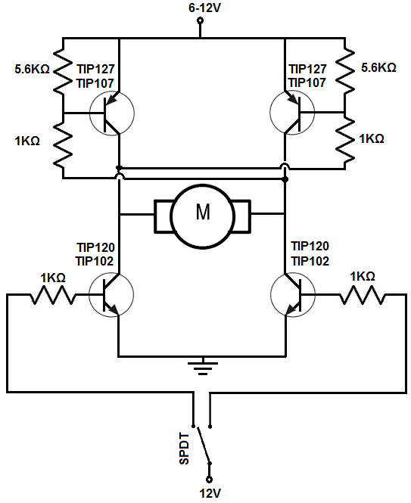
The breadboard circuit of the circuit above is shown below.
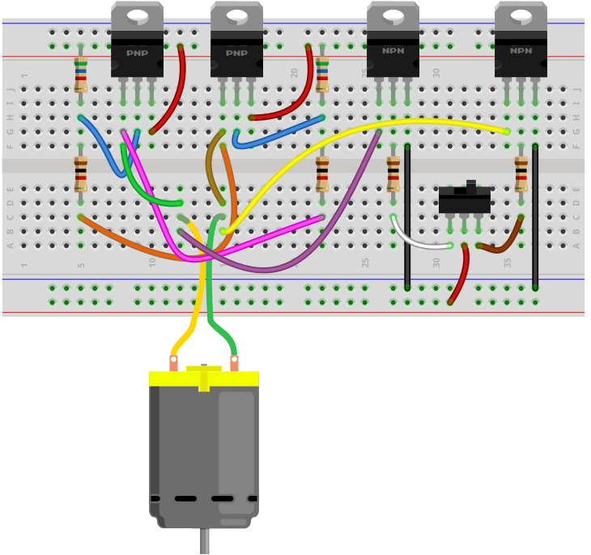
So the first thing that should be done is setting up power for the circuit. The circuit operates off of 6-12V, so it can run any type of motor. However, if you are using a much lower voltage-rated DC motor such as a 3V, you can use lower voltage.
The circuit is manually controlled through a single pole double throw (SPDT) switch, a toggle switch.
The positive voltage either powers the base of the transistor on the left or the right. This transistor that gets the positive voltage turns on.
This turns on the transistor on top on the other side.
Thus, if we turn on the left transistor, current flows from the right of the power source through the transistor on the top right, through the DC motor from right to left, and then from the left transistor to ground.
If we flip the toggle switch to the other side, the bottom right transistor will be powered on. This turns on the transistor at the top on the left side. Current flows from the power source, through the leftmost transistor at the top, through the DC motor, from left to right, and through the rightmost transistor and down to ground.
Therefore, the circuit functions as an H-bridge.
If the switch is flipped one way, the motor spins in one direction.
If the switch is flipped the other way, the motor spins in the other direction.
So the circuit is able to achieve bidirectionality of the motor, as an h bridge should.
Normally, we would put diodes in reverse biased across the transistors. These diodes would help dampen transient spikes that are generated by the motor's coils so that they do not damage other components in the circuits. When a transistor stops running, it can create reverse emf, transient voltage spikes that can be large. To prevent them, reverse biased diodes would stop these spikes from proceeding to other parts of the circuit, where they could cause damage. Being we're flipping the transistors on and off by flipping the toggle switch, you do want to have protection against back emf.
A SPDT switch is used for manual control to demonstrate how the circuit works. It is perfect because it only allows one of the NPN transistors to be on at any given time. Both transistors cannot be on at the same time because both transistors would have current flowing through, which is like a forbidden state. Therefore, it should be avoided. A SPDT switch avoids this condition.
The circuit, as is, will never be off unless the power supply is removed, being that the SPDT has no switch in which both transistors are grounded. To counter this, you could add a switch to the power supply so that the power supply disconnects from the circuit, if this is desired.
If you don't want the circuit to be manually controlled by a switch, you can remove the SPDT switch and instead connect the base of the NPN transistors to whatever device you want to control it, such as a microcontroller. You still keep the 1KΩ resistors at the base.
Another thing is that this circuit, as if, puts the DC motor at one speed. To vary the speeds, instead of inputting a fixed DC voltage to the base of the transistors, a pulse width modulated signal would be applied to the base. We won't get into this article what value of PWM signal you would need to achieve a given speed, but you can take this approach to vary the speed of the DC motor. This is a far more efficient way than using a potentiometer to vary the speed, which is inefficient since it creates large power waste, though you can still use it.
So this is how an h bridge circuit can be built with transistors.

How to Build an H-bridge Circuit
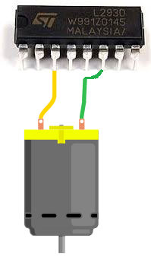
An h-bridge is a chip that allows DC motors to be run versatile as they are meant to- with an H-bridge, we can make a DC motor go forward, go reverse, and stop.
This directional ability that H-bridges allow in DC motors can equate to forward-reverse movement, right-left movement, or up/down movement, depending on the use of the motor in the circuit.
Without an H bridge, we could only make use of the bidirectional capabilities of an H-bridge with either extensive software programming or having to manually switch the voltage polarity to the DC motor to make it change directions; this means we would have to physically swap out the voltage polarity to get the motor to change directions.
Obviously, an H-bridge IC makes this a lot simpler.
In this circuit, we will show how to connect an H-bridge to a DC motor so that we can have the motor exhibit bidirectional capability.
This is really what makes an H-bridge. It can make a DC motor go forward and then in reverse.
We'll go over now how we can easily connect this up.
Components
- L293/SN754410 H-bridge Chip
- DC Motor
- 2 Pushbutton Switches
- Toggle Switch
- 2 10KΩ resistors
- Power Source
The L293/SN754410 H-bridge chip is 16-pin chip that can be used to drive and control inductive loads such as relays, solenoids, DC motors, and bipolar stepper motors.
However, in this project, we will be using a DC motor with the L293.
The L293/SN754410 is a relatively inexpensive chip that can be obtained for a little over $1. One place that sells the L293 is Tayda Electronics- L293 Driver IC.
Before we build this circuit, you must understand the chip and all of its pin connections. You must always know pin connections when hooking up any chip.
Overall, the L293/SN754410 chips aren't very as complicated as they may seem. They both have identical pinouts.
The pinout of the L293/SN754410 is shown below.
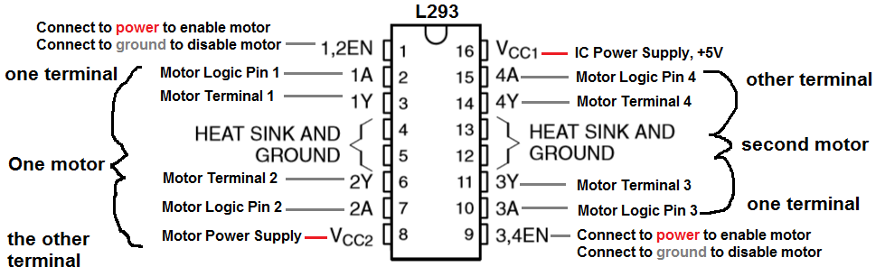
The L293/SN754410 is capable of controlling 2 motors.
It is a 4-channel H-bridge, meaning it can connect 4 terminal wires from motors. Since each motor has 2 terminals, it can control 2 motors (2x2=4).
Pin 1 is the enable pin for terminals 1 and 2. It enables motor to turn on when it is connected to a power. And disables the motor from functioning when connected to ground.
Pin 2 is the motor logic pin for terminal 1. This is the voltage level which one of the motor terminals receive. The logic level will determine what action the motor will take. This is one of the two logic levels that determines the function of the motor connected.
Pin 3 is the pin where we connect one of the terminals of the motor to.
Pin 4 and Pin 5 both get grounded.
Pin 6 is where we connect the other motor terminal to. This completes the 2-terminal connections necessary for a motor to be hooked up to the H-bridge IC.
Pin 7 is the motor logic pin for terminal 2. This is the second voltage signal we feed to the motor to determine the action the motor will take.
Pin 8 is the pin which receives the voltage needed to power on the motor. It is the motor power pin. This is the pin where we place the positive voltage of the power supply that will operate the DC motor. So if the motor is a 9V motor, then you will need to feed 9V into this pin. If the motor is a 12V motor, then you will need to feed 12V into this pin.
Pin 9 is the enable pin for terminals 3 and 4. It enables the motor to turn on when connected to power and disables the motor when connected to ground.
Pin 10 is the motor logic pin for terminal 3. This is one of the logic voltage signals that determines the action that the second motor will take.
Pin 11 is the pin where we connect one of the terminals of the second motor to.
Pin 12 and Pin 13 both get grounded.
Pin 14 is the pin where we connect the other terminal of the second motor to.
Pin 15 is the motor logic pin for terminal 4. It is the second voltage signal that we feed into the second motor to determine the action the motor will take.
Pin 16 is the pin which receives the voltage needed for power for the IC. It is the IC power pin. The IC needs just about 5V in order to operate. Therefore, we feed 5V into this pin.
These are all the pins of the motor. Once power is supplied to the IC and the motor and all the terminals of the motor are connected, then the pins which determine how the motor will operate are the logic levels that we feed into the motor.
The logic levels determine what action the motor will take.
A breakdown of logic levels and the resultant motor action are shown in the table below.
Enable | Logic Pin 1 | Logic Pin 2 | Result
High | Low | High | Forward
High | High | Low | Reverse
High | Low | Low | Stop
High | High | High | Stop
Low | Doesn't matter | Doesn't matter | Off

When the enable pin is high and the motor is fed a LOW voltage signal at the first terminal and a HIGH voltage signal at the second terminal, then it will spin forward. When the enable is high and the motor is fed a HIGH voltage signal at the first terminal and a LOW voltage signal at the second terminal, then it will spin in reverse. And with both logic levels at the same level (2 HIGHs or 2 LOWs), then the motor will stop spinning.
And this is how motor function will work.

H-bridge Circuit
The H bridge circuit we will build is shown below.
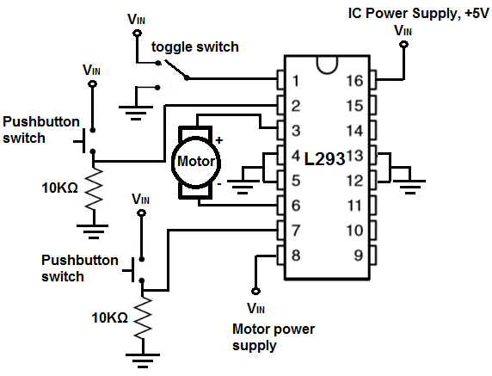
This above circuit built on a breadboard is shown below.
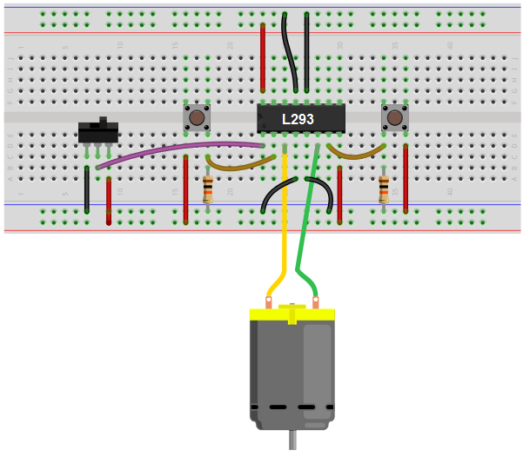
How this circuit works is based on the 3 switches.
First, turn the toggle switch to the ON position. This enables the motor to function. With this switch disabled, the motor will not do anything.
Now, there are 2 pushbuttons. The 2 pushbuttons are connected to the H-bridge IC using pull-down resistors. Without pressing down on them, they are normally LOW (connected to ground). Thus, when both pushbuttons aren't pressed, they're both at LOW logic levels. The motor does not move.
Now if we press down on the first pushbutton, which is connected to motor terminal 1, then the motor will spin in a forward direction. Once we release the pushbutton, then the motor will shut off.
Now if we press down on the second pushbutton, which is connected to motor terminal 2, then the motor will spin in a reverse direction. If we release from the press, the motor will shut off.
Now if we press down on both pushbuttons simultaneously, then both will be at HIGH logic levels, and the motor will not spin.
And this is how an H-bridge circuit can allow for forward and reverse movement of a motor.
This circuit shows how an H-bridge would work if control by manual pressing is wanted.

How to Build an H-bridge Circuit to Control 4 Motors
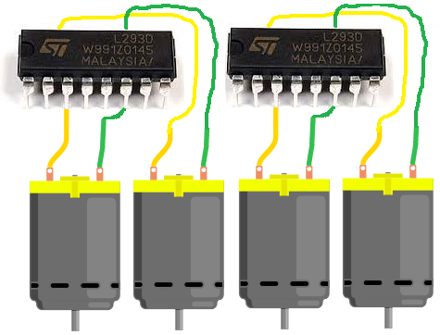
An H-bridge chip such as the L293/SN754410 can control up to 2 motors.
So in order to control 4 motors, we will need to use 2 H-bridge chips and tie them together.
We will build a circuit where all the motors are synchronized, meaning they act in symphony. Thus, if we input so that forward motion is activated, all the motors will spin in a forward direction. If we input reverse mode, all the motors will spin in reverse direction. So the motors act in concert.
This type of circuit is useful for any circuit that needs multiple motors. A common electronic device that now uses 4 DC motors are flying drones. If you go into amazon or any various online retailers to get a toy drone, the majority of them use 4 motors, the 4 of which act in concert. So this type of circuit has very valuable use in the real world.
In actuality, you could use how many motors you want. Since each H-bridge chip can operate 2 motors, then if you wanted to have 8 motors running, then you would need 4 H-bridge chips. If you want 16 motors running, then we need 8 H-bridge chips. You would just have to know how to connect them together, which is relatively simple. It's like just cascading them in a sequence.
But in this circuit, we do 4 motors.
The motor operation is
Components
- 2 L293/SN754410 H-bridge Chips
- 4 DC Motors
- 2 Pushbutton Switches
- 1 Toggle Switch
- 2 10KΩ resistors
- Power Source

The L293/SN754410 H-bridge chip is 16-pin chip that can be used to drive and control inductive loads such as relays, solenoids, DC motors, and bipolar stepper motors.
In this circuit, we will be using it to control 2 DC motors.
The L293/SN754410 is a relatively inexpensive chip that can be obtained for a little over $1. One place that sells the L293 is Tayda Electronics- L293 Driver IC.
Before we build this circuit, you must understand the chip and all of its pin connections. You must always know pin connections when hooking up any chip.
Overall, the L293/SN754410 chips aren't very as complicated as they may seem. They both have identical pinouts.
The pinout of the L293/SN754410 is shown below.
The L293/SN754410 is capable of controlling 2 motors.
It is a 4-channel H-bridge, meaning it can connect 4 terminal wires from motors. Since each motor has 2 terminals, it can control 2 motors (2x2=4).
Pin 1 is the enable pin for terminals 1 and 2. It enables motor to turn on when it is connected to a power. And disables the motor from functioning when connected to ground.
Pin 2 is the motor logic pin for terminal 1. This is the voltage level which one of the motor terminals receive. The logic level will determine what action the motor will take. This is one of the two logic levels that determines the function of the motor connected.
Pin 3 is the pin where we connect one of the terminals of the motor to.
Pin 4 and Pin 5 both get grounded.
Pin 6 is where we connect the other motor terminal to. This completes the 2-terminal connections necessary for a motor to be hooked up to the H-bridge IC.
Pin 7 is the motor logic pin for terminal 2. This is the second voltage signal we feed to the motor to determine the action the motor will take.
Pin 8 is the pin which receives the voltage needed to power on the motor. It is the motor power pin. This is the pin where we place the positive voltage of the power supply that will operate the DC motor. So if the motor is a 9V motor, then you will need to feed 9V into this pin. If the motor is a 12V motor, then you will need to feed 12V into this pin.
Pin 9 is the enable pin for terminals 3 and 4. It enables the motor to turn on when connected to power and disables the motor when connected to ground.
Pin 10 is the motor logic pin for terminal 3. This is one of the logic voltage signals that determines the action that the second motor will take.
Pin 11 is the pin where we connect one of the terminals of the second motor to.
Pin 12 and Pin 13 both get grounded.
Pin 14 is the pin where we connect the other terminal of the second motor to.
Pin 15 is the motor logic pin for terminal 4. It is the second voltage signal that we feed into the second motor to determine the action the motor will take.
Pin 16 is the pin which receives the voltage needed for power for the IC. It is the IC power pin. The IC needs just about 5V in order to operate. Therefore, we feed 5V into this pin.
These are all the pins of the motor. Once power is supplied to the IC and the motor and all the terminals of the motor are connected, then the pins which determine how the motors will operate are the logic levels that we feed into it.
The logic levels determine what action the motor will take.
A breakdown of logic levels and the resultant motor action are shown in the table below.
Enable | Logic Pin 1 | Logic Pin 2 | Result
High | Low | High | Forward
High | High | Low | Reverse
High | Low | Low | Stop
High | High | High | Stop
Low | Doesn't matter | Doesn't matter | Off

When the enable pin is high and the motor is fed a LOW voltage signal at the first pushbutton and a HIGH voltage signal at the second pushbutton, then the motors will spin forward. When the enable is high and the motor is fed a HIGH voltage signal at the first pushbutton and a LOW voltage signal at the second pushbutton, then the motors will spin in reverse. And with both logic levels at the same level (2 HIGHs or 2 LOWs), then the motors will stop spinning.

4-Motor H-bridge Circuit
The H bridge circuit we will build to control 4 motors is shown below.
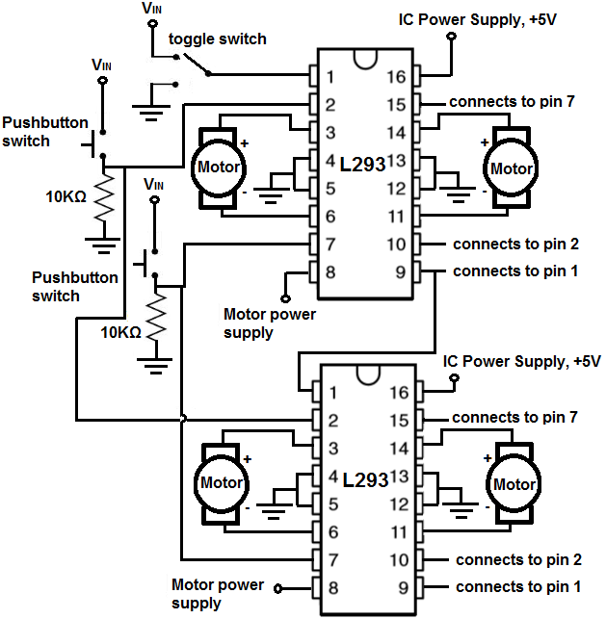
This above circuit built on a breadboard is shown below.
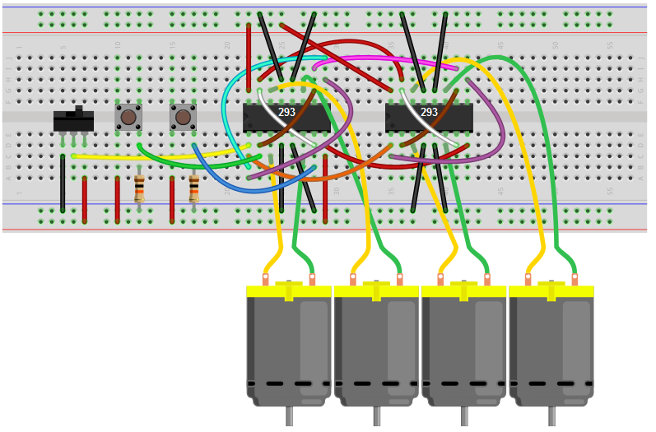
How this circuit works is based on the 2 switches that control the logic state and the 1 enable switch.
All the motor logic pins are tied together for each of the motors, so the 2 pushbuttons control the logic state for all the 4 motors. Thus, this is why they act in concert. So the first pushbutton controls the first logic state for each of the motors. And the second pushbutton controls the second logic state of each of the motors.
So with the motor logic pins normally LOW, if we press down on the second button while leaving the first one unpressed, then the motors will spin in a forward.
Now if we press down on the first pushbutton while leaving the second one unpressed, the motors will spin in the reverse direction.
If we leave both unpressed or press down on both simultaneously, the motors will not spin.
And this is all that is necessary for the operation of our 4-motor device.
To wire it up, it's pretty simple. For each chip, we connect terminals 1 and 3 and then connect terminals 2 and 4. This way, both motors of a chip are synched in together in a given chip. After this, for each additional chip we do the same, and then tie in the the logic pins of the chip before into the chip after, so that all logic pins are connected together.

How to Build an H-bridge Circuit with an Arduino Microcontroller
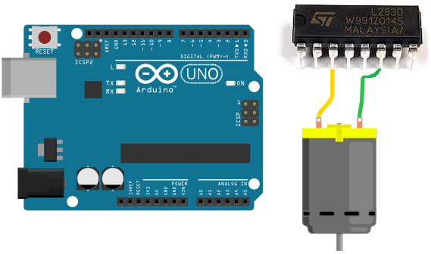
An h-bridge is a chip that allows DC motors to be run versatile, with bidirectional capability. With an H-bridge, motors can go forward or backward, left or right, up or down, etc, depending on the use of the motor(s) in the circuit.
Without a microcontroller, the only way to be able to control an H-bridge is through multiple switches. We would need a switch tied to the enable pin of the H-bridge (unless it's permanently enabled by being connected to power) and another 2 switches tied to the logic pins of the H-bridge, assuming we are connecting only one motor. Thus, we would have to have this network of switches with an H-bridge if we are using a microcontroller.
With a microcontroller such as the Arduino, we can do away with most of the switches. We no longer would need switches connected to the logic pins of the H-bridge, because the microcontroller through sofware can send the logic levels to the logic pins. So we no longer have to manually manipulate switches to control logic levels. We also no longer need a switch to the enable pi. Because this can be controlled through software programming so that we can decide whether the enable pin is on (connected to power) or off (connected to ground).
With our microcontroller circuit, we only use one switch and that is to decide whether the motor runs forward or in reverse, left or right, etc. If the switch is one way, the motor will spin in a certain direction. If the switch is flipped, the motor will spin in the opposite direction. This way, the user can decide which direction he or she wants the motor(s) to spin. This is the only switch we will use.
For our microcontroller, we will use an Arduino and connect it to a L293 H-bridge chip.
Connecting an H-bridge chip to a microcontroller such as the Arduino isn't too complicated and doesn't have too many connections. We will show exactly how to connect so that we can control motors and allow for bidirectional movement through code.
Components Needed
- L293/SN754410 H-bridge Chip
- DC Motor
- Toggle Switch
- Power Source

The L293/SN754410 H-bridge chip is 16-pin chip that can be used to drive and control inductive loads such as relays, solenoids, DC motors, and bipolar stepper motors.
However, in this project, we will be using a DC motor with the L293.
The L293/SN754410 is a relatively inexpensive chip that can be obtained for a little over $1. One place that sells the L293 is Tayda Electronics- L293 Driver IC.
Before we build this circuit, you must understand the chip and all of its pin connections. You must always know pin connections when hooking up any chip.
Overall, the L293/SN754410 chips aren't very as complicated as they may seem. They both have identical pinouts.
The pinout of the L293/SN754410 is shown below.
The L293/SN754410 is capable of controlling 2 motors.
It is a 4-channel H-bridge, meaning it can connect 4 terminal wires from motors. Since each motor has 2 terminals, it can control 2 motors (2x2=4).
Pin 1 is the enable pin for terminals 1 and 2. It enables motor to turn on when it is connected to a power. And disables the motor from functioning when connected to ground.
Pin 2 is the motor logic pin for terminal 1. This is the voltage level which one of the motor terminals receive. The logic level will determine what action the motor will take. This is one of the two logic levels that determines the function of the motor connected.
Pin 3 is the pin where we connect one of the terminals of the motor to.
Pin 4 and Pin 5 both get grounded.
Pin 6 is where we connect the other motor terminal to. This completes the 2-terminal connections necessary for a motor to be hooked up to the H-bridge IC.
Pin 7 is the motor logic pin for terminal 2. This is the second voltage signal we feed to the motor to determine the action the motor will take.
Pin 8 is the pin which receives the voltage needed to power on the motor. It is the motor power pin. This is the pin where we place the positive voltage of the power supply that will operate the DC motor. So if the motor is a 9V motor, then you will need to feed 9V into this pin. If the motor is a 12V motor, then you will need to feed 12V into this pin.
Pin 9 is the enable pin for terminals 3 and 4. It enables the motor to turn on when connected to power and disables the motor when connected to ground.
Pin 10 is the motor logic pin for terminal 3. This is one of the logic voltage signals that determines the action that the second motor will take.
Pin 11 is the pin where we connect one of the terminals of the second motor to.
Pin 12 and Pin 13 both get grounded.
Pin 14 is the pin where we connect the other terminal of the second motor to.
Pin 15 is the motor logic pin for terminal 4. It is the second voltage signal that we feed into the second motor to determine the action the motor will take.
Pin 16 is the pin which receives the voltage needed for power for the IC. It is the IC power pin. The IC needs just about 5V in order to operate. Therefore, we feed 5V into this pin.
These are all the pins of the motor. Once power is supplied to the IC and the motor and all the terminals of the motor are connected, then the pins which determine how the motor will operate are the logic levels that we feed into the motor.
The logic levels determine what action the motor will take.
A breakdown of logic levels and the resultant motor action are shown in the table below.
Enable | Logic Pin 1 | Logic Pin 2 | Result
High | Low | High | Forward
High | High | Low | Reverse
High | Low | Low | Stop
High | High | High | Stop
Low | Doesn't matter | Doesn't matter | Off

When the enable pin is high and the motor is fed a LOW voltage signal at the first terminal and a HIGH voltage signal at the second terminal, then it will spin forward. When the enable is high and the motor is fed a HIGH voltage signal at the first terminal and a LOW voltage signal at the second terminal, then it will spin in reverse. And with both logic levels at the same level (2 HIGHs or 2 LOWs), then the motor will stop spinning.
And this is how motor function will work.

Arduino Microcontroller H-bridge Circuit
The Arduino microcontroller H bridge circuit we will build is shown below.
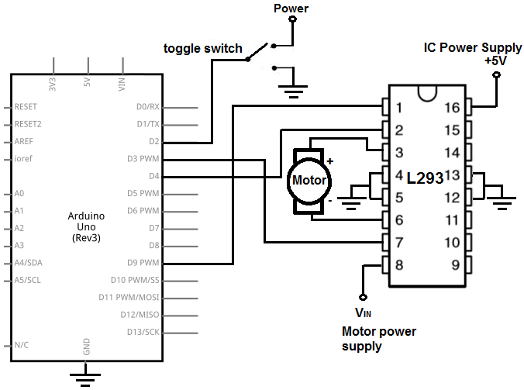
This above circuit built on a breadboard is shown below.
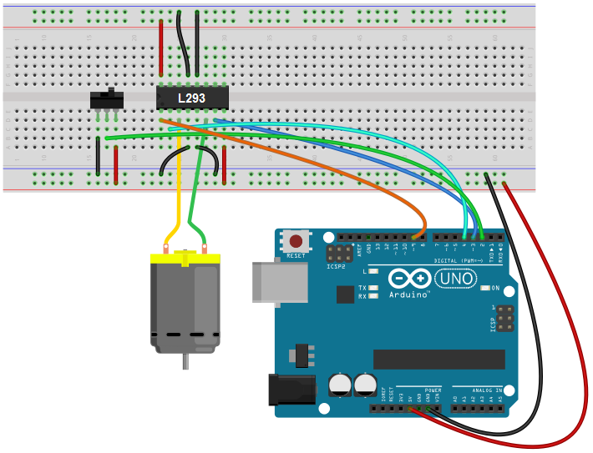
How this circuit works is based on a single switch, the toggle switch.
The toggle switch controls the direction that the motor will spin.
If flipped to the other side, the direction that the motor spins will be opposite. So it controls the forward/backward or left/right movement of the motor. In the software code, which is shown below, we make it so that the toggle switch controls this direction.

Code
The code needed to operate this H-bridge circuit with an Arduino is shown below.
const int toggleSwitch = 2; // Digital Pin 2 connects to the toggle switch
const int motorTerminal1 = 3; // Digital Pin 3 connects to motor terminal 1
const int motorTerminal2 = 4; // Digital Pin 4 connects to motor terminal 2
const int enablePin = 9; // Digital pin 9 connects to the enable pin
void setup() {
pinMode(toggleSwitch, INPUT); //the toggle switch functions as an input
//The rest of the pins function as outputs
pinMode(motorTerminal1, OUTPUT);
pinMode(motorTerminal2, OUTPUT);
pinMode(enablePin, OUTPUT);
digitalWrite(enablePin, HIGH);
}
void loop() {
if (digitalRead(toggleSwitch) == HIGH) {
digitalWrite(motorTerminal1, LOW); //these logic levels create forward direction
digitalWrite(motorTerminal2, HIGH);
}
else {
digitalWrite(motorTerminal1, HIGH); // these logic levels create reverse direction
digitalWrite(motorTerminal2, LOW);
}
}
The first block code establishes all the pin connections of the H-bridge to the Arduino.
The next block of code, the setup() function, defines the inputs and outputs. The only input to the circuit is the toggle switch. The rest of the pins, including the motor terminals and the enable pin, are outputs. We then write the digital value of HIGH to the enable pin, so that it is permanently enabled through software.
The last block of code, our loop() function, which is the function that executes over and over again, makes it so that if the toggle switch is flipped one way, the motor will spin in one direction and if it's flipped the other way, the motor will spin in the opposite direction. The digitalRead() function reads the value from the toggle switch to determine if it is HIGH or LOW. If HIGH, it will send the logic levels of LOW for motor terminal 1 and HIGH for motor terminal 2; this gives forward direction. If LOW, it will send logic levels of HIGH for motor terminal 1 and LOW for motor terminal 2; this gives reverse direction.
And this is how a microcontroller such as the arduino can control motors through an H-bridge IC.

How to Build a Servo Motor Circuit (with Arduino)
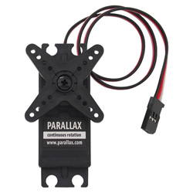
In this project, we will go over how to build a servo motor circuit using an arduino.
This is a circuit which can control and rotate a servo motor to rotate a certain amount of degrees.
Specifically, in our circuit, we will make it so that the servo motor rotates 180 degrees and then stops and then rotates 180 degrees back (in the direction it began).
To control the servo, we connect it to the arduino board and then program it so that rotates in the manner discussed before. We'll see how we do this in code.

Background on Servos
Servos are motors that are used to accurately control physical movement. This is because they generally move to a position instead of continuously rotating. They are ideal for making something rotate over a range of 0 to 180 degrees.
Servos are easy to connect to the arduino and control, because the motor driver is built into the servo. This means that the driver circuit to operate the motor is internally constructed into the servo. So we don't have to connect a driver circuit, since it already is connected. Thus, all we do is connect the pins of the servo directly to the arduino board and program it, and that's all that needs to be done.
Internally, servo motors contain a small motor connected through gears to an output shaft. The output shaft drives a servo arm and is also connected to a potentiometer to provide position feedback to an internal control circuit.
Continuous rotation servos that have positional feedback disconnected can rotate continuously clockwise and counterclockwise with some control over the speed. These function like brushed motors, except that continuous rotation servos use the servo library code instead of analogWrite and don't require a motor shield. The disadvantages are that the speed and power choices are limited compared to external motors, and the precision of speed control is usually not as good as with a motor shield (since the electronics is designed for accurate positioning, not linear speed control).

Components Needed

- Servo Motor
- Arduino
- 3 pin male to male header

The servo motor from Parallax is a good standard motor that can be used for this project. It is a motor that can hold any position between 0 and 180 degrees. And it works between a operating voltage of 4V to 6VDc. Thus, it can function well with the power pin connected to the 5V terminal of the arduino.
The motor can be found at the Parallax site at the following link: Parallax- Standard Servo Motor.
The datasheet for the motor can be found at the following link: Parallax Servo Motor Datasheet.
The motor has 3 terminals, the power pin, ground, and output.
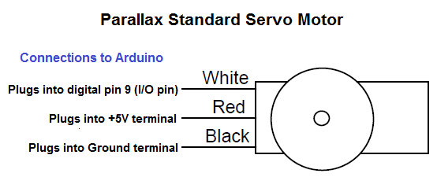
The different pin terminals are differentiated on the servo motor by their colors. The red wire is the positive voltage pin. This is the pin that gets fed the 5V from the arduino pin so that the power can be powered and run. The black wire is ground. This gets connected to the ground terminal of the arduino board. The white wire is the I/O wire. It gets connected to digital output pin D9 of the arduino.
Parallax Wire | Connects to Arduino Terminal
Red Wire | +5V terminal
Black Wire | GND terminal
White Wire | D9 (digital output pin)

Servo Motor Circuit Schematic
The circuit shcematic we will build is shown below.
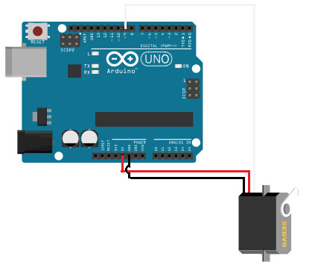
So you can see all connections of the servo made to the arduino board.
All we need now is the code to make the servo rotate.

Code
The code is shown below.
//code must include Servo.h library in order to work
#include <Servo.h>
Servo myservo;
//creates servo object to control a servo
int angle=0;
void setup()
{
myservo.attach(9); //attaches the servo on pin 9 to the servo object
}
void loop()
{
for (angle=0; angle<180; angle+=1)
//goes from 0 to 180 degrees in steps of 1 degree
{
myservo.write(angle); //directs servo to go to position in variable 'angle'
delay(20);
//waits 20ms between servo commands
}
for (angle=180; angle>=1; angle-=1) //goes from 180 to 0 degrees
{
myservo.write(angle); //moves servo back in opposite direction
delay(20); //waits 20ms between servo commands
}
}
So this is the basic code to make the servo rotate 180 degrees and then rotate back 180 degrees. To work, as shown in the code, you must include the Servo.h library code.

What is a Stepper Motor?
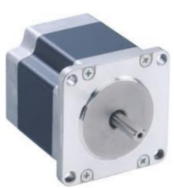
A stepper motor (also called simply a stepper) is a digitally controlled brushless motor that rotates a specific number of degrees (a step) every time a clock pulse is applied to a special translator circuit that is used to control the motor.
The number of degrees that the motor turns per step varies for each motor. The number of degrees can be as small as 0.72° per step or as large as 90° per step. Common general-purpose resolutions are 15° and 30° per step.
Unlike RC servos, stepper motors can rotate a full 360° and can be made to rotate in a continuous manner as well like a dc motor, although it has a lower maximum speed. It can function in a continuous manner with the aid of proper digital control circuitry.
An advantage of stepper motors over dc motors is that they provide a large amount of torque at low speeds. Torque is the ability of a force to cause rotation. So with stepper motors providing high torque at low speeds, it can be used efficiently in applications where low speed and high-precision control is necessary. As an example, they are used in printers to control paper feed and also in plotter- and sensor-positioning applications.

How to Build a Simple Force Sensing Resistor (FSR) Circuit
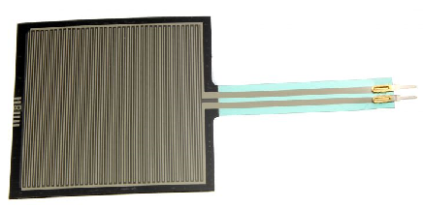
In this article, we will go over how to connect a force sensing resistor, or force sensitive resistor, (FSR) to a circuit to build many different types of useful circuits with them.
Force sensing resistors are variable resistors which change resistance according to the pressure or force applied to them. Under no force, the resistance is very high, pretty much infinite. When a light pressure is applied to the sensor, its resistance drops to about 100KΩ. When maximum pressure is applied, its resistance drops to about 200Ω.
So with no pressure or weight applied, the FSR circuit will be essentially open because its resistance is so high.
With a good amount of pressure applied, about 20lbs needed, the resistance drops dramatically and can go as low as 200Ω.
We will use the basic functioning principles that FSRs have to create a meaningful circuit.
We will wire an FSR to an arduino board. We wire a 10KΩ resistor in series with the force sensing resistor in order to create a voltage divider. One terminal of the FSR will connect to the 5-volt voltage supply of the arduino board and the other terminal will connect to ground. The 5 volts of voltage will be divided based on the resistance of the fixed resistor and the FSR. The fixed resistor will always stay 10KΩ. However, the FSR serves as the variable resistor. It will change resistance based on the pressure applied to its surface. When there is no pressure applied, its resistance is very high, so most of the voltage falls across it rather than the 10KΩ resistor. When it is pressed against with maximum pressure, its resistance falls to near 200Ω, so most of the voltage falls across the 10KΩ resistor and not the FSR.
Based on these voltage divisions, we can get readings of how much pressure it is being applied to the FSR. If a high voltage is across it, we know that it barely has any pressure applied to it. If a low voltage is across it, then it has a lot of pressure applied to it. The arduino serves as a microcontroller that can give us "pressure" readings of the FSR circuit.
This type of circuit could be useful for a wide range of real-life scenarios. Think of a car seat that is equipped with a seatbelt light on the car dashboard. How does it know to light the dashboard, indicating that the passenger seatbelt is not on? How does it know that a passenger is present in the passenger seat or not? It knows because it detects weight. If it detects weight and the seatbelt is not on, the seatbelt LED on the dashboard lights up, indicating that the seatbelt is not on.

We could apply this circuit that we're going to build for a situation such as the car seatbelt lights. If our FSR has a very low voltage, this indicates that a lot of pressure is being applied to it. This would indicate that a passenger is present in the seat. If this is the case and the seatbelt is not on, this would trigger the passenger seatlight light to turn on in the dashboard.
Components Needed
- Force sensing resistor
- 10KΩ Resistor
- Arduino Board

The force sensing resistor can be obtained from many different online retailers. It can be bought in a circular form or square form. A great selection can be found at digikey at the following link: Digikey- Force sensing resistors.
We will use 5 volts of power from the 5V terminal of the arduino.

FSR Circuit
The circuit we will build is shown below:
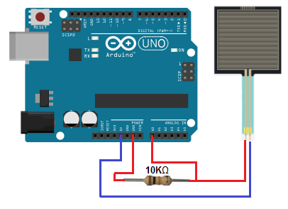

Again, the 10KΩ resistor is in series with the FSR. This forms a voltage divider circuit with the 5 volts powering it. This 5 volts will be divided between the 2 components, based on the resistance of each of the components. Based on the voltage across the components, the arduino board can read how much pressure is being applied to the FSR.

Code
The code for the arduino to obtain pressure readings of the FSR is shown below.
int FSR = A0; //the FSR is connected to analog pin 0 (A0)
void setup(){
Serial.begin(9600);
}
void loop(){
int FSRValue = analogRead(FSR);//this takes a reading of the analog value of the FSR
Serial.println(FSRValue);//this gives a printout of the reading of the analog value that is measured
delay(5000); //this slows down the readings so that they're given every 5 seconds
}
So this is basic arduino code that takes and prints out the analog value across the FSR. Since the FSR is connected to arduino terminal pin 0, we set it equal to A0 in our code. We then read the value of using the analogRead() function and then display this value using the Serial.println() function. We use the delay() function to give readings every 5 seconds. You can modify the time if you want readings given more or less frequently.
Of course, we can modify the code and hardware of this circuit to do a much wider range of activities. For example, instead of simply reading the value of the FSR and displaying it, we can read the value and use if statements to make choices. For example, if the reading is below a certain threshold, a certain event can take place. If the reading is above a certain threshold, another event take place. For example, we can connect an LED to a digital pin of the arduino. If the reading is below a certain level, the LED is off. If the reading is above a certain level, the LED turns on.
An FSR is very useful when imprecise pressure readings need to be determined, such as in the scenarios mentioned above.

Logic NOT Gate Tutorial
The Logic NOT Gate is the most basic of all the logical gates and is often referred to as an Inverting Buffer or simply an Inverter
Inverting NOT gates are single input device which have an output level that is normally at logic level “1” and goes “LOW” to a logic level “0” when its single input is at logic level “1”, in other words it “inverts” (complements) its input signal. The output from a NOT gate only returns “HIGH” again when its input is at logic level “0” giving us the Boolean expression of: A = Q.
Then we can define the operation of a single input digital logic NOT gate as being:

“If A is NOT true, then Q is true”

Transistor NOT Gate
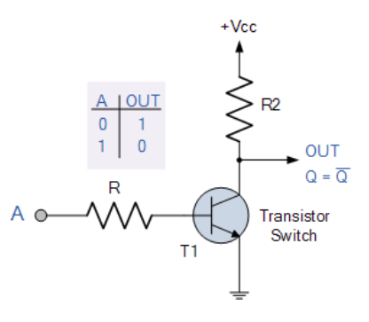
A simple 2-input logic NOT gate can be constructed using a RTL Resistor-transistor switches as shown below with the input connected directly to the transistor base. The transistor must be saturated “ON” for an inverted output “OFF” at Q.

Logic NOT Gates are available using digital circuits to produce the desired logical function. The standard NOT gate is given a symbol whose shape is of a triangle pointing to the right with a circle at its end. This circle is known as an “inversion bubble” and is used in NOT, NAND and NOR symbols at their output to represent the logical operation of the NOT function. This bubble denotes a signal inversion (complementation) of the signal and can be present on either or both the output and/or the input terminals.

http://www.learningaboutelectronics.com

